**Dhaka University Calendar Management Application**

Submitted by

Pritom Kumar Das BSSE0919

Miran Al Mehrab BSSE0931

Supervised By

Dr. Kazi Muheymin-Us-Sakib

Professor

Institute of Information Technology,

University of Dhaka

**Date: 20/03/2019**

**Letter of Transmittal**

Dr. Kazi Muheymin-Us-Sakib

Professor

Institute of Information Technology,

University of Dhaka

Subject: Submission of term report on “Dhaka University Calendar Management Application”.

Sir,

With due respect, we would like to submit you the report on Software Requirement Specification on the above topic you assigned us. The report reflects our effort to gather requirements and analyzing them. We have included every steps what we have done through the whole time for requirement specification of the mentioned topic.

Therefore, we earnestly hope that you will excuse our error and obliged thereby.

Yours Sincerely,

Pritom Kumar Das

BSSE0919

Miran Al Mehrab

BSSE0931

3rd year, 5th semester, 9th batch

Institute of Information Technology

University of Dhaka

Session: 2016-17

**Acknowledgement**

We are highly indebted for getting such a tremendous opportunity to prepare the report on Dhaka University Calendar Management Application .We would like to thank whole-heartedly our supervisor, Dr. Kazi Muheymin-Us-Sakib , Professor , Institute of Information Technology, University of Dhaka, for giving us guidelines about how we can prepare this report. We are also thankful of those people who gave requirements to do this job.

**Abstract**

The calendar committee of Dhaka University publishes a calendar for the very first year students of the university to be familiar with the University campus and its glorious history every year . We are fortunate to take the task of creating an android application that represents Dhaka University Calendar . So, this is the SRS (Software Requirements Specification) of Dhaka University Calendar Management Application from the gathered requirements. The report represents the objective and also describes the need of this trendy strategy.

**Contents**

|  |  |  |  |
| --- | --- | --- | --- |
| Chapter 1: Introduction: **.........................................................................................................................** | | | **7** |
| **1.1 Purpose** ................................................................................................................................................... | | | 7 |
| **1.2 Intended Audience** ................................................................................................................................. | | | 7 |
| **1.3** | **Conclusion**............................................................................................................................................... | | 7 |
| **Chapter 2: Inception ..............................................................................................................................** | | | **8** |
| **2.1** | **Introduction** ............................................................................................................................................ | | 8 |
| **2.1.1** | | **Identifying Stakeholders** ................................................................................................................. | 8 |
| **2.1.2** | | **Recognizing Multiple Viewpoints** ................................................................................................... | 9 |
| **2.1.3** | | **Working towards collaboration** ...................................................................................................... | 10 |
| **2.1.4** | | **Asking the First Questions** .............................................................................................................. | 10 |
| **2.2.Conclusion** .............................................................................................................................................. | | | 12 |
| Chapter 3 : Elicitation **.............................................................................................................................** | | | **13** |
| **3.1** | **Introduction** ............................................................................................................................................ | | 13 |
| **3.2** | **Eliciting Requirements** ........................................................................................................................... | | 13 |
| **3.3** | **Collaborative Requirements Gathering** ................................................................................................. | | 13 |
| **3.4 Quality Function Deployment** ................................................................................................................ | | | 13 |
| **3.4.1 Normal Requirements** ..................................................................................................................... | | | 14 |
| **3.4.2** | | **Expected Requirements** .................................................................................................................. | 14 |
| **3.4.3** | | **Exciting requirements** ..................................................................................................................... | 15 |
| **3.4.3** | | **Usage Scenario** ............................................................................................................................. | 15 |
| Chapter 4: Scenario Based Modeling **.......................................................................................................** | | | **18** |
| **4.1** | **Introduction** ............................................................................................................................................ | | 18 |
| **4.2 Use Case Scenario** ................................................................................................................................... | | | 18 |
| **4.3** | **Use Case Descriptions** ............................................................................................................................ | | 20 |
| **4.4 Use Case Diagram** ................................................................................................................................... | | | 23 |
| **4.5 Activity Diagram generated Use Cases: ………………………………………..**..................................................... | | | 31 |
| **4. 6 Diagram of generated Use Cases:…………………………………………………** ..................................................... | | | 42 |
| Chapter 5: Data Modeling **.......................................................................................................................** | | | **52** |
|  |  | 6 |  |

**5.1 Data modeling concept** **52**

**5.2 Data objects****52**

Chapter 6: Class Based Modeling **70**

**6.1 Class Based Modeling Concept****70**

**6.2 General Classification****70**

**6.3 Selection Criteria****75**

**6.4 Potential** **Classes** **77**

**6.5 Associate Noun and Verb Identification****78**

**6.6 Analysis of Potential Class:****79**

**6.7 Finalizing Classes****80**

**6.8 Class Cards****81**

**6.9 UML Diagram****88**

Chapter 7: Flow-Oriented Model **89**

**7.1 Introduction****89**

**7.2 Data Flow Diagram (DFD)****89**

Chapter 8: Behavioral Model **97**

**8.1 State Diagram**98

**8.2 Sequence Diagram**105

Chapter 9: Conclusion 111

**References**

**Chapter 1: Introduction**

This chapter is a part of “Dhaka University Calendar Management Application” intended to specify the purpose of this document and the intended audience of it.

**1.1 Purpose**

This document is the Software Requirements Specification (SRS) for “Dhaka University Calendar Management Application”. It contains detailed functional, non-functional, and support requirements and establishes a requirements baseline for development of the system. The requirements contained in the SRS are independent, uniquely numbered, and organized by topic. The SRS serves as the official means of communicating user requirements to the developer and provides a common reference point for both the developer team and stakeholder community. The SRS will evolve over time as users and developers work together to validate, clarify and expand its contents.

**1.2 Intended Audience**

This SRS is intended for several audiences, including the customer as well as the project managers, designers, developers, and testers.

* The customer will use this SRS to verify that the developer team has created a product that is acceptable to the customer.
* The project managers of the developer team will use this SRS to plan milestones and a delivery date, and ensure that the developing team is on track during development of the system.
* The designers will use this SRS as a basis for creating the system’s design. The designers will continually refer back to this SRS to ensure that the system they are designing will fulfill the customer’s needs.
* The developers will use this SRS as a basis for developing the system’s functionality. The developers will link the requirements defined in this SRS to the software they create to ensure that they have created software that will fulfill all of the customer’s documented requirements.
* The testers will use this SRS to derive test plans and test cases for each documented requirement. When portions of the software are complete, the testers will run their tests on that software to ensure that the software fulfills the requirements documented in this SRS. The testers will again run their tests on the entire system when it is complete and ensure that all requirements documented in this SRS have been fulfilled.

**1.3 Conclusion**

This analysis of the audience helped us to focus on the users who will be using our analysis. This overall document will help each and every person related to this project to have a better idea about the project.

12

**Chapter 2: Inception**

In this chapter, the Inception part of the SRS will be discussed briefly.

**2.1 Introduction**

Inception is the beginning phase of requirements engineering. It defines how does a software project get started and what is the scope and nature of the problem to be solved. The goal of the inception phase is to identify concurrence needs and conflict requirements among the stakeholders of a software project. To establish the groundwork we have worked with the following factors related to the inception phases:

* Identifying Stakeholders
* Recognizing multiple viewpoints
* Working towards collaboration
* Asking the First Questions

**2.1.1 Identifying Stakeholders**

Stakeholder refers to any person or group who will be affected by the system directly or indirectly. Stakeholders include end-users who interact with the system and everyone else in an organization that may be affected by its installation. At inception, a list of people who will contribute input as requirements are elicited. The initial list will grow as stakeholders are contacted because every stakeholder will be asked: “whom else do you think I should talk to?”

The following stakeholders were identified for the “Dhaka University Calendar Management Application”.

* **Dhaka University Administrative Body:** As the highest ranking Administrative body of Dhaka University they take all the important decisions concerning Dhaka University . Only with their support and approval this application can serve its purpose to its fullest potential.
* **Dhaka University Calendar Committee** : As the committee responsible for delivering and maintaining Dhaka University Calendar each year they are considered the Admin of this application . They operate to gather the necessary information needed for the application .
* **Student:** A student is a first year student of Dhaka University . They are the main users of this application. A student provides his/her information to create his/her profile .
* **Teacher :** As they are the faculty members of various departments/institutions of Dhaka University they can use the app to find relative information . They are also part of the Dhaka University Administrative Body and Dhaka University Calendar Committee.
* **Software Developer:** A software developer is concerned with facets of the softwaredevelopment process, including the research, design, programming, maintenance and testing of computer software. He/She will be responsible for the outcomes of the software.

13

**2.1.2 Recognizing Multiple Viewpoints**

Different stakeholders demand different features from the software. To satisfy the stakeholders, most of these features should be included in the software.

**Dhaka University Administrative Body’s viewpoint**

* Error free system
* Getting all the useful information about Dhaka University
* Checking the security of the system
* Check the validity of provided information
* Keeping record of users
* Update any information that might be wrong
* Maintain public image of Dhaka University
* Strong authentication system

**Dhaka University Calendar Committee’s viewpoint**

* User friendly
* Error free system
* Keeping a track of new information provided by departments/institutes
* Getting accurate information and check validity of the information
* Easy maintainability
* Add new structures that’s not currently in the provided information
* Respond to any complaints and provide solutions
* Strong authentication system
* Response to security issues
* High scalability
* Keeping a backup of the data

**Student’s viewpoint**

* User friendly
* Quick search result for information
* Error free system
* Easy to use
* Fast response
* Easy to connect with friends
* Check history on conversation

**Teacher’s viewpoint**

* User friendly
* Quick search result for information
* Error free system
* Check validity of the information
* Check history

**Developer’s viewpoint**

* Easy to built
* Error free effective software
* Readable and effective code review
* No conflicting requirement
* Easy to add expand or change software
* Create secure software

**2.1.3 Working towards collaboration**

While working with different stakeholders, some conflicting and common viewpoints can be noticed. For this reason, final requirements can be gotten by collaborating the viewpoints. We followed following steps to merge these requirements:

* Identify the common and conflicting requirements
* Categorize the requirements
* Take priority points for each requirements from stakeholders and on the basis of this voting prioritize the requirements
* Make final decision about the requirements

**Common Requirements:**

* Web based interfaces
* The application can be accessed from any computer that has internet access.
* Allow any user to search for Information
* Attractive and easy to use User Interface
* Secure application
* Easy to maintain
* Maintain a database for all users and information in the system

**Conflicting Requirements:**

* Strong authentication problem when check out
* Whether login required or not to use the system
* Design of the User Interface
* Weather or not add messenger in application
* Separate application for admins

**Final Requirements:**

* Error free easy accessible system
* Android application
* Separate web based interface for admins
* Accessible via the Internet.
* Allow valid users to login and logout.
* Restrict access to functionality of the system based upon user roles
* Allow administrators of the system to change provided information and configure parameters of the system
* Allow any user to search for information in the application without having to log in to the system
* Allow valid users that log in to use exciting features of application.
* Allow Administrators to delete , modify, add or update any information regarding Dhaka University
* This application can be used by any android device with connection to internet.
* A dedicated server have to run all the time to help users get information.
* Maintain proper security for all the data.
* Maintain a database of all users and information.
* Allows user option to create profile or not.
* Allows user option to change language.
* Allows user to contact with admin through email if needed

Restrict access to functionality of the system based upon user roles. For example, only Administrators of the system will be provided functionality to change static information of Dhaka university .

**2.1.4 Asking the First Questions**

We set our first set of context-free questions focuses on the students and other stakeholders, overall project goals and benefits. The questions are mentioned above. These questions helped us to identify all stakeholders, measurable benefit of the successful implementation and possible alternatives to custom software development. Next set of question helped us to gain a better understanding of problem and allows the user to voice his or her perception about the solution. The final set of question focused on the effectiveness of the communication activity itself and the acceptability of the application itself.

**2.2 Conclusion**

Inception phase helped us to establish basic understanding about “Dhaka University Calendar Management Application” and its importance in Dhaka University, identify the people who will be ben**e**fited if Dhaka University Calendar Management System becomes automated, define the nature of the Calendar management software and establish a preliminary communication with our stakeholders. More studies and communication will help both side (developer and client) to understand the future prospect of the project. Our team believes that the full functioning document will help us to define that future prospect.

**Chapter 3: Elicitation**

This chapter specifies the Elicitation phase.

**3.1 Introduction**

Requirements Elicitation is a part of requirements engineering that is the practice of gathering requirements from the students, admin and other stakeholders. Many difficulties were faced, like understanding the problems, making questions for the stakeholders, limited communication with the stakeholders due to a short amount of time and volatility. Though it is not easy to gather requirements within a very short time, these problems have been surpassed in an organized and systematic manner.

**3.2 Eliciting Requirements**

The main task of this phase is to combine the elements of problem solving, elaboration, negotiation and specification. The collaborative working approach of the stakeholders is required to elicit the requirements. The following tasks were done for eliciting requirements:

1. Collaborative Requirements Gathering
2. Quality Function Deployment
3. Usage Scenarios
4. Elicitation work products

**3.3 Collaborative Requirements Gathering**

Many different approaches to collaborative requirements gathering have been proposed. Each makes use of a slightly different scenario. We completed following steps to do it.

* The meetings were conducted with the Dhaka University Calendar Committee members and they were questioned about their requirements and expectations from the Dhaka University Calendar Management Application.
* The Calendar Committee was asked to see there satisfaction with the current system.
* At last we selected our final requirements from the meetings

**3.4 Quality Function Deployment**

Quality Function Deployment (QFD) is a technique that translates the needs of the users into technical requirements for software. It concentrates on maximizing user satisfaction from the Software engineering process. With respect to our project the following requirements are identified by a QFD.

17

**3.4.1 Normal Requirements**

The normal requirements are generally the objectives and goals that are stated for a product or system during meetings with the user. The presence of these requirements fulfills users’ satisfaction. These are the normal requirements for the project.

1. Error free easy accessible system
2. Android application
3. Effective System
4. Separate web based interface for admins
5. Accessible via the Internet.
6. Allow valid users to login and logout.
7. Restrict access to functionality of the system based upon user roles
8. Allow administrators of the system to change provided information and configure parameters of the system
9. Allow any user to search for information in the application without having to log in to the system
10. Allow valid users that log in to use exciting features of application.
11. Allow Administrators to delete , modify, add or update any information regarding Dhaka University
12. This application can be used by any android device with connection to internet.
13. A dedicated server have to run all the time to help users get information.
14. Maintain proper security for all the data.
15. Maintain a database of all users and information.
16. Allows user option to create profile or not.
17. Allows user option to change language.
18. Allows user to contact with admin through email if needed
19. Fast loading application.
20. Provide users with Dhaka University Map.

**3.4.2 Expected Requirements**

These requirements are intrinsic to the product or system and may be so elementary that the customer does not explicitly state them. Their absence will be a cause for significant dissatisfaction. Below the expected requirements for our project are briefly described.

1. Error free software
2. Strong authentication system
3. User friendly
4. Effective system
5. No ambiguous feature
6. Data backup
7. Sending notification to users if necessary.

18

**3.4.3 Exciting requirements**

These requirements are for features that go beyond the customer's expectations and prove to be very satisfying when present

1. The user interface should provide appropriate error messages for invalid input or show message if search results are not found.
2. The user interface should follow standard web practices such that the web interface is consistent with typical internet applications.
3. Offer log in with mobile phone
4. Users will also be given a list of exciting places within Dhaka University .
5. There will be a personalized calendar for each student which will contain academic schedule.
6. Messenger for first year students.

**Usage scenario**

This is an android application that is entitled to the name “Dhaka University Calendar”. People can avail this application to be familiar with Dhaka University by using the basic features such as – infrastructure info, transport info, map info, general calendar, university map as well as exciting feature like specific calendar and group chat.

**Account Creation**

**Sign Up:**

The user can download the application from Google play store or Dhaka University main website page (admission page). Any person with Google account are eligible for sign up and to complete their profile the users will have to provide their user name and type, such as- student, teacher or other. Depending on their type they will be required to enter their department/institute name and academic year.

**Sign In:**

After sign up is done, users can sign in to their account with Firebase Auth 2.0 Sign In.

**Update account**:

Logged users can update their profile by entering new name, department/institute name or academic year.

**Delete account**: Logged users can delete their account as their wish any time and their data from firebase database will be deleted accordingly.

**User Based Privilege**

As exciting features are specific for different users, so these features are shown according to the user type:

**Other**: This type of users can use the basic features, such as - infrastructure info, transport info, map info, general calendar and university map.

**Teachers:** Teachers can use the basic features as well as specified calendar, group chat based on their given department.

**Student:** Students can use the basic features can use all the basic features as well as specified calendar, group chat based on their given academic year.

**Management Parts of Project**

**Information management:**

It includes university brief history, notable achievement, information about Administrative body, department / institute description, halls, Club details, description of popular places in university campus. Description of the information management parts are given below:

Dhaka University Administrative body: This includes the name, rank and picture of the Dhaka University Administrative body.

Administrative committee: This includes the name and rank of the administrative committee members.

Editorial committee: This includes the name and rank of the editorial committee members.

List of Faculty Deans: This includes a list of faculty names and its Deans.

Department /Institute/hall/offices: This includes department /institute name, establishment year , description of the department/institutes/hall/offices and locations.

**Transport Management:**

Users can see the schedule of buses on different route and their stoppage on the way.

**Map management:**

Users can see their current position. They can also search and get route for their destination. They can also see exciting places near their position within the university area.

**Communication Management:**

A group chat option is available for the students based on their academic session and department. Students can also leave and rejoin this chat group as their wish.

**Calendar Management:**

There will be two kinds of calendar for the users. A general calendar that entails all holiday and events marked by Dhaka University calendar committee is available for general or other users. And there will be a specific calendar for each department / institute that will mark down all the academic activities as well as university holidays.

**Administrative Responsibilities**

There will be multiple role based admin account for this project. They will have a different web interface for their convenience. They can upload, update or delete information to the server and database will be updated accordingly. They have the responsibility to maintain the database and server that’s providing service for the application. They will have ensure the data integrity and security.

**Design Overview of Application**

**Homepage:**

There will be icons for all the functions such as map, calendar, transport, chat group, infrastructure icons in the homepage. Users will find a search option to search information. In the settings option users can change the language to Bengali or English.

**Other Pages:**

Users can go to other pages from home page. The design of the page will be created on the content of the page like – the combination of text, image or other buttons.

**Search**

Users can search for any information in the application. The search string will be used to generate database query to find information from the database. If result of the query is null then it will show specific page regarding no result found. If query result is found, then link to the page will be shown to the users.

**Chapter 4: Scenario Based Modeling**

**4.1 Introduction**

In this model the system is described from the user’s point of view. As this is the first model, it serves as input for creation of other modeling elements.

**4.2 Use Case Scenario**

Table 1: Use Case Scenario

|  |  |  |  |
| --- | --- | --- | --- |
| Level 0 | Level 1 | Level  **2** | Level 3 |
|  | Account management | Sign up |  |
| Log out |
| Log in |
| Update |
| Remove |
| Dhaka University Calendar | Information management | Infrastructure | University |
| Information modification |
| Department |
| Hall |
| Club |
| Office |
| Administrative body | Governing body |
| Administrative committee |
| Editorial committee |
| Faculty deans |
| Governing body modification |
| Transport |  |
| Update information |  |
|  | Map management | Search location |  |
| Nearby places |
| Location suggestion |
| Location modification |
|  |
|  | Calendar management | General calendar |  |
| Specific calendar |
| Calendar modification |
|  | Communication management |  |  |

**4.3 Use Case Descriptions**

**Use case**: Sign up

**Primary** **actor**: user

**Goal in context**: to create an account

**Preconditions**:

1.System has been designed to have sign up option

2.System has interface to sign up

**Triggers:** User have to sign up

**Scenario:**

1. Get authenticated using OAuth 2.0
2. Enter user type, user name, department, academic session

**Exception:**

1. Already authenticated

**Priority**: Essential, must be implemented

**When available**: First increment

**Use case**: Sign in

**Primary actor**: user

**Goal in context:** to enter into system

**Preconditions:**

1.System has been designed to have sign up option

2.System has interface to sign up

3.User must be authenticated using oauth 2.0

**Scenario:**

1.Click on the right authenticated Google account

**Exception:**

1.User is blocked

**Priority:** Essential, must be implemented

**When available:** First increment

**Use case**: update account

**Primary actor:** user

**Goal in context:** change user information

**Preconditions:**

1.System has been designed to have update option

2.System has interface to update

3.User must be logged in

**Scenario:**

1.Click on the right interface option

2.Enter required data in the fields

3.confirm to change

**Triggers:** User has to change his department or academic year.

**Exception:** 1.information is like the old one.

**Priority:** Essential, must be implemented

**When available:** First increment

**Use case:** Log out

**Primary actor :**user

**Goal in context:** get out of the system

**Preconditions:**

1.System has been designed to have log out option

2.System has interface to og out

3.User must be logged in

**Scenario:**

1. Click on the log out option on the interface.

**Triggers:**

User needs to stop current system service.

**Exception:**

1.User isn’t logged in.

**Priority:** Essential, must be implemented

**When available:** First increment

**Use case:** Transport info

**Primary actor:** user

**Goal in context:** to see available transport service in the university

**Preconditions:**

1.System has been designed to have transport info option

2.System has interface to transport info option

3.User must be logged in

**Scenario:**

1.Click on the transport info option

**Triggers:** User want to use desired bus service.

**Exception:**

1.User isn’t logged in.

2. Data not available

**Priority:** Optional, should be implemented

**When available:** First increment

**Use case:** update database

**Primary actor:** admin

**Goal in context:** To manipulate existing data.

**Preconditions:**

1.System has been designed to have update database

2.System has interface to update database option

3.Admin must be logged in.

**Scenario:**

1. Admin select data to be updated
2. Admin add new data
3. Admin delete existing data

**Triggers:**

Data needs to be changed to various reason.

**Exception:**

1.Network failure.

2.System failure.

3.Database inconsistency

4.partial update

**Priority:** Essential, must be implemented

**When available:** First increment

**Use case:** Map

**Primary actor:** user

**Goal in context:** to get familiar with the university locations

**Preconditions:**

1.System has been designed to have map option

2.System has interface to map option

3.User must be logged in

**Scenario:**

1.User turns on location option in device

2.search location and get route to destination

**Triggers:** To need to go for official or personal purpose on unfamiliar place.

**Exception:**

1.Location not available.

2.Google map service not available.

**Priority:** Optional, should be implemented

**When available:** First increment

**Use case:** Information management

**Primary actor:** user

**Goal in context:** To get familiar with the university

**Preconditions:**

1.System has been designed to have information

2.System has interface to option for information

3.User must be logged in

**Scenario:**

1.Users select different information option from the interface

**Triggers:** Students,teachers or other people to get familiar with the university

**Exception:**

1. System doesn’t provide information.
2. Network error to fetch data from server

**Priority:** Essential, must be implemented

**When available:** First increment

**4.4 Use Case Diagram**

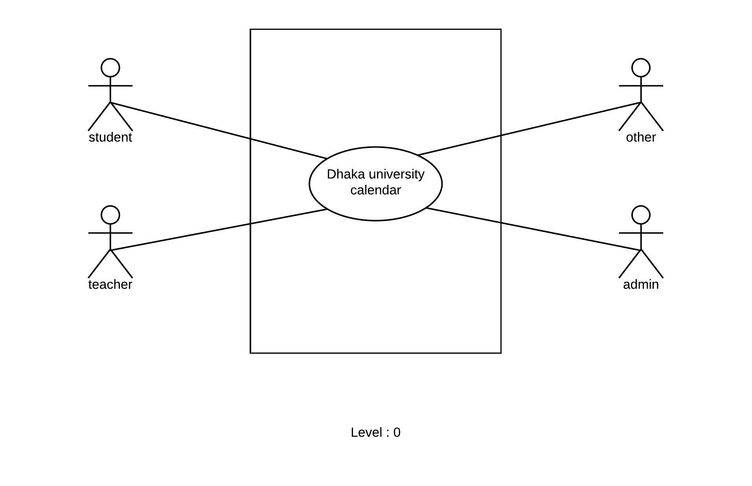

**Figure : Level 0 for Dhaka University Calendar Management System**

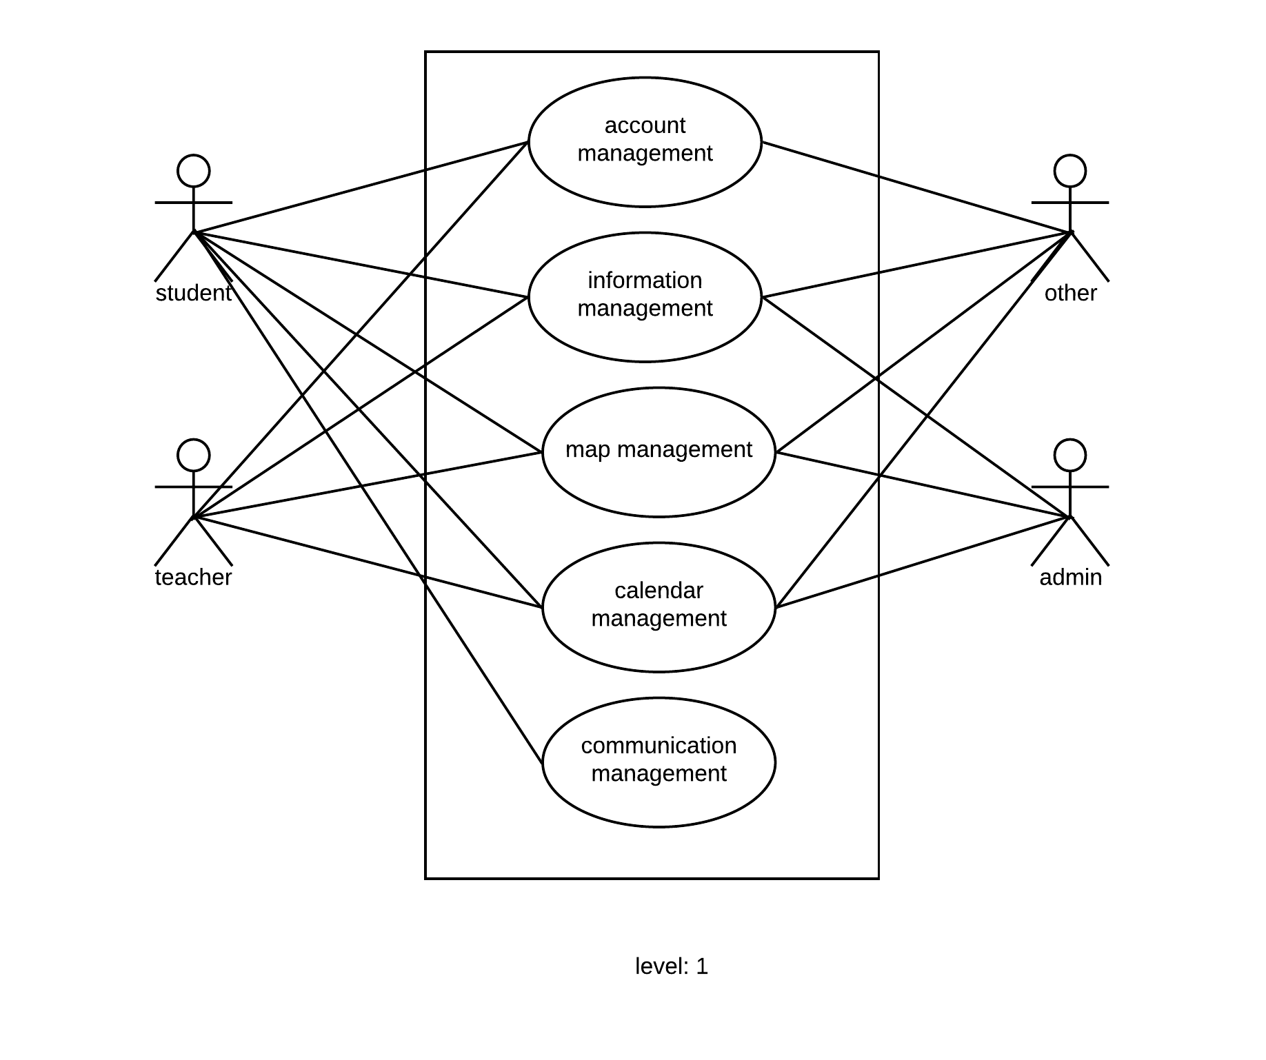

**Figure : Level 1 for Dhaka University Calendar Management System**

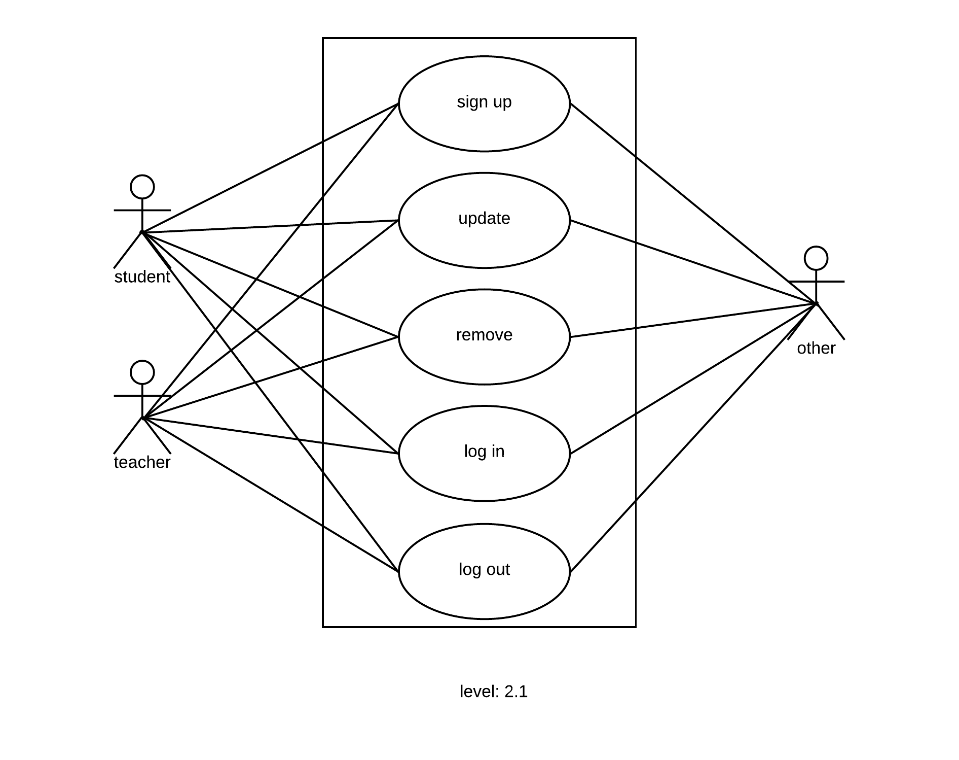

**Figure : Level 2.1 for Dhaka University Calendar Management System**

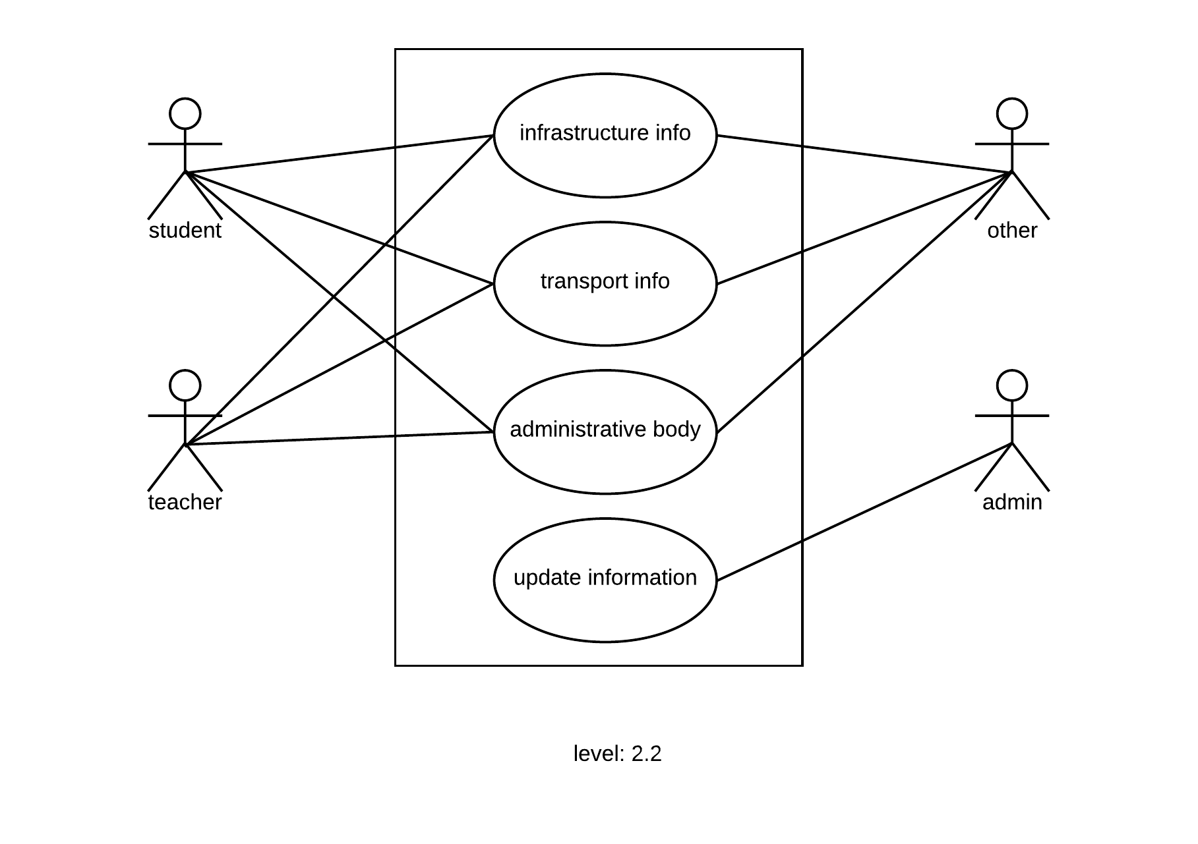

**Figure : Level 2.2 for Dhaka University Calendar Management System**

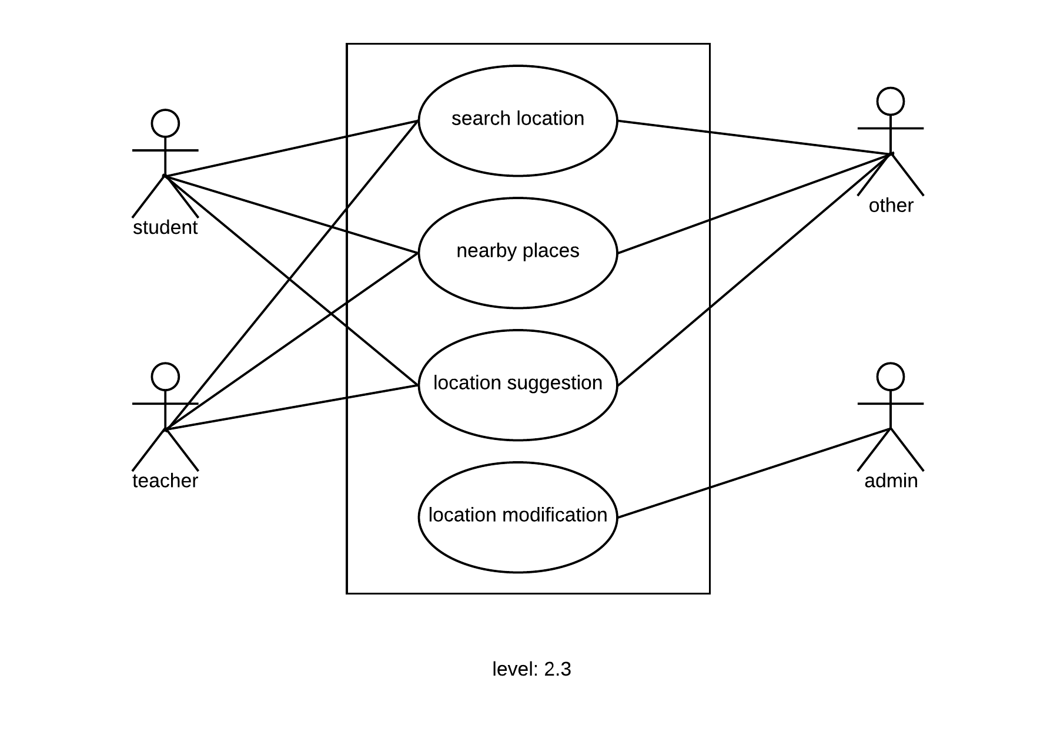

**Figure : Level 2.3 for Dhaka University Calendar Management System**

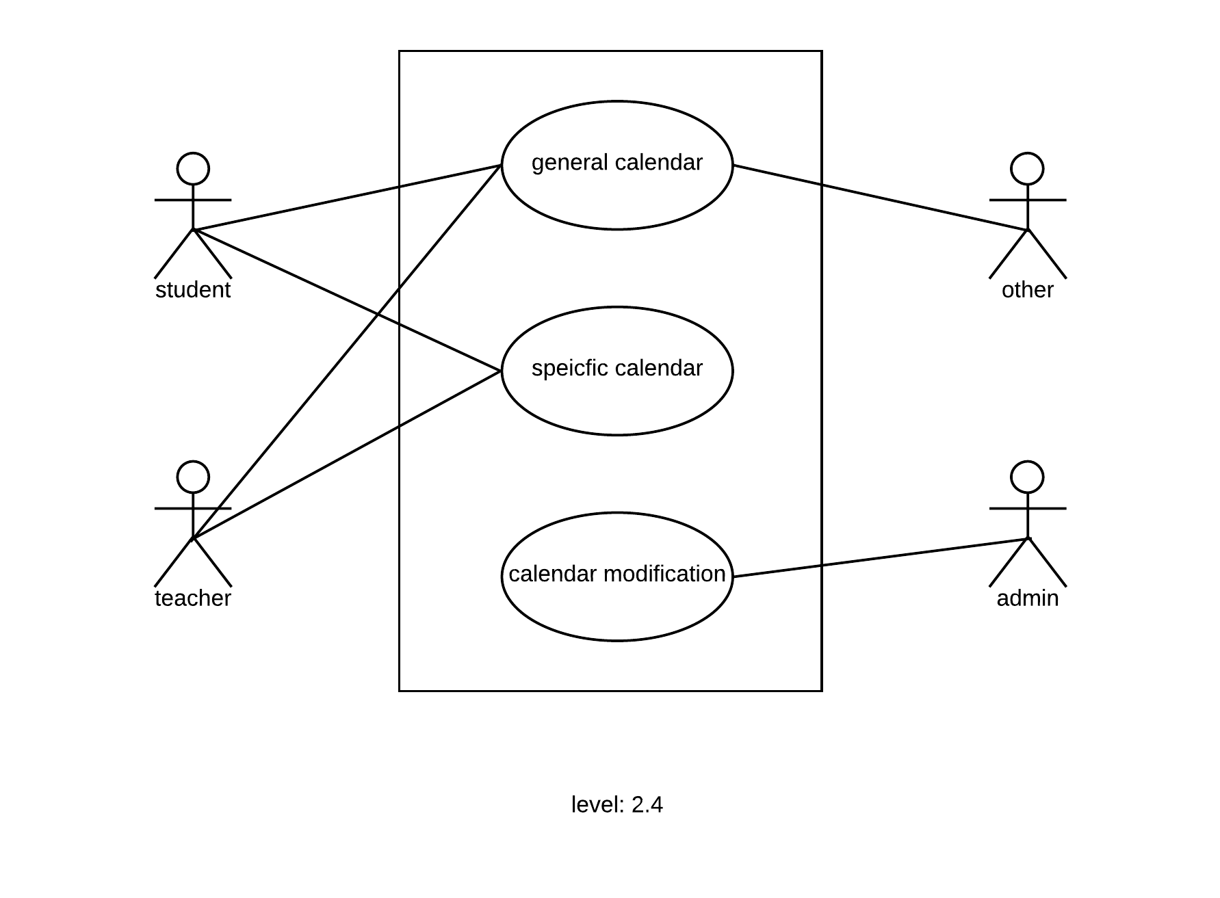

**Figure : Level 2.4 for Dhaka University Calendar Management System**

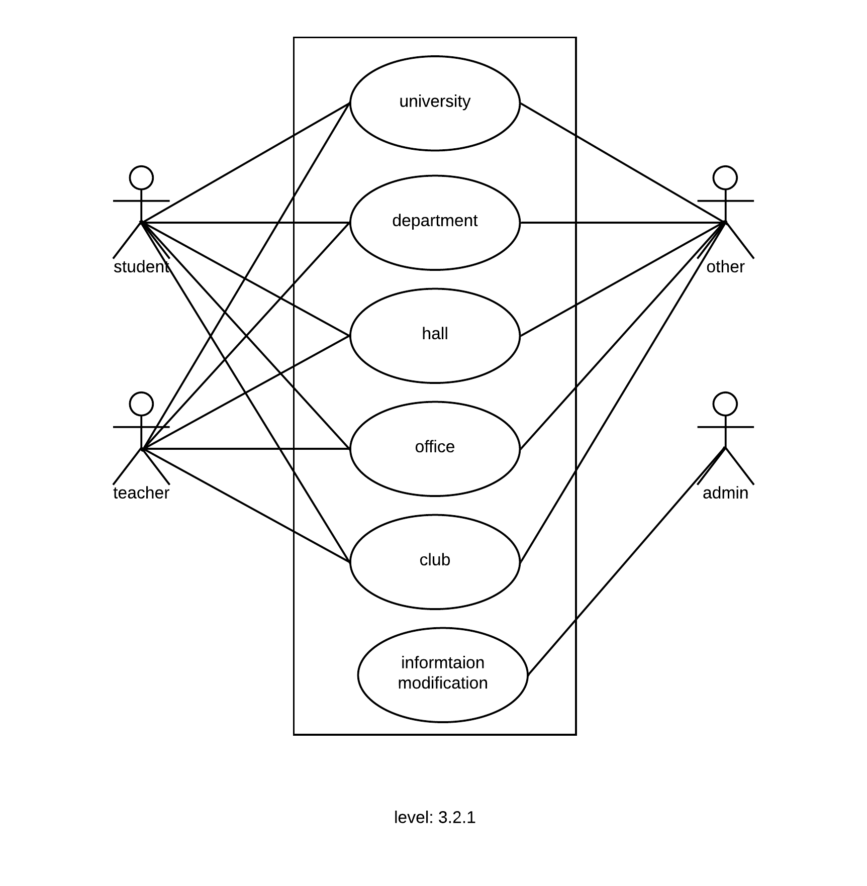

**Figure : Level 3.2.1 for Dhaka University Calendar Management System**

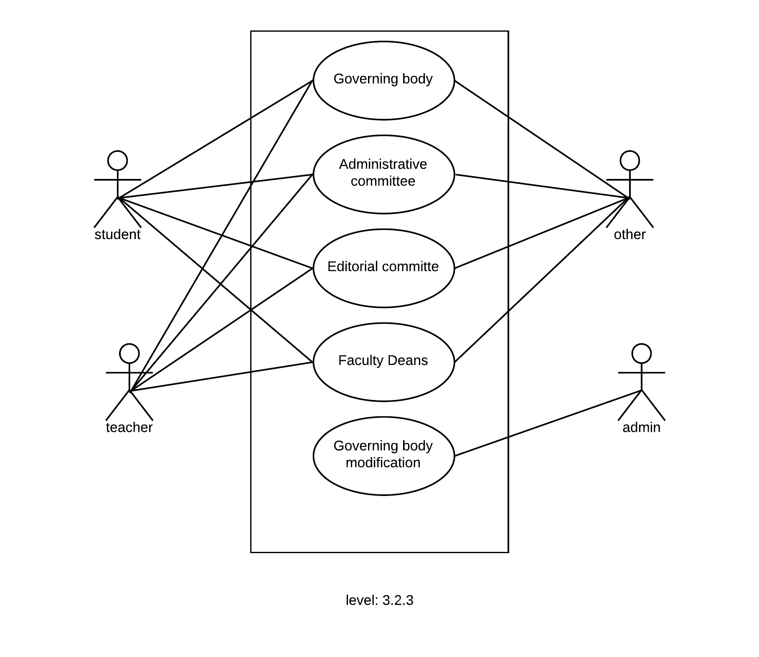

**Figure : Level 3.2.3 for Dhaka University Calendar Management System**

**4.5 Activity Diagram and Swimlane Diagram of generated Use Cases:**

**Activity Diagram:**

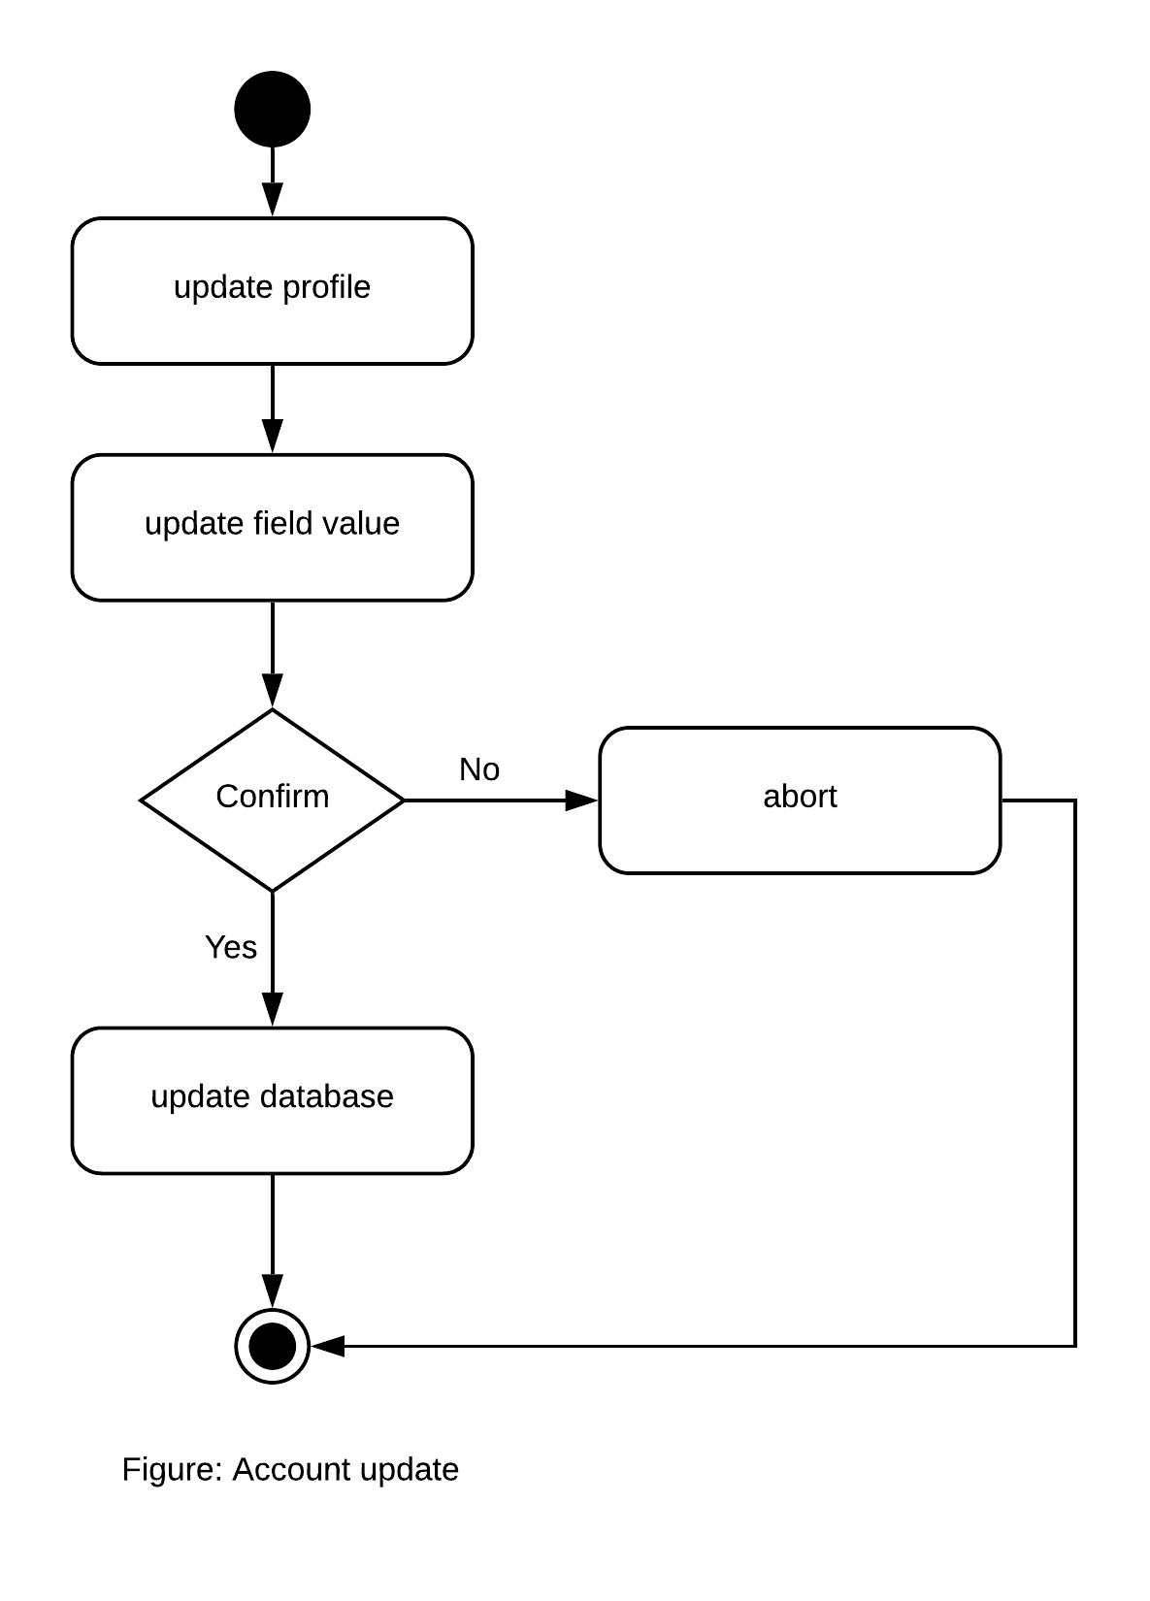

**Figure : Activity Account Update**

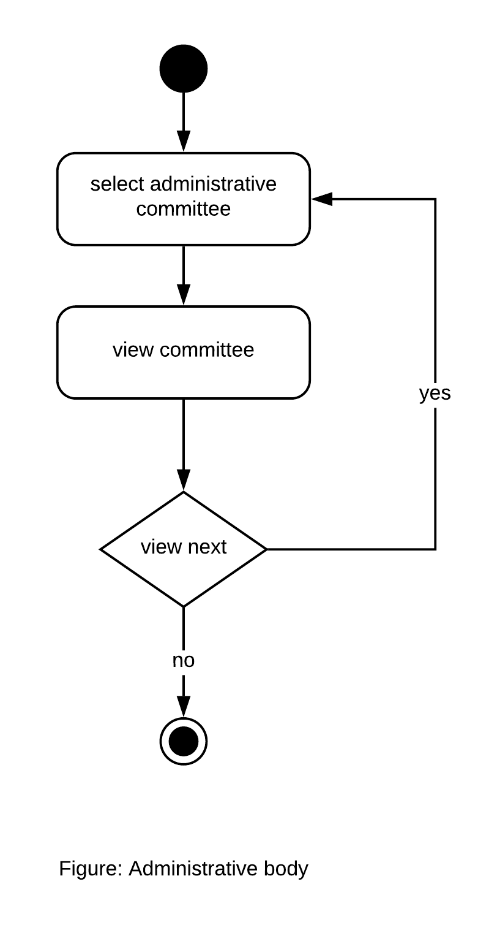

**Figure : Activity Administrative Body**

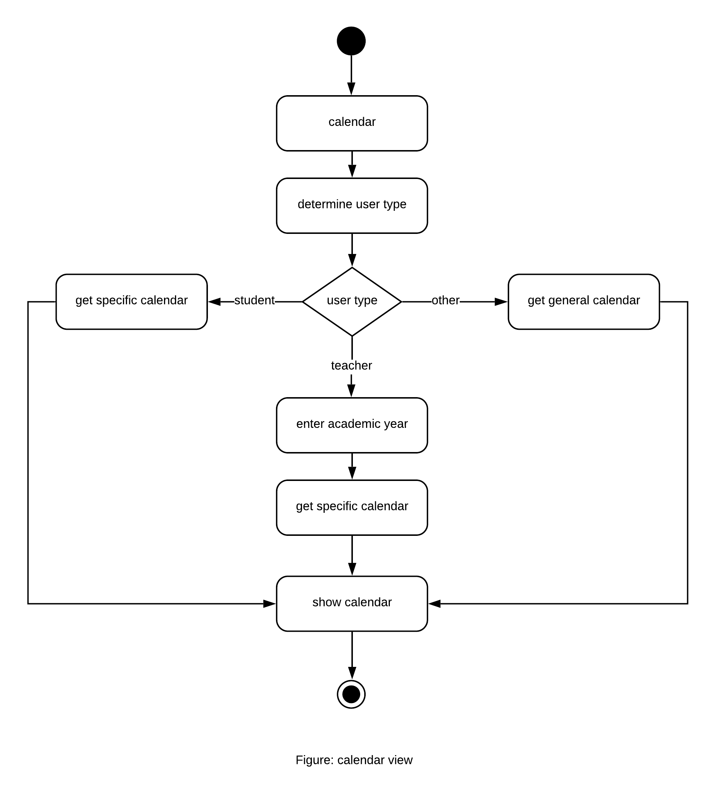

**Figure : Activity Calendar View**

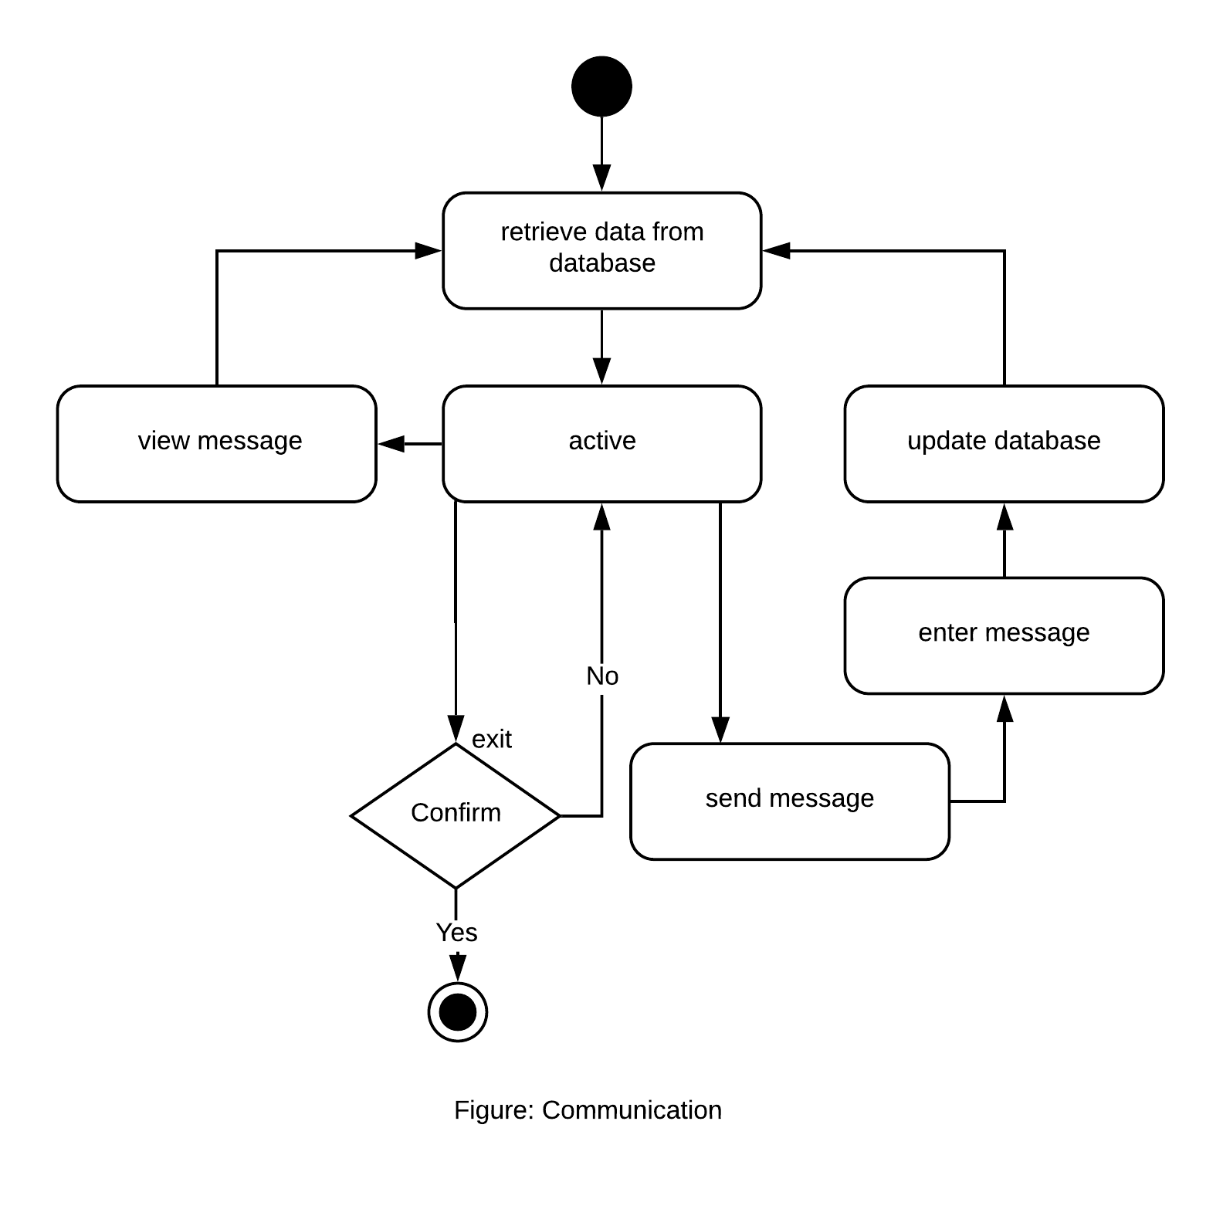

**Figure : Activity Communication**

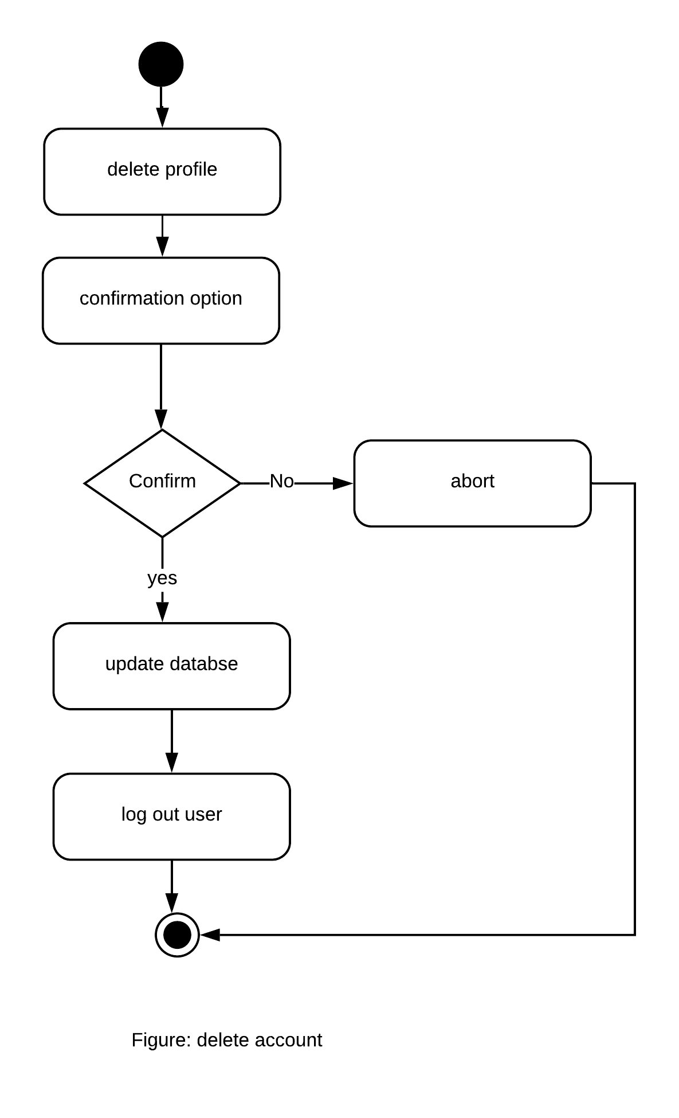

**Figure : Activity Delete Account**

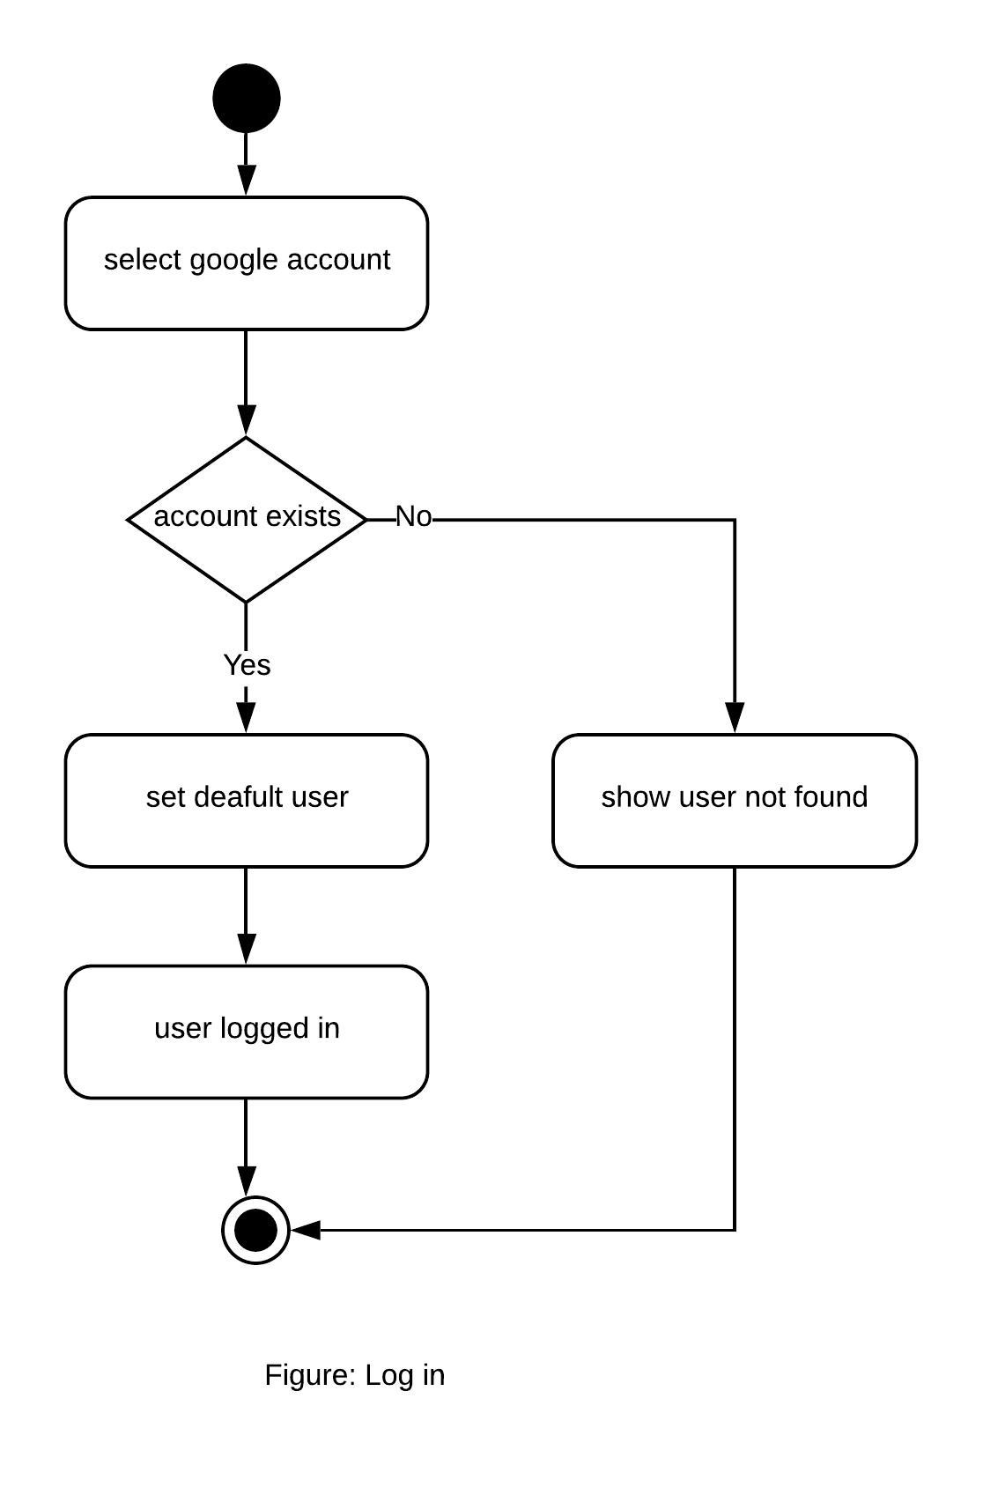

**Figure : Activity Sign In**

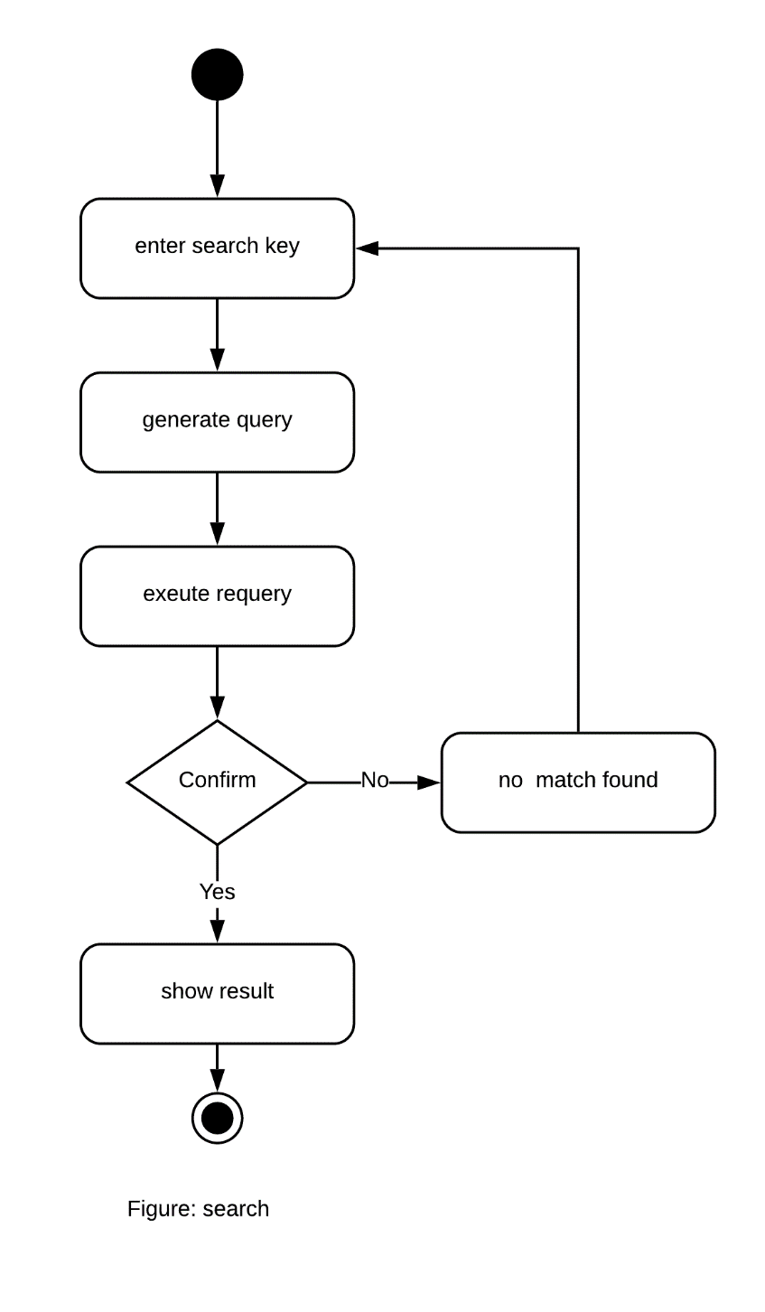

**Figure : Activity Search**

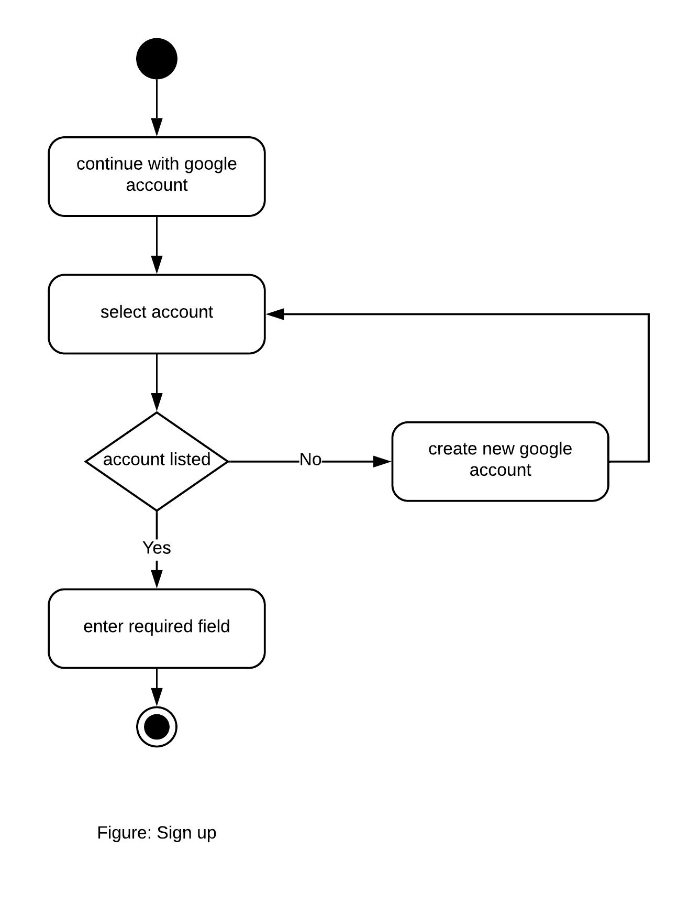

**Figure : Activity Sign UP**

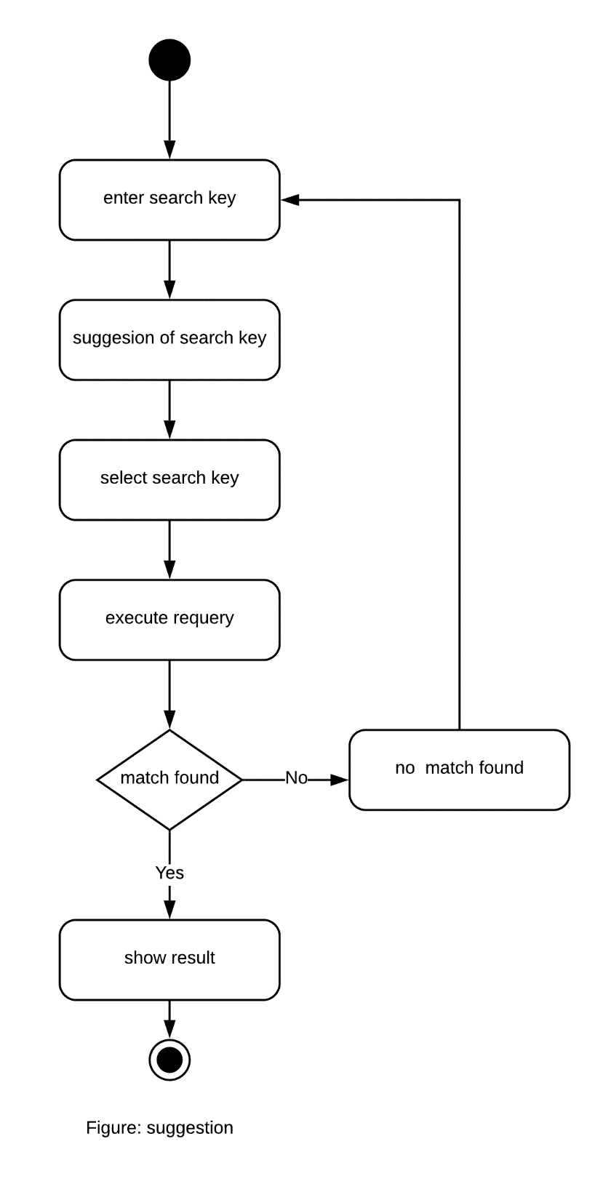

**Figure : Activity Suggestion**

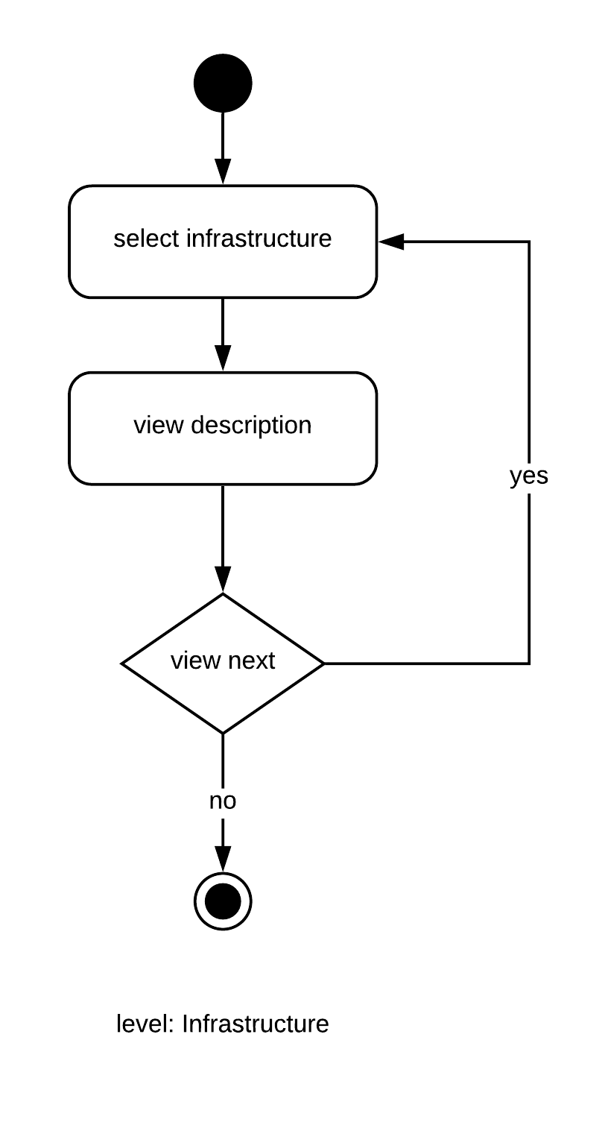

**Figure : Activity Infrastructure**

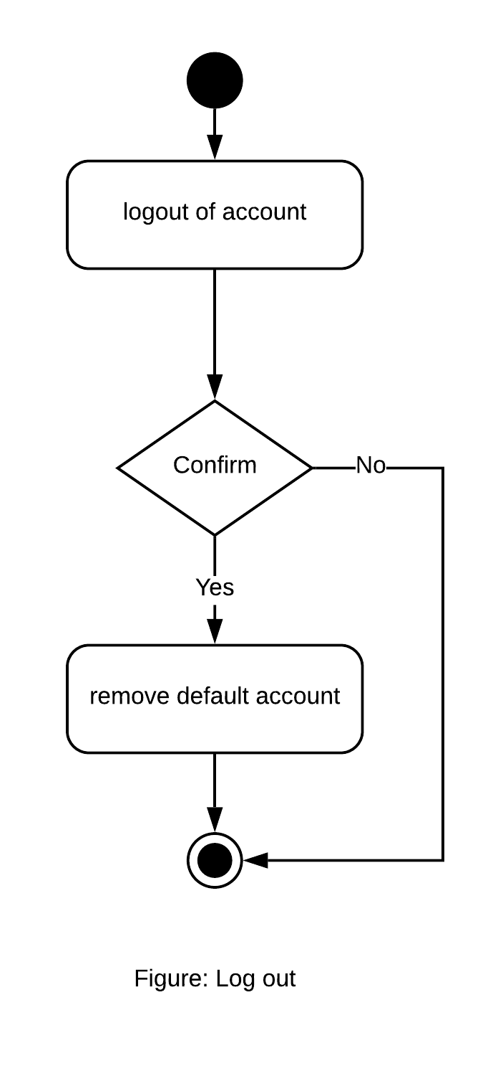

**Figure : Activity Log out**

**Swimlane Diagram**

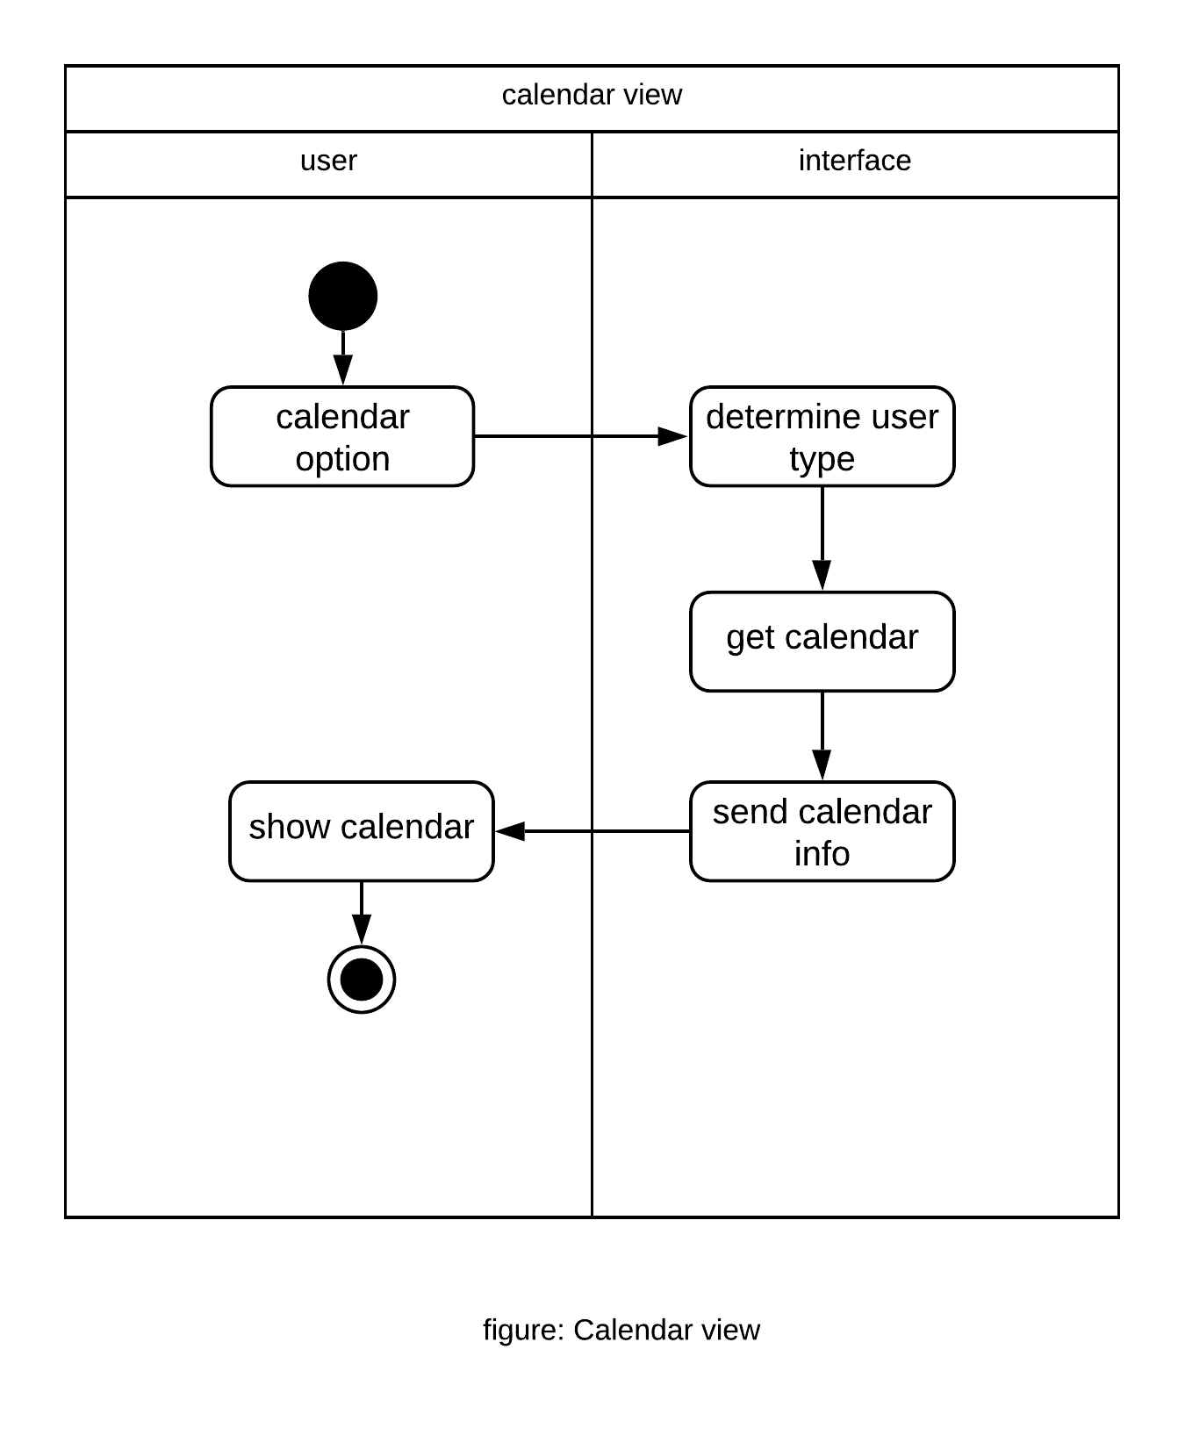

**Figure : Swimlane Calendar View**

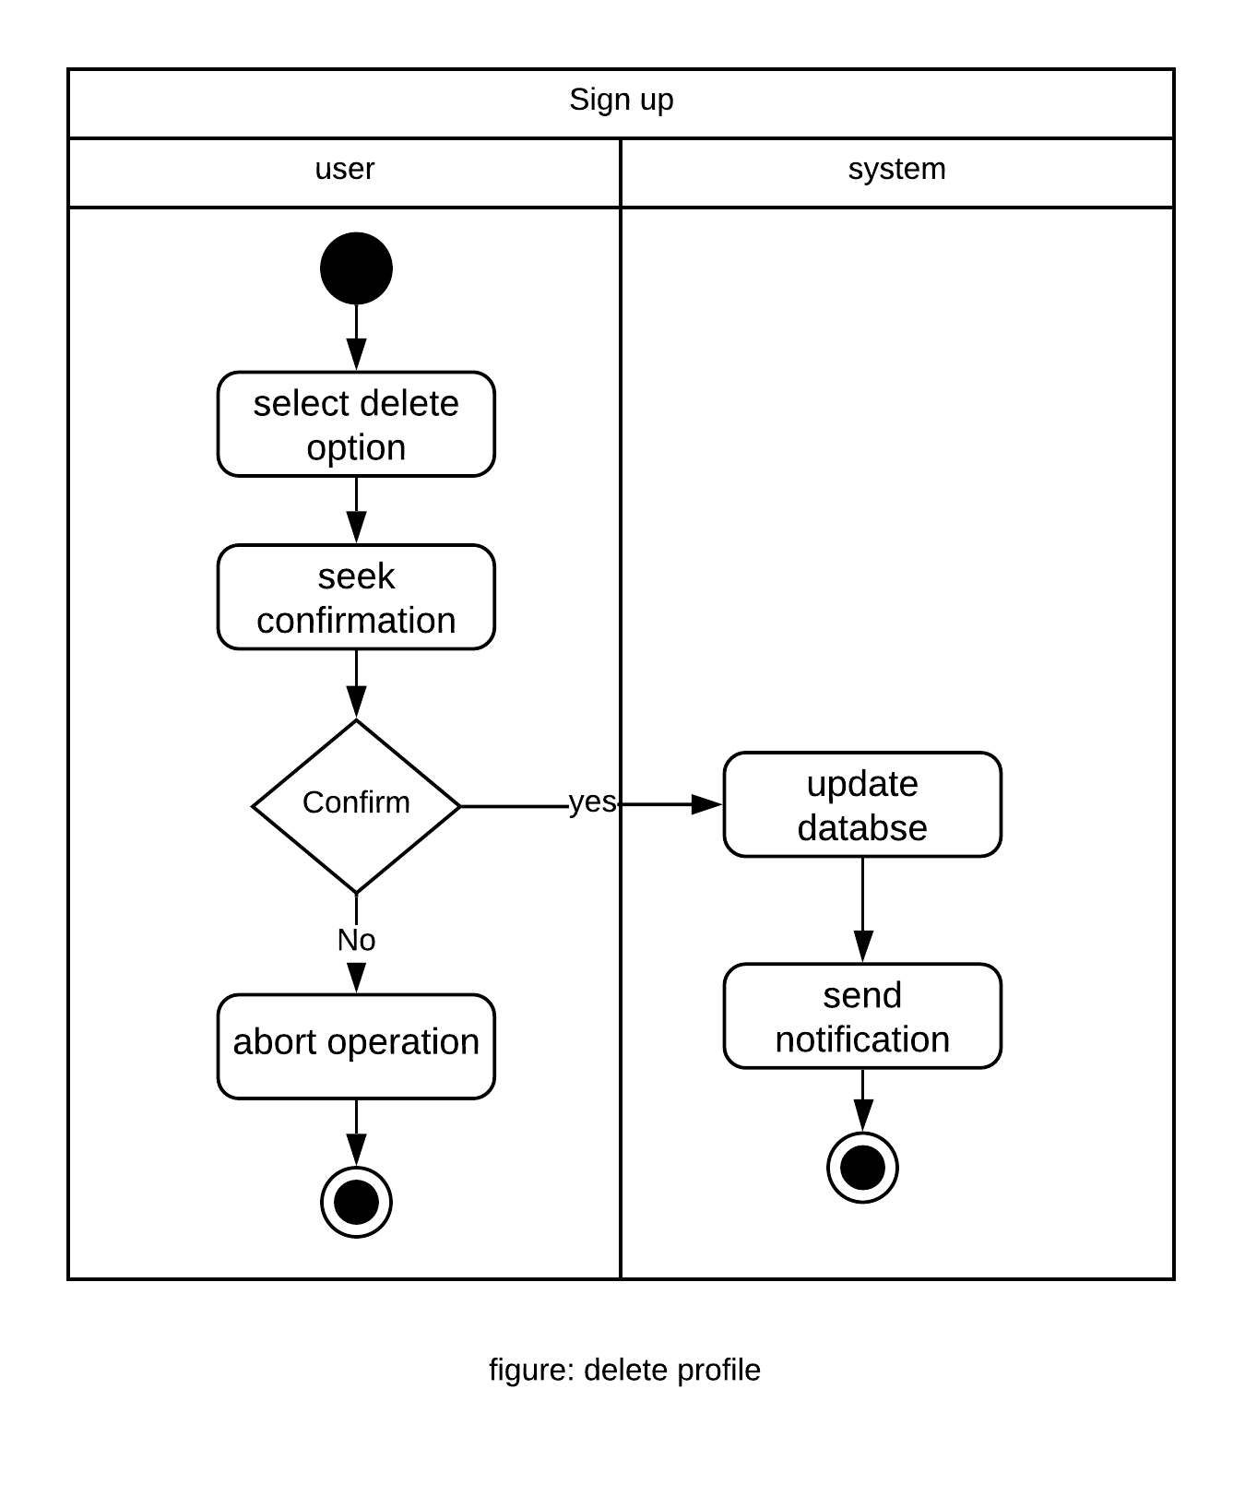

**Figure : Swimlane Delete Profile**

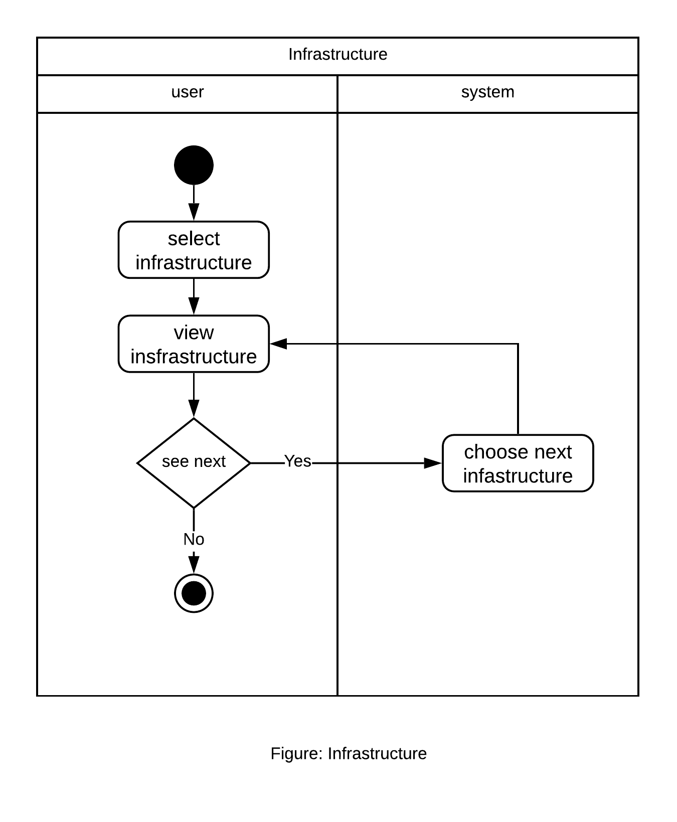

**Figure : Swimlane Infrastructure**

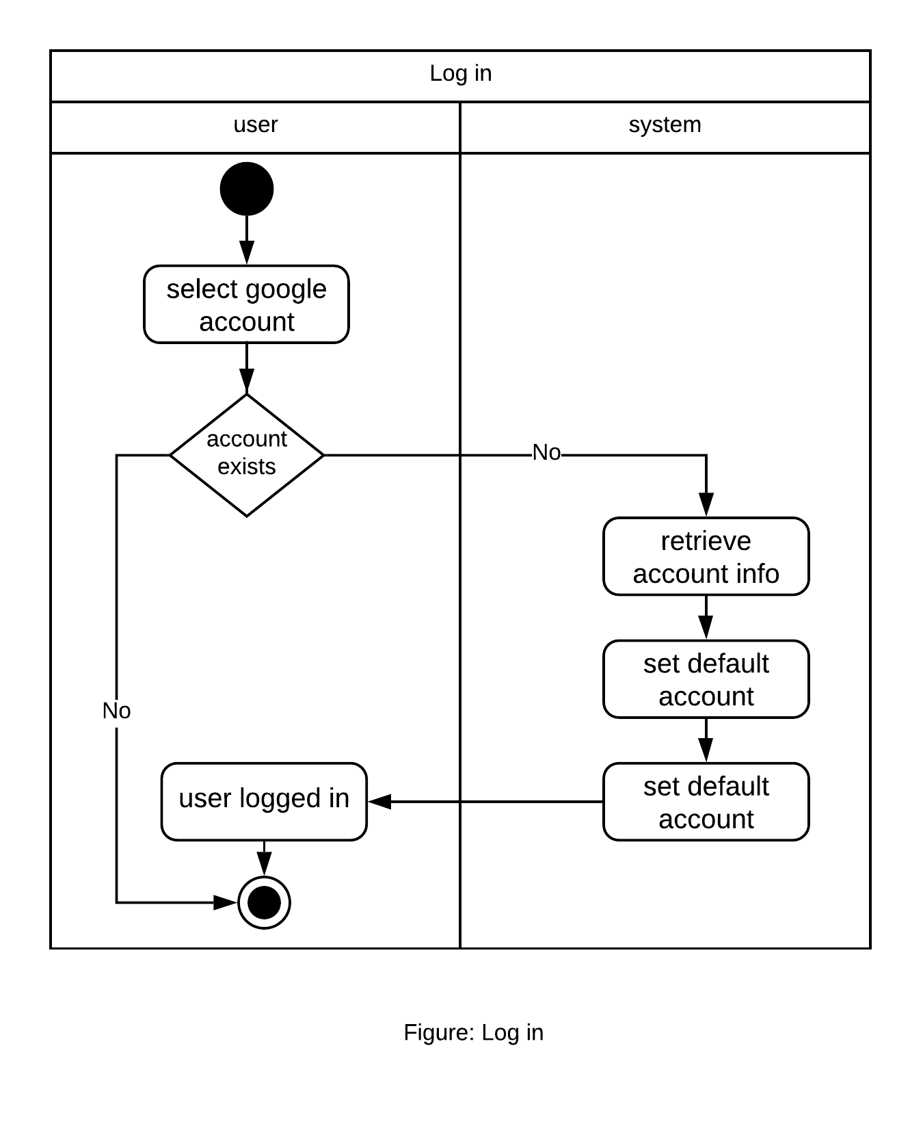

**Figure : Swimlane Sign in**

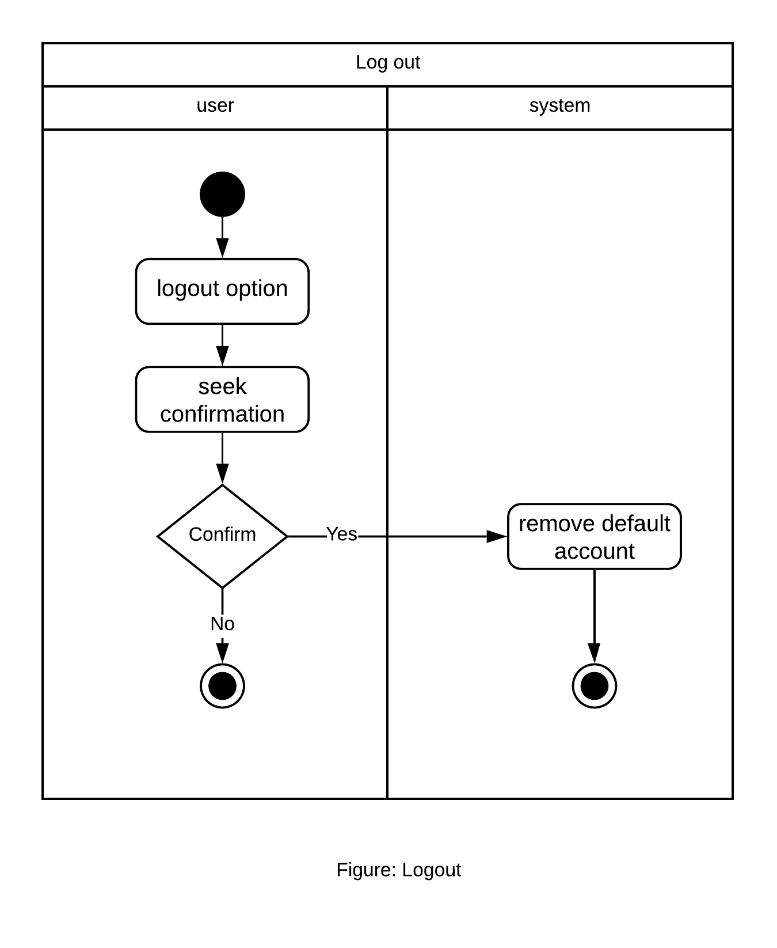

**Figure : Swimlane Log Out**

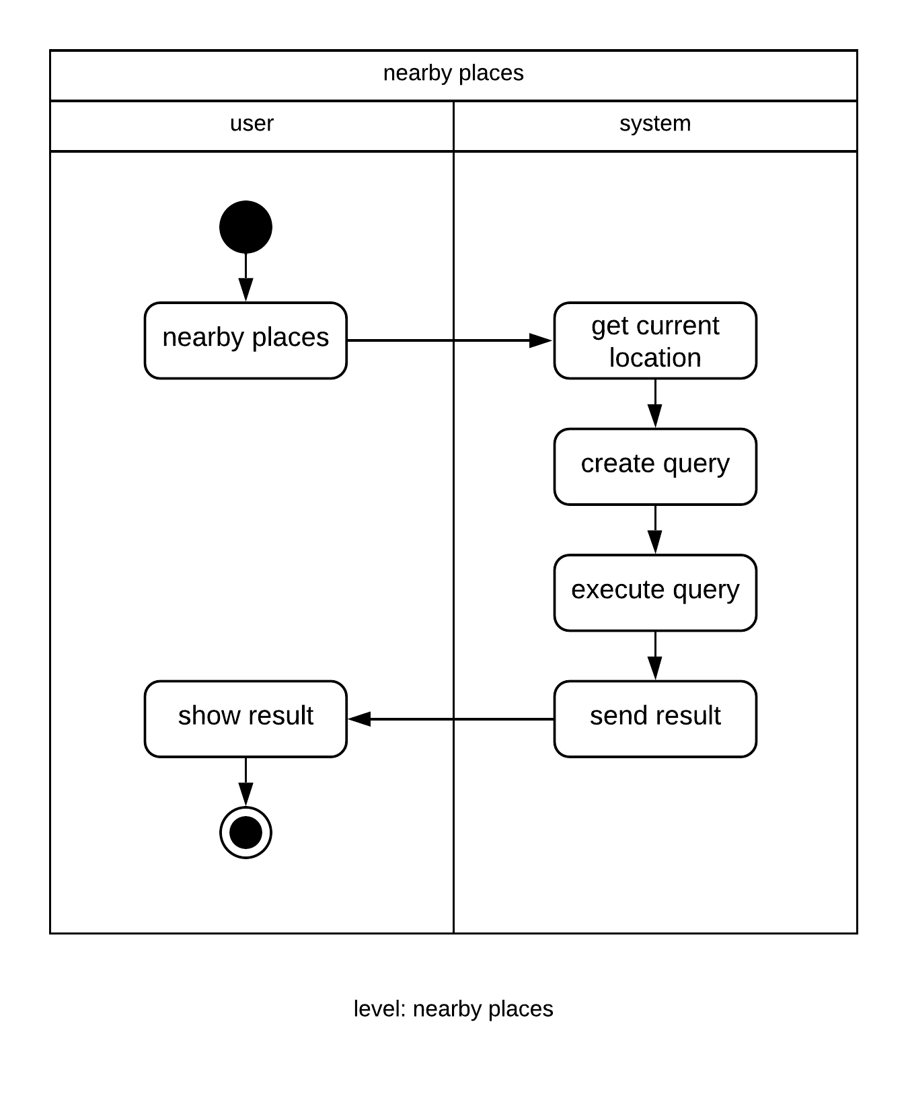

**Figure : Swimlane Exciting Places**

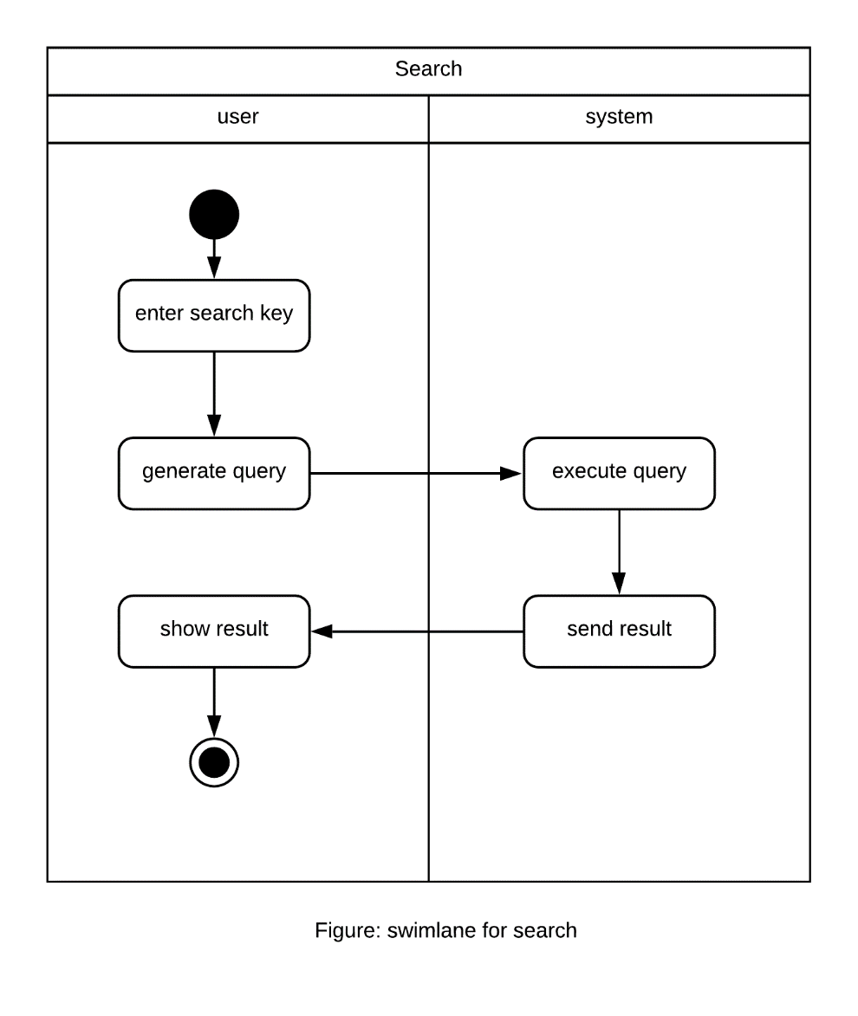

**Figure : Swimlane Search**

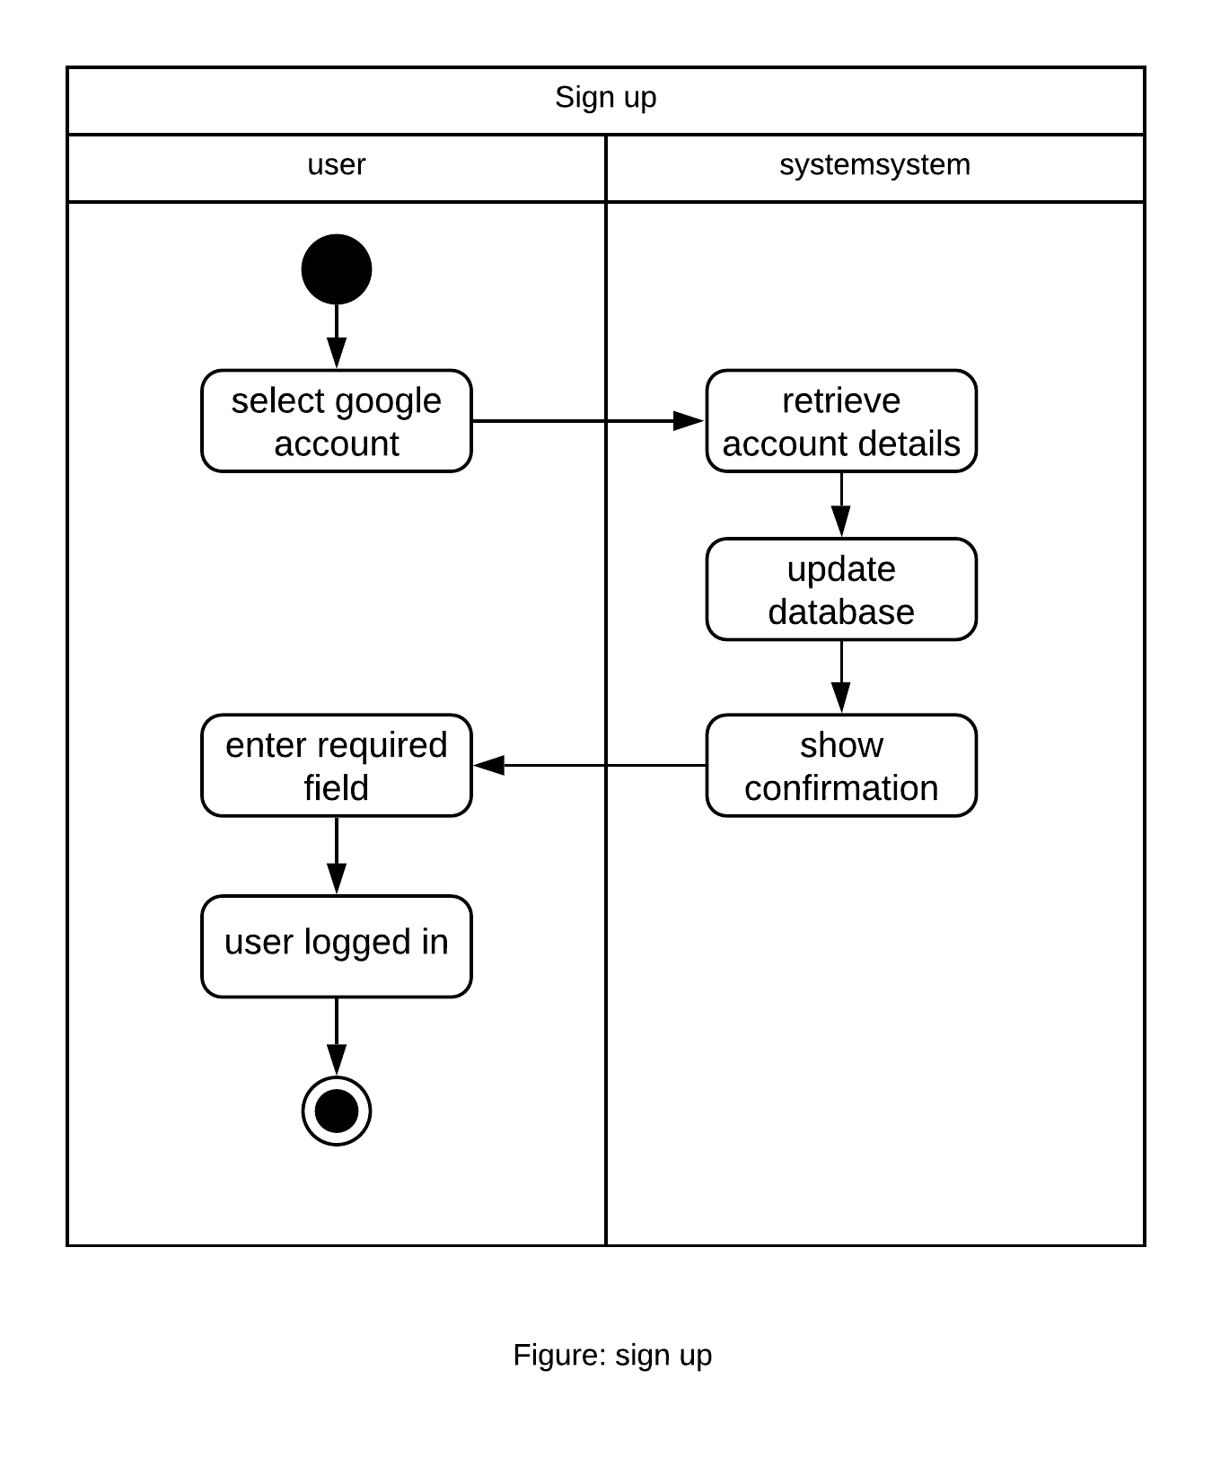

**Figure : Swimlane Sign Up**

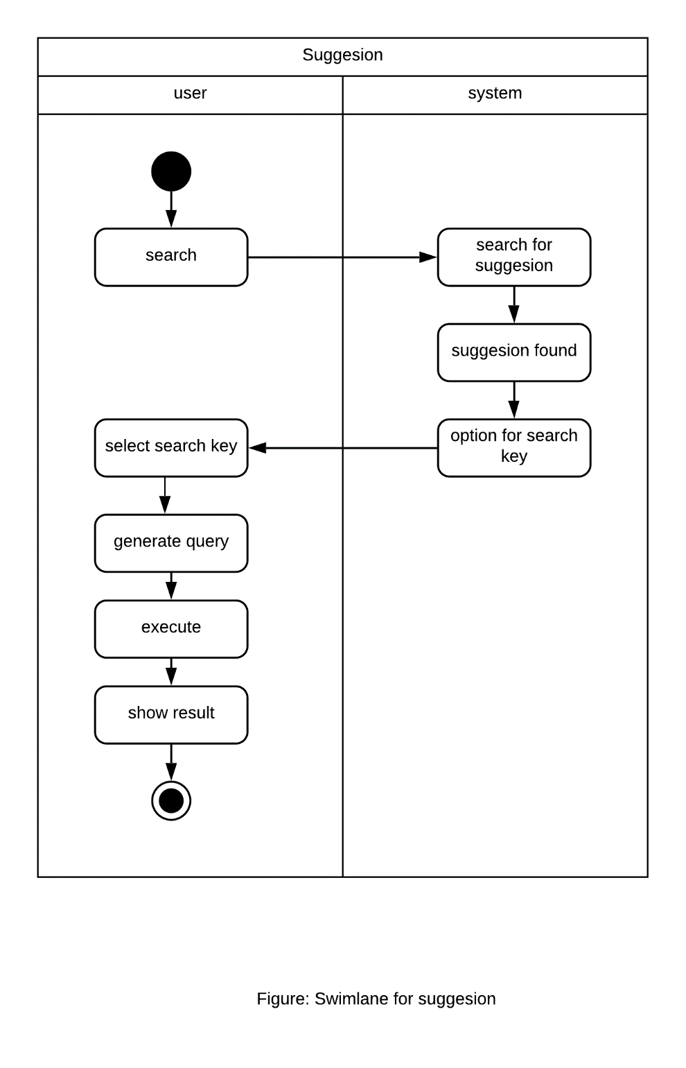

**Figure : Swimlane Suggestion**

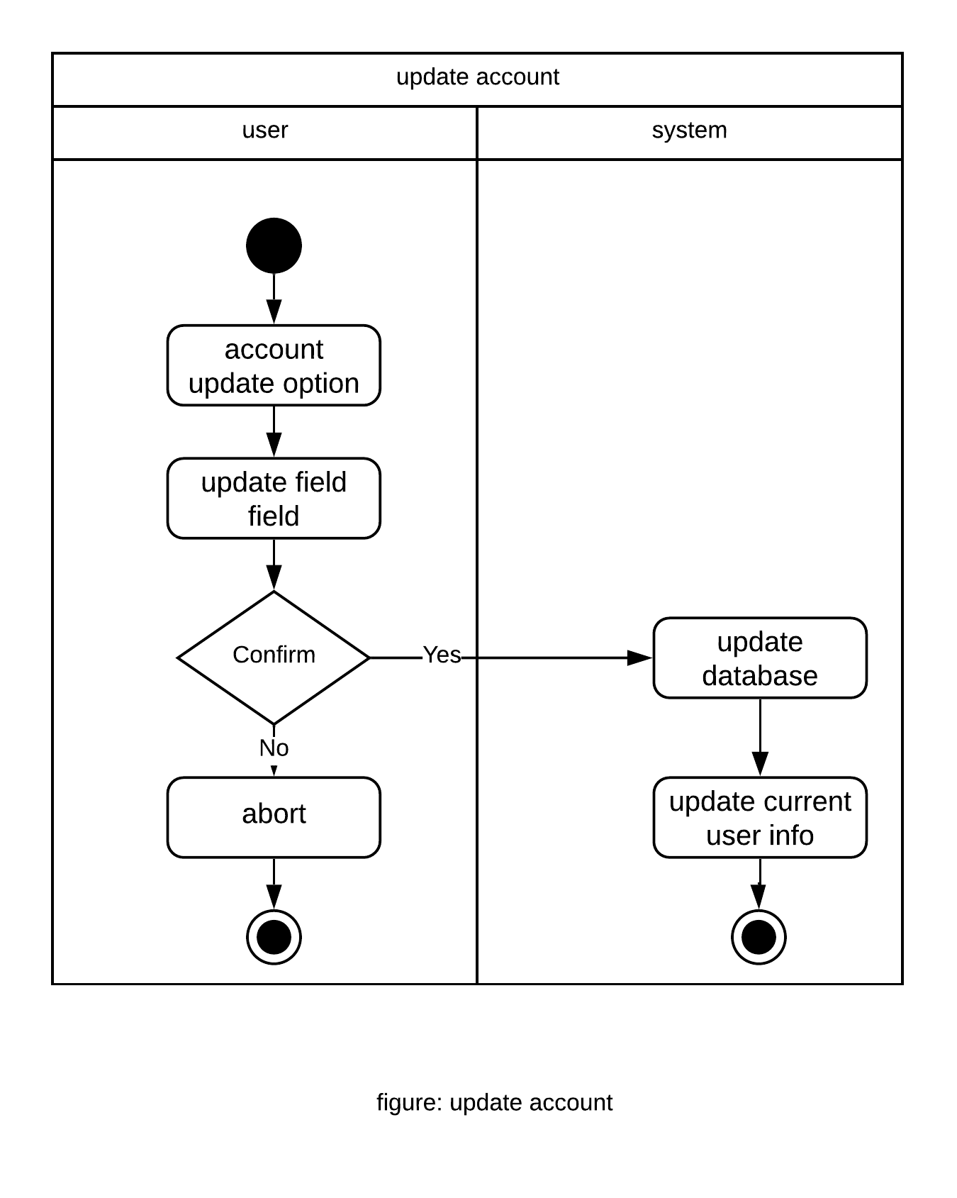

**Figure : Swimlane Update Account**

80

**Chapter 5: Data Model**

**5.1 Data modeling concept**

If software requirements include the necessity to create, extend or interact with a database or complex data structures need to be constructed and manipulated, then the software team chooses to create data models as part of overall requirements modeling. The entity-relationship diagram (ERD) defines all data objects that are processed within the system, the relationships between the data objects and the information about how the data objects are entered, stored, transformed and produced within the system.

**5.2 Data objects**

A data object is a representation of composite information that must be understood by the software. Here, composite information means an information that has a number of different properties or attributes. A data object can be an external entity, a thing, an occurrence, a role, an organizational unit, a place or a structure.

**Noun Identification**

* All the nouns in the scenario were identified.

Table 2: Noun Identification for data modelling

|  |  |  |  |
| --- | --- | --- | --- |
| **SL NO** | **NOUN** | **P/S** | **Attributes** |
|  |  |  |  |
| 1 | Account | S | 6 |
| 2 | User | S | 6,11 |
| 3 | Application | P | 71,72,74,75,76 |
| 4 | Google play store | S | - |
| 5 | Dhaka University | P | 13, 37-43 |
| 6 | Google account | P | 17,18 |
| 7 | Profile | S | 8,9,10,11,105 |
| 8 | User Name | S | - |
| 9 | Academic Year | S | - |
| 10 | Email | S | 6 |
|  |  |  |  |

|  |  |  |  |  |
| --- | --- | --- | --- | --- |
| 11 | Type | S |  | - |
| 12 | delete | S |  | 14 |
| 13 | Department | S |  | 87,96,100,101,102,104,105 |
| 14 | specified | S |  | - |
| 15 | Sign up | S |  | - |
| 16 | Sign in | S |  | - |
| 17 | Authentication | S |  | 14 , 18 |
| 18 | Firebase Auth 2 | P |  | - |
| 19 | Information | P |  | - |
| 20 | Log out | P |  | - |
| 21 | dropdown | P |  | - |
| 22 | Menu | S |  | - |
| 23 | Admin | P |  | 8,10,35,115 |
| 24 | features | P |  | - |
| 25 | year | P |  | 26 |
| 26 | Keyword | S |  | - |
| 27 | exciting | P |  | - |
| 28 | calendar | S |  | 60,61 |
| 29 | group chat | P |  | 30,54,64 |
| 30 | messenger | P |  | 83 |
| 31 | activities | P |  | - |
| 32 | update | P |  | - |
| 33 | Confirmation | S |  | - |
| 34 | separate | S |  | - |
| 35 | website | P |  | - |
| 36 | wish | S |  | - |
| 37 | DU brief history | P |  | - |
| 38 | achievement | S |  | - |
| 39 | Administrative Body | S |  | 88,89,90 |
| 40 | Halls | S |  | 87,100,101,102 |
| 41 | Club | S |  | 87,100,101,102 |
| 42 | society | S |  | - |
| 43 | places | P |  | - |
| 44 | view | S |  | - |
| 45 | search | S |  | 26,80 |
| 46 | Transport | S |  | 47,48,51,52 |
| 47 | bus | P |  | 113,48,51,52,114 |
| 48 | stoppage | P |  |  |
| 49 | Map | P |  | 45,51,52,103 |

|  |  |  |  |  |
| --- | --- | --- | --- | --- |
| 50 | current position | S |  | - |
| 51 | destination | P |  | - |
| 52 | route | P |  | - |
| 53 | offices | P |  | - |
| 54 | Communication | P |  | 29,30,64 |
| 55 | first | P |  | - |
| 56 | person | P |  | - |
| 57 | Database | S |  | - |
| 58 | private chat | S |  | - |
| 59 | option | S |  | - |
| 60 | holiday | P |  | - |
| 61 | events | P |  | - |
| 62 | Notification | S |  | - |
| 63 | Contact1 | S |  |  |
| 64 | Chat | S |  | - |
| 65 | academic | S |  | - |
| 66 | web interface | S |  | - |
| 67 | server | S |  | - |
| 68 | data transparency | S |  | - |
| 69 | service | S |  | - |
| 70 | security | S |  | - |
| 71 | Homepage | S |  | - |
| 72 | icons | S |  | - |
| 73 | top | S |  | - |
| 74 | settings | S |  | - |
| 75 | language | S |  | - |
| 76 | layout | S |  | - |
| 77 | tree based | S |  | - |
| 78 | design | S |  | 77,76 |
| 79 | structure | S |  | - |
| 80 | database query | S |  | - |
| 81 | two | S |  | - |
| 82 | restriction | P |  | - |
| 83 | Message | P |  | - |
| 84 | link | P |  | - |
| 85 | right | P |  | - |
| 86 | Status | S |  | - |
| 87 | Student | S |  | 8,9,10,11,105 |
| 88 | picture | P |  | - |
| 89 | name | P |  | - |
| 90 | rank | P |  | - |
|  |  |  |  |  |
|  |  |  |  |  |

|  |  |  |  |  |
| --- | --- | --- | --- | --- |
| 91 | Administrative committee | S |  | 11,89,90 |
| 92 | Editorial committee | S |  | 11,89,90 |
| 93 | Faculty Deans | S |  | 11,94,95 |
| 94 | faculty name | P |  | - |
| 95 | Dean | P |  | - |
| 96 | Department ID | P |  | 29,30,64 |
| 97 | Institute ID | P |  | - |
| 98 | Hall ID | P |  | - |
| 99 | Office ID | S |  | - |
| 100 | establishment year | S |  | - |
| 101 | Description | S |  | - |
| 102 | Location | P |  | - |
| 103 | Area | P |  | - |
| 104 | Teacher | S |  | 8,10,11,105 |
| 105 | Department Name | P |  |  |
| 106 | Institute | S |  | 87,97,100,101,102,104,107 |
| 107 | Institute Name | P |  |  |
| 108 | Specific Calendar | S |  | 60,61,109,110 |
| 109 | Date | P |  | - |
| 110 | Academic Schedule | P |  | - |
| 111 | Other user | S |  | 8,10,11 |
| 112 | Infrastructure | S |  | 100,101,102 |
| 113 | Bus ID | P |  | - |
| 114 | Bus name | P |  | - |
| 115 | password | P |  | - |
|  |  |  |  |  |

**Potential Data Objects:**

* Account : 6
* User : 6,7,11
* Application : 71,72,74,75,76
* Dhaka University : 13, 37-43
* Google account : 17,18
* Profile : 8,9,10,11,105
* Email : 6
* Department : 87,96,100,101,102,104,105
* Authentication : 18
* Admin : 8,10,32,35,115
* General Calendar : 60,61,109
* group chat : 30,54,64
* Administrative Body : 88,89,90
* Hall : 87,97,100,101,102
* Club : 87,98,100,101,102
* Search : 26,80
* Transport : 47,48,51,52
* Map : 51,52,103
* Office : 99,100,101,102
* Communication : 29,30,64
* Design : 77,76
* Student : 8,9,10,11,12,13
* Administrative committee : 11,89,90
* Editorial committee : 11,89,90
* Faculty Dean : 11,94,95
* Teacher : 8,9,10,11,105
* Department : 87,96,100,101,102,104,107
* Institute : 87,97,100,101,102,104,107
* Specific Calendar : 60,61,109,110
* Other User : 8,10,11
* Infrastructure : 100,101,102
* Bus : 48,51,52,113

**Analysis for finalizing Data objects**

* + Account , user , application , profile , email are all part of other user object . So , they are not considered.
  + Authentication , Search , communication are attributes of other data object. So they are not considerable .
  + Department , Office , Hall , Club are all part of Infrastructure . So infrastructure is the parent class.
  + Administrative body , Administrative committee , Editorial committee , Faculty Deans are all part of Administrative committee list .
  + All other data objects can be used as data objects as they have enough importance in the system.

**Final Data objects**

|  |  |  |  |  |
| --- | --- | --- | --- | --- |
|  |  | **Table 3: Final Data Objects** | |  |
|  |  |  |  |  |
| 1 | User : User ID, Email , Type. | | |  |
|  |  |  |  |  |
| 2 | Student: User Name, Academic Year, Email, Department Name, Type | | |  |
|  |  |  |  |  |
| 3 | Teacher: User Name, Email, Department Name , Type | | |  |
|  |  |  |  |  |
| 4 | Other User : User Name, Email, Type | | |  |
|  |  |  |  |  |
| 5 | Infrastructure : establishment year, Description, Location | | |  |
|  |  |  |  |  |
| 6. | Department : Department ID, establishment year, Description, Location ,  Student id , Teacher id , Department name | | |  |
|  |  |  |  |
|  |  |  |  |  |
| 7. | Institute : Institute ID, establishment year, Description, Location ,  Student id , Teacher id , Institute name | | |  |
|  |  | | |  |
| 8. | Office : Office ID , establishment year, Description, Location | | |  |
| 9. | Hall : Hall ID , Student Id ,establishment year, Description, Location | | |  |
|  |  | | |  |
| 10. | Club : Club ID , Student Id , establishment year, Description, Location | | |  |
|  |  | | |  |
| 11. | Administrative Body : Type, Name | | |  |
| 12 . | Administrative committee : Type, Name , Rank | | |  |

|  |  |
| --- | --- |
| 13 . | Map : location ID , destination , Area |
| 14 . | Transport : Transport ID , Type |
| 15 . | Bus : Bus ID , Bus Name , destination , Stoppage |
| 16. | General Calendar : Holiday, Events , Date |
| 17 . | Specific Calendar : Holiday, Events , Date , Academic Schedule |
| 18 . | Group Chat : Messenger , Communication ,Chat |
| 19. | Admin : Admin ID, User name , Email , password , website |
| 20 | Editorial committee : Type, Name , Rank |
| 21 | Faculty Dean List : Type, Name , Faculty name |

**Entity Relationship Diagram**

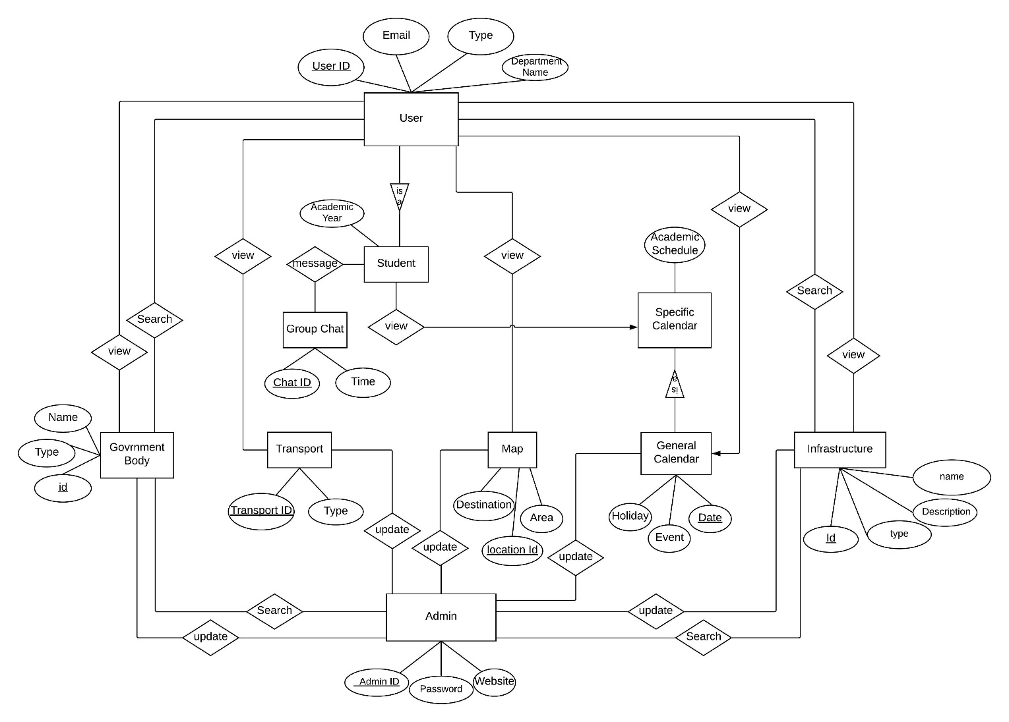

**Figure : Entity Relationship Diagram for Dhaka University Calendar Management Application**

**Relational Schema**

|  |  |  |  |  |  |
| --- | --- | --- | --- | --- | --- |
|  |  |  |  | **Table : Schema for User** | |
|  |  |  |  |  |  |
|  | **User** | |  |  |  |
|  |  |  |  |  |  |
|  | **Attribute** | | **Type** |  | **Size** |
|  |  | |  |  |  |
|  | User_id | | Number |  | 30 |
|  |  |  |  |  |  |
|  | Email | | Varchar2 |  | 40 |
|  |  | |  |  |  |
|  | Type | | Varchar2 |  | 20 |
|  |  | |  |  |  |

**Table : Schema for Student**

**Student**

|  |  |  |  |  |  |
| --- | --- | --- | --- | --- | --- |
|  | **Attribute** |  | **Type** | **Size** | |
|  |  |  |  |  |  |
|  | Student_id |  | Number | 30 |  |
|  |  |  |  |  |  |
|  | Academic Year |  | Varchar2 | 20 |  |
|  | Email |  | Varchar2 | 40 |  |
|  |  |  |  |  |  |
|  | User Name |  | Varchar2 | 20 |  |
|  |  |  |  |  |  |
|  | Department Name |  | Varchar2 | 20 |  |
|  |  |  |  |  |  |
|  | Type |  | Varchar2 | 10 |  |

|  |  |  |  |  |  |  |  |  |  |  |
| --- | --- | --- | --- | --- | --- | --- | --- | --- | --- | --- |
|  |  |  |  |  |  |  | **Table : Schema for Teacher** | | | |
|  |  |  |  |  |  |  |  |  |  |  |
|  | **Teacher** | | | |  |  |  |  |  |  |
|  |  |  |  |  |  |  |  |  |  |  |
|  | **Attribute** | | | |  | **Type** |  |  | **Size** | |
|  |  |  | |  |  |  |  |  |  |  |
|  | Teacher_id | | | |  | Number |  |  | 30 |  |
|  |  |  |  | |  |  |  |  |  |  |
|  | Email |  | | |  | Varchar2 |  |  | 40 |  |
|  | Department Name | | | |  | Varchar2 |  |  | 30 |  |
|  |  |  | | |  |  |  |  |  |  |
|  | Type | | | |  | Varchar2 |  |  | 20 |  |
|  |  |  | | |  |  |  |  |  |  |
|  |  |  |  |  |  |  | **Table : Schema for Other User** | | | |
|  |  |  | | |  |  |  |  |  |  |
|  | **Other User** | | | |  |  |  |  |  |  |
|  |  |  | | |  | |  |  | |  |
|  | **Attribute** | | | | **Type** | |  | **Size** | |  |
|  |  | | | |  | |  |  | |  |
|  | User_id |  | | | Number | |  | 30 | |  |
|  |  | | | |  | |  |  | |  |
|  | Email | | | | Varchaer2 | |  | 30 | |  |
|  |  | | | |  | |  |  | |  |
|  | Type | | | | Varchar2 | |  | 20 | |  |
|  |  | | | |  | |  |  | |  |
|  |  |  |  |  |  |  | 88 |  |  |  |

|  |  |  |  |  |  |
| --- | --- | --- | --- | --- | --- |
|  |  |  |  | **Table : Schema for Infrastructure** | |
|  |  |  |  |  |  |
|  | **Infrastructure** | |  |  |  |
|  |  |  |  |  |  |
|  | **Attribute** | | **Type** |  | **Size** |
|  |  | |  |  |  |
|  | Infrastructure ID | | Number |  | 30 |
|  |  |  |  |  |  |
|  | Established Year |  | Number |  | 30 |
|  | Description | | Varchar2 |  | 3000 |
|  |  | |  |  |  |
|  | Location | | Number , | Number | 32,32 |
|  |  | |  |  |  |

|  |  |  |  |  |  |
| --- | --- | --- | --- | --- | --- |
|  |  |  |  | **Table : Schema for Department** | |
|  |  |  |  |  |  |
|  | **Department** | |  |  |  |
|  |  |  |  |  |  |
|  | **Attribute** | | **Type** |  | **Size** |
|  |  | |  |  |  |
|  | Department ID | | Number |  | 30 |
|  | Student ID |  | Number |  | 30 |
|  | Teacher ID |  | Number |  | 30 |
|  | Established Year |  | Number |  | 30 |
|  | Description | | Varchar2 |  | 3000 |
|  |  | |  |  |  |
|  | Department Name | | Varchar2 |  | 30 |
|  | Location | | Number , | Number | 32,32 |
|  |  | |  |  |  |

|  |  |  |  |  |  |  |
| --- | --- | --- | --- | --- | --- | --- |
|  |  |  | |  | **Table : Schema for Department** | |
|  |  |  | |  |  |  |
|  | **Department** | | |  |  |  |
|  |  |  | |  |  |  |
|  | **Attribute** | | | **Type** |  | **Size** |
|  |  | | |  |  |  |
|  | Department ID | | | Number |  | 30 |
|  |  |  | |  |  |  |
|  | Student ID |  | | Number |  | 30 |
|  | Teacher ID |  | | Number |  | 30 |
|  | Established Year | |  | Number |  | 30 |
|  | Description | | | Varchar2 |  | 3000 |
|  |  | | |  |  |  |
|  | Department Name | | | Varchar2 |  | 30 |
|  | Location | | | Number , | Number | 32,32 |
|  |  | | |  |  |  |

|  |  |  |  |  |  |  |
| --- | --- | --- | --- | --- | --- | --- |
|  |  |  | |  | **Table : Schema for Hall** | |
|  |  |  | |  |  |  |
|  | **Hall** | | |  |  |  |
|  |  |  | |  |  |  |
|  | **Attribute** | | | **Type** |  | **Size** |
|  |  | | |  |  |  |
|  | Hall ID | | | Number |  | 30 |
|  |  |  | |  |  |  |
|  | Student ID |  | | Number |  | 30 |
|  | Established Year | |  | Number |  | 30 |
|  | Description | | | Varchar2 |  | 3000 |
|  |  | | |  |  |  |
|  | Location | | | Number , | Number | 32,32 |
|  |  | | |  |  |  |

|  |  |  |  |  |  |
| --- | --- | --- | --- | --- | --- |
|  |  |  |  | **Table : Schema for Club** | |
|  |  |  |  |  |  |
|  | **Club** | |  |  |  |
|  |  |  |  |  |  |
|  | **Attribute** | | **Type** |  | **Size** |
|  |  | |  |  |  |
|  | Club ID | | Number |  | 30 |
|  |  |  |  |  |  |
|  | Student ID |  | Number |  | 30 |
|  | Established Year |  | Number |  | 30 |
|  | Description | | Varchar2 |  | 3000 |
|  |  | |  |  |  |
|  | Location | | Number , | Number | 32,32 |
|  |  | |  |  |  |

|  |  |  |  |  |  |
| --- | --- | --- | --- | --- | --- |
|  |  |  |  | **Table : Schema for Office** | |
|  |  |  |  |  |  |
|  | **Office** | |  |  |  |
|  |  |  |  |  |  |
|  | **Attribute** | | **Type** |  | **Size** |
|  |  | |  |  |  |
|  | Office ID | | Number |  | 30 |
|  | Established Year |  | Number |  | 30 |
|  | Description | | Varchar2 |  | 3000 |
|  |  | |  |  |  |
|  | Location | | Number , | Number | 32,32 |
|  |  | |  |  |  |

|  |  |  |  |  |  |
| --- | --- | --- | --- | --- | --- |
|  |  |  |  | **Table : Schema for Person View** | |
|  |  |  |  |  |  |
|  | **Person View** | |  |  |  |
|  |  |  |  |  |  |
|  | **Attribute** | | **Type** |  | **Size** |
|  |  | |  |  |  |
|  | User ID | | Number |  | 30 |
|  | User Name |  | Varchar2 |  | 30 |
|  | Type | | Varchar2 |  | 30 |
|  |  | |  |  |  |
|  |  |  |  | **Table : Schema for Administrative Committee** | |
|  |  |  |  |  |  |
|  | **Administrative Committee** | |  |  |  |
|  |  |  |  |  |  |
|  | **Attribute** | | **Type** |  | **Size** |
|  |  | |  |  |  |
|  | User ID | | Number |  | 30 |
|  | User Name |  | Varchar2 |  | 30 |
|  | Rank |  | Varchar2 |  | 30 |
|  | Type | | Varchar2 |  | 30 |
|  |  | |  |  |  |

|  |  |  |  |  |  |
| --- | --- | --- | --- | --- | --- |
|  |  |  |  | **Table : Schema for Editorial Committee** | |
|  |  |  |  |  |  |
|  | **Editorial Committee** | |  |  |  |
|  |  |  |  |  |  |
|  | **Attribute** | | **Type** |  | **Size** |
|  |  | |  |  |  |
|  | User ID | | Number |  | 30 |
|  | User Name |  | Varchar2 |  | 30 |
|  | Rank | | Varchar2 |  | 30 |
|  |  | |  |  |  |
|  | Type | | Varchar2 |  | 30 |
|  |  | |  |  |  |

|  |  |  |  |  |  |
| --- | --- | --- | --- | --- | --- |
|  |  |  |  | **Table : Schema for Faculty Deans** | |
|  |  |  |  |  |  |
|  | **Faculty Dean** | |  |  |  |
|  |  |  |  |  |  |
|  | **Attribute** | | **Type** |  | **Size** |
|  |  | |  |  |  |
|  | User ID | | Number |  | 30 |
|  | User Name |  | Varchar2 |  | 30 |
|  | Faculty Name | | Varchar2 |  | 30 |
|  |  | |  |  |  |
|  | Type | | Varchar2 |  | 30 |
|  |  | |  |  |  |

|  |  |  |  |  |  |
| --- | --- | --- | --- | --- | --- |
|  |  |  |  | **Table : Schema for Map** | |
|  |  |  |  |  |  |
|  | **Map** | |  |  |  |
|  |  |  |  |  |  |
|  | **Attribute** | | **Type** |  | **Size** |
|  |  | |  |  |  |
|  | Location ID | | Number , | Number | 30 , 30 |
|  | Destination |  | Float , | Float | 40,40 |
|  | Area | | Varchar2 |  | 50 |
|  |  | |  |  |  |

|  |  |  |  |  |  |
| --- | --- | --- | --- | --- | --- |
|  |  |  |  | **Table : Schema for Transport** | |
|  |  |  |  |  |  |
|  | **Transport** | |  |  |  |
|  |  |  |  |  |  |
|  | **Attribute** | | **Type** |  | **Size** |
|  |  | |  |  |  |
|  | Transport ID | | Number |  | 30 |
|  | Type |  | Varchar2 |  | 30 |

|  |  |  |  |  |  |
| --- | --- | --- | --- | --- | --- |
|  |  |  |  | **Table : Schema for Bus** | |
|  |  |  |  |  |  |
|  | **Bus** | |  |  |  |
|  |  |  |  |  |  |
|  | **Attribute** | | **Type** |  | **Size** |
|  |  | |  |  |  |
|  | Bus ID | | Number |  | 30 |
|  | Bus name |  | Varchar2 |  | 30 |
|  | Destination | | Varchar2 |  | 50 |
|  |  | |  |  |  |
|  | Stoppage | | Varchar2 |  | 50 |
|  |  | |  |  |  |

|  |  |  |  |  |  |
| --- | --- | --- | --- | --- | --- |
|  |  |  |  | **Table : Schema for General Calendar** | |
|  |  |  |  |  |  |
|  | **General Calendar** | |  |  |  |
|  |  |  |  |  |  |
|  | **Attribute** | | **Type** |  | **Size** |
|  |  | |  |  |  |
|  | Date | | Varchar2 |  | 30 |
|  | Holiday |  | Varchar2 |  | 100 |
|  | Event | | Varchar2 |  | 100 |
|  |  | |  |  |  |

|  |  |  |  |  |  |
| --- | --- | --- | --- | --- | --- |
|  |  |  |  | **Table : Schema for Special Calendar** | |
|  |  |  |  |  |  |
|  | **Special Calendar** | |  |  |  |
|  |  |  |  |  |  |
|  | **Attribute** | | **Type** |  | **Size** |
|  |  | |  |  |  |
|  | Date | | Varchar2 |  | 30 |
|  | Holiday |  | Varchar2 |  | 100 |
|  | Academic Schedule |  | Varhcar2 |  | 100 |
|  | Event | | Varchar2 |  | 100 |
|  |  | |  |  |  |

|  |  |  |  |  |  |
| --- | --- | --- | --- | --- | --- |
|  |  |  |  | **Table : Schema for search** | |
|  |  |  |  |  |  |
|  | **Search** | |  |  |  |
|  |  |  |  |  |  |
|  | **Attribute** | | **Type** |  | **Size** |
|  |  | |  |  |  |
|  | Source Id | | Varchar2 |  | 30 |
|  | Destination Id | | Varchar2 |  | 30 |
|  | Search key |  | Varchar2 |  | 30 |

**Chapter 6: Class Based Modeling**

**6.1 Class Based Modeling Concept**

Class-based modeling represents the objects that the system will manipulate, the operations that will applied to the objects, relationships between the objects and the collaborations that occur between the classes that are defined.

**6.2 General Classification**

To identify the potential classes, nouns were selected from the solution space of the story. These were then characterized in seven general classifications. The seven general characteristics are as follows:

1. External entities
2. Things
3. Events
4. Roles
5. Organizational units
6. Places
7. Structures

Following are the specifications of the nouns according to the general classifications

## Table : General Classification of Noun

|  |  |  |  |
| --- | --- | --- | --- |
| **SL NO** | **NOUN** | **P/S** | **General Classification** |
|  |  |  |  |
| 1 | Account | S | - |
| 2 | User | S | 4,5 |
| 3 | Application | P | - |
| 4 | Google play store | S | - |
| 5 | Dhaka University | P | 5,7 |
| 6 | Google account | P | - |
| 7 | Profile | S | - |
| 8 | User Name | S | - |
| 9 | Academic Year | S | - |
| 10 | Email | S | - |
|  |  |  |  |

|  |  |  |  |  |
| --- | --- | --- | --- | --- |
| 11 | Type | S |  | - |
| 12 | delete | S |  | 3 |
| 13 | Department | S |  | 5,7 |
| 14 | specified | S |  | - |
| 15 | Sign up | S |  | 3 |
| 16 | Sign in | S |  | 3 |
| 17 | Authentication | S |  | - |
| 18 | Firebase Auth 2 | P |  | 1 |
| 19 | Information | P |  | - |
| 20 | Log out | P |  | 3 |
| 21 | dropdown | P |  | - |
| 22 | Menu | S |  | - |
| 23 | Admin | P |  | 4,5 |
| 24 | features | P |  | - |
| 25 | year | P |  | - |
| 26 | Keyword | S |  | - |
| 27 | exciting | P |  | - |
| 28 | calendar | S |  | 3,5 |
| 29 | group chat | P |  | 5 |
| 30 | messenger | P |  | - |
| 31 | activities | P |  | 2 |
| 32 | update | P |  | 3 |
| 33 | Confirmation | S |  | - |
| 34 | separate | S |  | - |
| 35 | website | P |  | 2 |
| 36 | wish | S |  | - |
| 37 | DU brief history | P |  | - |
| 38 | achievement | S |  | - |
| 39 | Administrative Body | S |  | 4,5 |
| 40 | Halls | S |  | 5,7 |
| 41 | Club | S |  | 5,7 |
| 42 | society | S |  | - |
| 43 | places | P |  | - |
| 44 | view | S |  | - |
| 45 | search | S |  | 3 |
| 46 | Transport | S |  | 2,7 |
| 47 | bus | P |  | 2,7 |
| 48 | stoppage | P |  |  |
| 49 | Map | P |  | 3 |

|  |  |  |  |  |
| --- | --- | --- | --- | --- |
| 50 | current position | S |  | - |
| 51 | destination | P |  | - |
| 52 | route | P |  | - |
| 53 | offices | P |  | 7 |
| 54 | Communication | P |  | - |
| 55 | first | P |  | - |
| 56 | person | P |  | 5 |
| 57 | Database | S |  | 5 |
| 58 | private chat | S |  | - |
| 59 | option | S |  | - |
| 60 | holiday | P |  | 3 |
| 61 | Events | P |  | 3 |
| 62 | Notification | S |  | 3 |
| 63 | Group | S |  |  |
| 64 | Chat | S |  | 3 |
| 65 | academic | S |  | 7 |
| 66 | web interface | S |  | 5 |
| 67 | server | S |  | 2 |
| 68 | data transparency | S |  | - |
| 69 | service | S |  | - |
| 70 | security | S |  | - |
| 71 | Homepage | S |  | - |
| 72 | icons | S |  | - |
| 73 | top | S |  | - |
| 74 | settings | S |  | - |
| 75 | language | S |  | - |
| 76 | layout | S |  | - |
| 77 | tree based | S |  | - |
| 78 | design | S |  | - |
| 79 | structure | S |  | - |
| 80 | database query | S |  | 3,7 |
| 81 | two | S |  | - |
| 82 | restriction | P |  | - |
| 83 | Message | P |  | 3 |
| 84 | link | P |  | - |
| 85 | System | P |  | 4,5 |
| 86 | Status | S |  | - |
| 87 | Student | S |  | 4,5,7 |
| 88 | picture | P |  | - |
| 89 | name | P |  | - |
| 90 | rank | P |  | - |
|  |  |  |  |  |
|  |  |  |  |  |

|  |  |  |  |  |
| --- | --- | --- | --- | --- |
| 91 | Administrative committee | S |  | 4,7 |
| 92 | Editorial committee | S |  | 4,7 |
| 93 | Faculty Deans | S |  | 4,7 |
| 94 | faculty name | P |  | - |
| 95 | Dean | P |  | - |
| 96 | Department ID | P |  | - |
| 97 | Institute ID | P |  | - |
| 98 | Hall ID | P |  | - |
| 99 | Office ID | S |  | - |
| 100 | establishment year | S |  | - |
| 101 | Description | S |  | - |
| 102 | Location | P |  | - |
| 103 | Area | P |  | - |
| 104 | Teacher | S |  | 4,5,7 |
| 105 | Department Name | P |  |  |
| 106 | Institute | S |  | 5,7 |
| 107 | Institute Name | P |  |  |
| 108 | Specific Calendar | S |  | 4,5, |
| 109 | Date | P |  | - |
| 110 | Academic Schedule | P |  | 5 |
| 111 | Other user | S |  | 4 |
| 112 | Infrastructure | S |  | 7 |
| 113 | Bus ID | P |  | - |
| 114 | Bus name | P |  | - |
| 115 | password | P |  | - |
|  |  |  |  |  |

**6.3 Selection Criteria**

The potential classes were then selected as classes by six Selection Criteria. A potential class becomes a class when it fulfills all six characteristics.

1. Retained Information
2. Needed Services
3. Multiple Attributes
4. Common attributes
5. Common operations
6. Essential requirements

**Table : Selection Criteria of Potential Classes**

|  |  |  |  |
| --- | --- | --- | --- |
| **SL NO** | **NOUN** | **P/S** | **Selection Criteria** |
|  |  |  |  |
| 1 | User | S | 1,2,3,4,5 |
| 2 | Dhaka University | P | - |
| 3 | Delete | S | - |
| 4 | Department | S | 4 |
| 5 | Dhaka University | P | - |
| 6 | Sign up | S | - |
| 7 | Sign in | S | - |
| 8 | Infrastructure | S | 1,3,4,5 |
| 9 | Log out | P | - |
| 10 | Admin | P | 1,2,3,4,5,6 |
| 11 | General Calendar | S | 1,2,4 |
| 12 | Group Chat | P | 2,4,5 |
| 13 | activities | P | - |
| 14 | update | P | - |
| 15 | website | P | - |
| 16 | Administrative Body | S | 1,2,4 |
| 17 | Halls | S | 4 |
| 18 | Club | S | 4 |
| 19 | search | S | 2 |
| 20 | Transport | S | 2,3,4,6 |
| 21 | Map | P | 1,2,4,5 |
| 22 | bus | P | - |
|  |  |  |  |

|  |  |  |  |
| --- | --- | --- | --- |
| 23 | Offices | P | 4 |
| 24 | person | P | - |
| 25 | Database | S | 1,2,6 |
| 26 | Holiday | P | - |
| 27 | Events | P | - |
| 28 | Notification | S | - |
| 29 | Chat | S | - |
| 30 | academic | S | - |
| 31 | web interface | S | - |
| 32 | server | S | - |
| 33 | database query | S | - |
| 34 | Message | P | 2 |
| 35 | Student | S | 1,2,3,4,5 |
| 36 | Editorial committee | S | 2 |
| 37 | Faculty Deans | S | - |
| 38 | Teacher | S | 1,2,3,4 |
| 39 | Institute | S | 4 |
| 40 | Specific Calendar | S | 1,2,4 |
| 41 | Academic Schedule | P | - |
| 42 | Other user | S | 1,2,3,4 |
| 43 | System | S | 2,3,4,6 |
|  |  |  |  |

**6.4 Potential Classes**

From above table, we have taken all the noun who passed three or more accepted criteria. So these are the candidate classes who are selected primarily:

* User
* Student
* Teacher
* Other User
* Admin
* Infrastructure
* Administrative Body
* Transport
* Map
* Database
* Group Chat
* General Calendar
* Specific Calendar
* System

**6.5 Associate Noun and Verb Identification**

The nouns and the verbs associated with the potential classes are identified to find out the attributes and methods of each class.

**Table 18: Associate Noun and Verbs**

|  |  |  |  |
| --- | --- | --- | --- |
| **No** | **Potential Class** | **Noun** | **Verb** |
| 1 | User | User ID, Email , Type | Search , Sign In , Sign Out , view information , access , update account , delete Account , modify account ,access general calendar , view map , view transport |
| 2 | Student | User Name, Academic Year, Email, Department Name, Type | Search , Sign In , Sign Out , view information, access , update account , delete Account , modify account , complete profile , Send message to group chat , access general calendar , view map , view transport ,access specific calendar |
| 3 | Teacher | User Name, Email, Department Name , Type | Search , Sign In , Sign Out , view information , access , update account , delete Account , modify account ,access general calendar , view map , view transport |
| 4 | Other User | User Name, Email, Type | Search , Sign In , Sign Out , view information , access , update account , delete Account , modify account ,access general calendar , view map , view transport |
| 5 | Admin | Admin ID, User name , Email , password , website | Update information , delete information , modify information ,  Update map , delete map information , modify map information, Update transport , delete transport information , Update or delete calendar information , maintain server and database , maintain security |
| 6 | Infrastructure | establishment year, Description, Location | Store information ,knowledge , view location , view description |
| 7 | Administrative Body | Type, Name | View information about Administrative body |

|  |  |  |  |
| --- | --- | --- | --- |
| 8 | Transport | Transport ID , Type, destination, Stoppage | view the schedule of buses , View stoppage and route of the transport |
| 9 | Map | location ID , destination , Area | View current position , search , get route , view exciting places in map |
| 10 | Database | Information , store, Update , retrieve | Update , retrieve , store information |
| 11 | Group Chat | Messenger , Communication, Chat | Message other user, leave group , join group ,chat |
| 12 | General Calendar | Holiday, Events , Date | View all holiday ,events of Dhaka University |
| 13 | Specific Calendar | Holiday, Events , Date , Academic Schedule | View all holiday ,events of Dhaka University, View all academic activities |
| 14 | System | Send , retrieve , generate | Generate database Query , send formatted information to user ,  Communicate with database |

**6.6 Analysis of Potential Classes**

* Teacher class , other user class and user class all have the same functionalities . So we will only consider user class .
* Student class has some similarities with user class , So , student extends user class.
* Specific calendar class has some similarities with general calendar class , So , Specific calendar extends general calendar class.

**6.7 Final Classes**

From above analysis, our final classes are:

**1.** User  
 **a.** Student  
**2.** Admin  
**3.** Infrastructure  
**4.** Administrative Body  
**5.** Transport

**6.** Map

**7.** Group Chat

**8.** General Calendar

**a.** Specific Calendar

**9.** Database

**10.** System

**6.8 Class Cards**

**Table 24: Class Card of User**

|  |  |
| --- | --- |
| **User** |  |
| **Attributes** | **Methods** |
| User ID  User name  Email  Type | * viewMap() * viewTransport() * viewGeneralCalendar() * viewInformation() * viewaccount() * updateAccount() * search() * signIn() * signOut() * deleteAccount() * getEmail() * getUserID() * getType() * setUserID() * setEmail() * setType() |
| **Responsibilities** | **Collaborator** |
| Search Administrative Body | Administrative Body |
| Search Infrastructure | Infrastructure |
| Get Location | Map |
| Access Calendar | Calendar |

**Table 24: Class Card of Student**

|  |  |
| --- | --- |
| **Student** |  |
| **Attributes** | **Methods** |
| User ID  User Name  Email  Type  Department Name  Academic Year | * viewMap() * viewTransport() * viewGeneralCalendar() * viewInformation() * viewaccount() * updateAccount() * search() * signIn() * signOut() * deleteAccount() * getEmail() * getUserID() * getType() * setUserID() * setEmail() * setType() * getDepartmentName() * getAcademicYear() * joinGroupChat() * leaveGroupChat() |
| **Responsibilities** | **Collaborator** |
| Search Administrative Body | Administrative Body |
| Search Infrastructure | Infrastructure |
| Get Location | Map |
| Access Calendar | Calendar |
| Access Specific Calendar | Specific Calendar |
| Join Group Chat | Group Chat |

**Table 24: Class Card of Admin**

|  |  |
| --- | --- |
| **Admin** |  |
| **Attributes** | **Methods** |
| Admin ID  User name  Email  Password  Website | * updateMap() * updateTransport() * updateGeneralCalendar() * updateInformation() * viewaccount() * search() * getWebsite() * getEmail() * getAdminID() * getPasword() * setWebsite() * setEmail() * setType() * updateInformation() |
| **Responsibilities** | **Collaborator** |
| Search Administrative Body | Administrative Body |
| Search Infrastructure | Infrastructure |
| Search Calendar | Calendar |
| Update Administrative Body | Administrative Body |
| Update Infrastructure | Infrastructure |
| Update Map | Map |
| Update transport | transport |

**Table 24: Class Card of General Calendar**

|  |  |
| --- | --- |
| **General Calendar** |  |
| **Attributes** | **Methods** |
| Date  Holiday  Event | * getDate() * getHoliday() * getEvent() * setDate() * setHoliday() * setEvent() |
| **Responsibilities** | **Collaborator** |
| Store University Holiday | Admin |
| Store University Event | Admin |

**Table 24: Class Card of Specific Calendar**

|  |  |
| --- | --- |
| **Specific Calendar** |  |
| **Attributes** | **Methods** |
| Date  Holiday  Event  Academic Schedule | * getDate() * getHoliday() * getEvent() * setDate() * setHoliday() * setEvent() * getAcademicYear() * getAcademicSchedule() * setAcademicSchedule() |
| **Responsibilities** | **Collaborator** |
| Store University Holiday | Admin |
| Store University Event | Admin |
| Get Academic Year | Student |

**Table 24: Class Card of Infrastructure**

|  |  |
| --- | --- |
| **Infrastructure** |  |
| **Attributes** | **Methods** |
| Establishment Year  Description  Location | * getEstablishmentYear() * getDescription() * getLocation() * setEstablishmentYear() * setDescription() * setLocation () * viewLocation() |
| **Responsibilities** | **Collaborator** |
| Collaborate with Administrative Body | Administrative Body |

**Table 24: Class Card of Administrative Body**

|  |  |
| --- | --- |
| **Administrative Body** |  |
| **Attributes** | **Methods** |
| Name  Type | * getName() * getUserID() * getType() * setType() * setName() |
| **Responsibilities** | **Collaborator** |
| Make Decision | Infrastructure |
| Get User ID | User |

**Table 24: Class Card of Transport**

|  |  |
| --- | --- |
| **Transport** |  |
| **Attributes** | **Methods** |
| TransportationID  Type  Destination  Stoppage | * getTransportID() * getType() * getDestination() * setTransportID() * setDestination() * setStoppage() * getLocation() |
| **Responsibilities** | **Collaborator** |
| Get Location | Map |
| List Stoppage | Administrative Body |
| Use Transport | User |
| View Current Position | Map |

**Table 24: Class Card of Map**

|  |  |
| --- | --- |
| **Map** |  |
| **Attributes** | **Methods** |
| Location ID  Destination  Area | * getLocationID() * getArea() * getDestination() * setLocationID() * setDestination() * setArea() * viewLocation() |
| **Responsibilities** | **Collaborator** |
| View Exciting Places | Infrastructure |

**Table 24: Class Card of Group Chat**

|  |  |
| --- | --- |
| **Group Chat** |  |
| **Attributes** | **Methods** |
| Messenger  Communication  Chat ID  Message | * getMessage() * setMessage() * getChatID() * setChatID() * username() * time() |
| **Responsibilities** | **Collaborator** |
| Get User Name | Student |
| Get Time | System |
| Send Message | Student |
| Get Academic Year | Student |

**Table 24: Class Card of Database**

|  |  |
| --- | --- |
| **Database** |  |
| **Attributes** | **Methods** |
| store  update  retrieve  information | * store() * update() * getInformation() * SetInforamtion() * retrieve() * viewInformation() |
| **Responsibilities** | **Collaborator** |
| Store Information | Admin |
| update Information | Admin |
| Retrieve information | user |

**Table 24: Class Card of System**

|  |  |
| --- | --- |
| **System** |  |
| **Attributes** | **Methods** |
| GenerateQuery  Send  Retrieve | * generateSearchQuery() * send() * retrieve() * showInfo() * FormatInfo() |
| **Responsibilities** | **Collaborator** |
| Generate search key to database query | database |
| Send information to database | admin |
| Format information to show to user | user |

**6.9 UML Diagram**

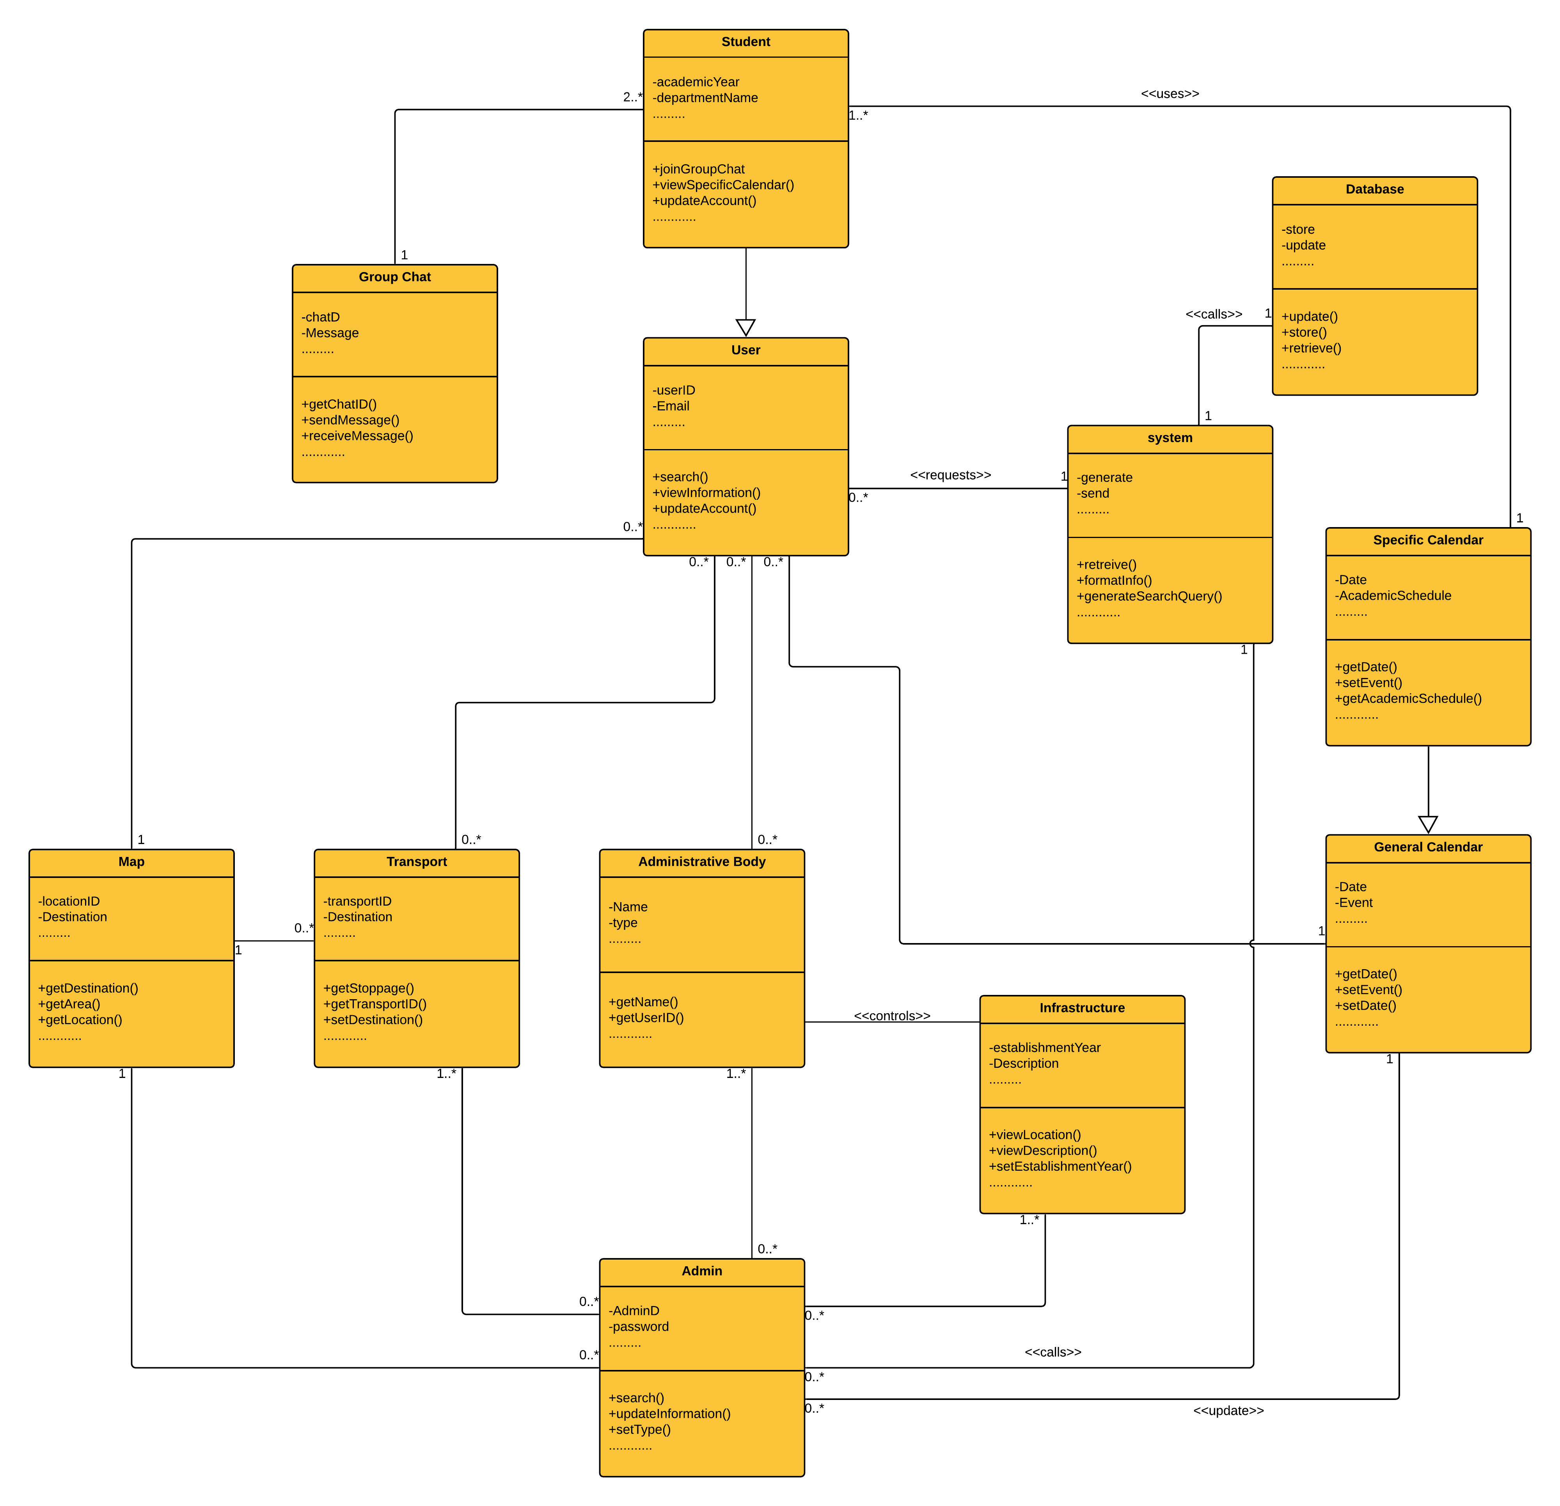

**Figure** 51**: UML Diagram of Dhaka University Calendar Management Application**

119

**Chapter 7: Flow-Oriented Model**

This chapter focuses on the flow oriented modeling.

**7.1 Introduction**

Although data flow-oriented modeling is perceived as an outdated technique by some software engineers, it continues to be one of the most widely used requirements analysis notations in use today. It provides additional insight into system requirements and flow.

**7.2 Data Flow Diagram (DFD)**

The DFD takes an input-process-output view of a system. In the figures, data objects are represented by labeled arrows and transformations are represented by circles.

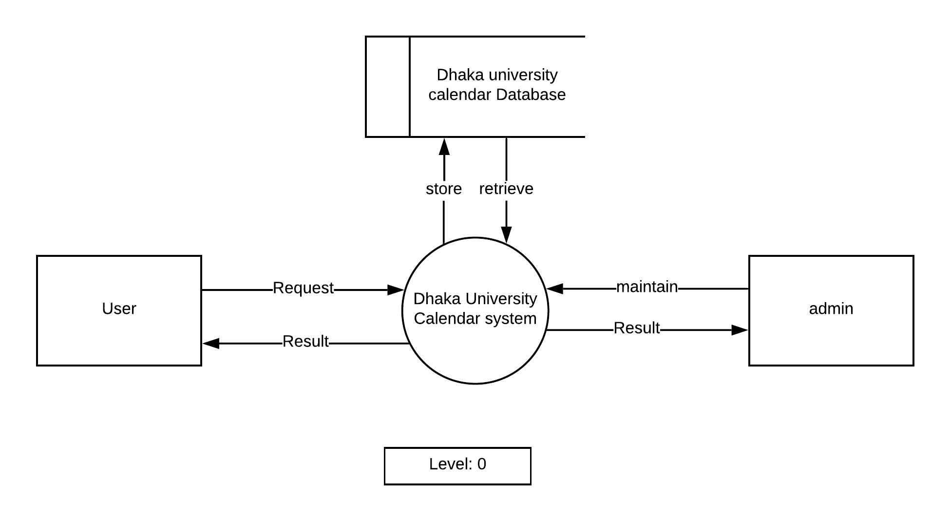

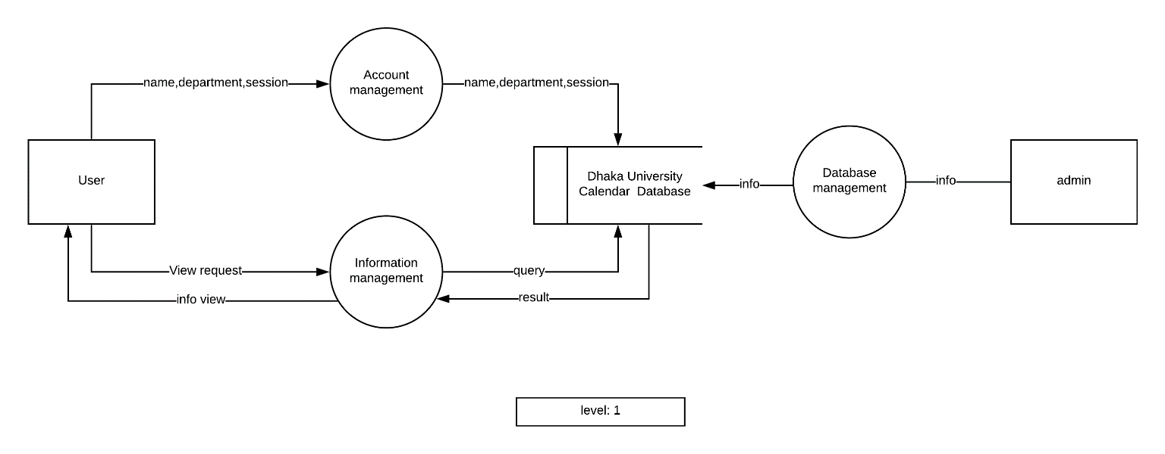

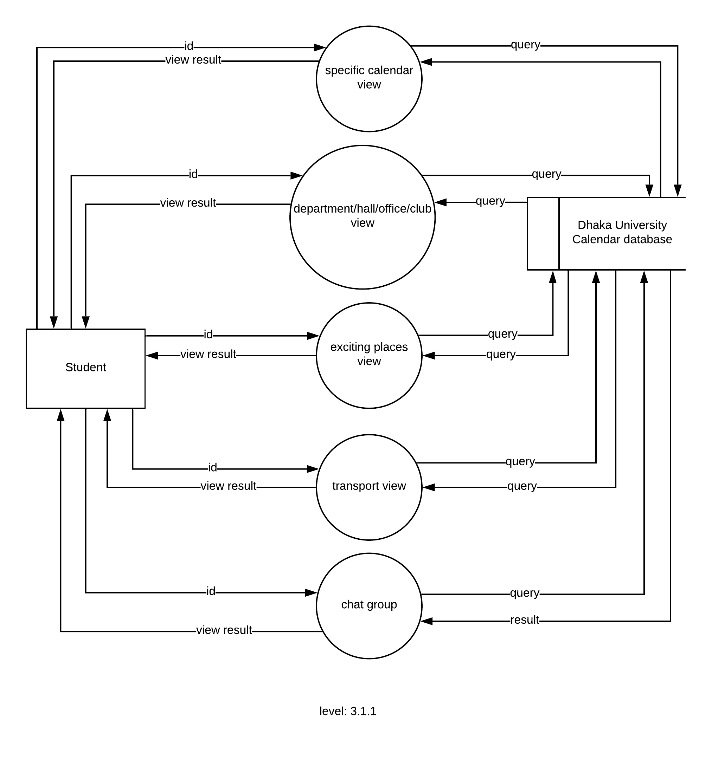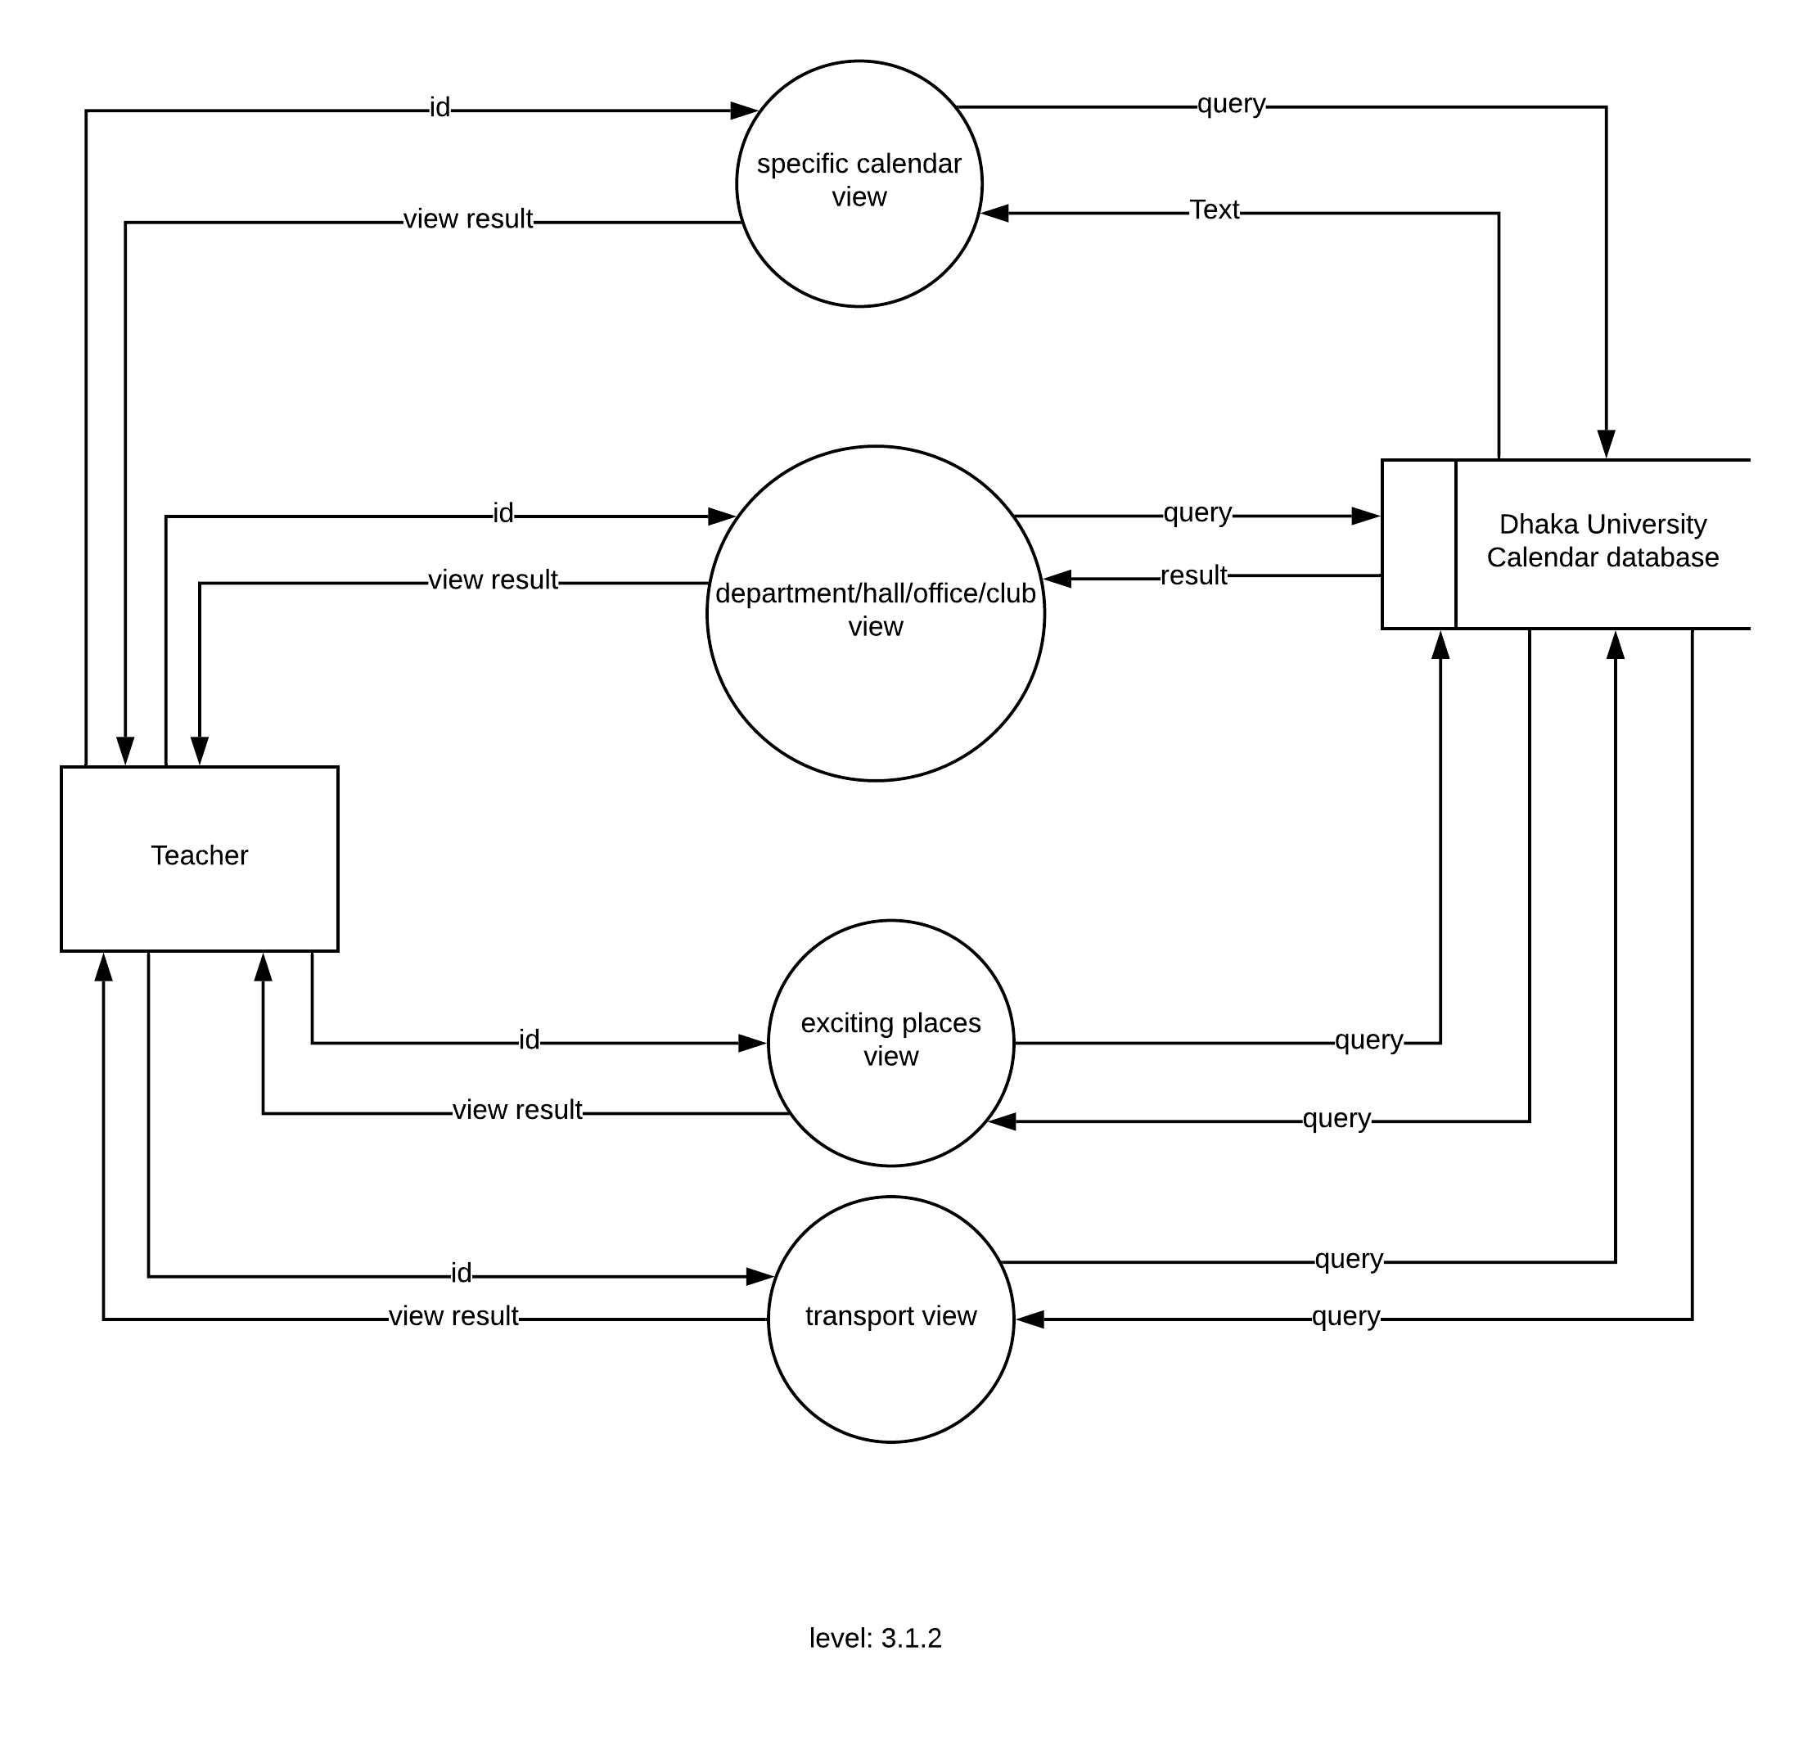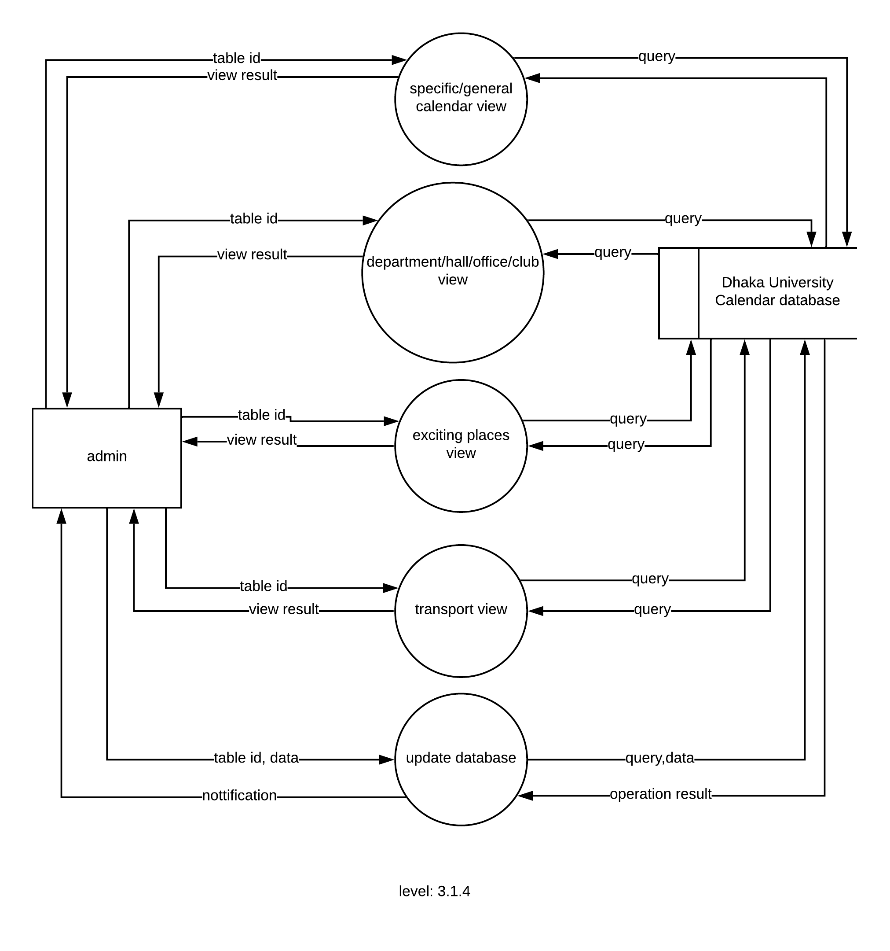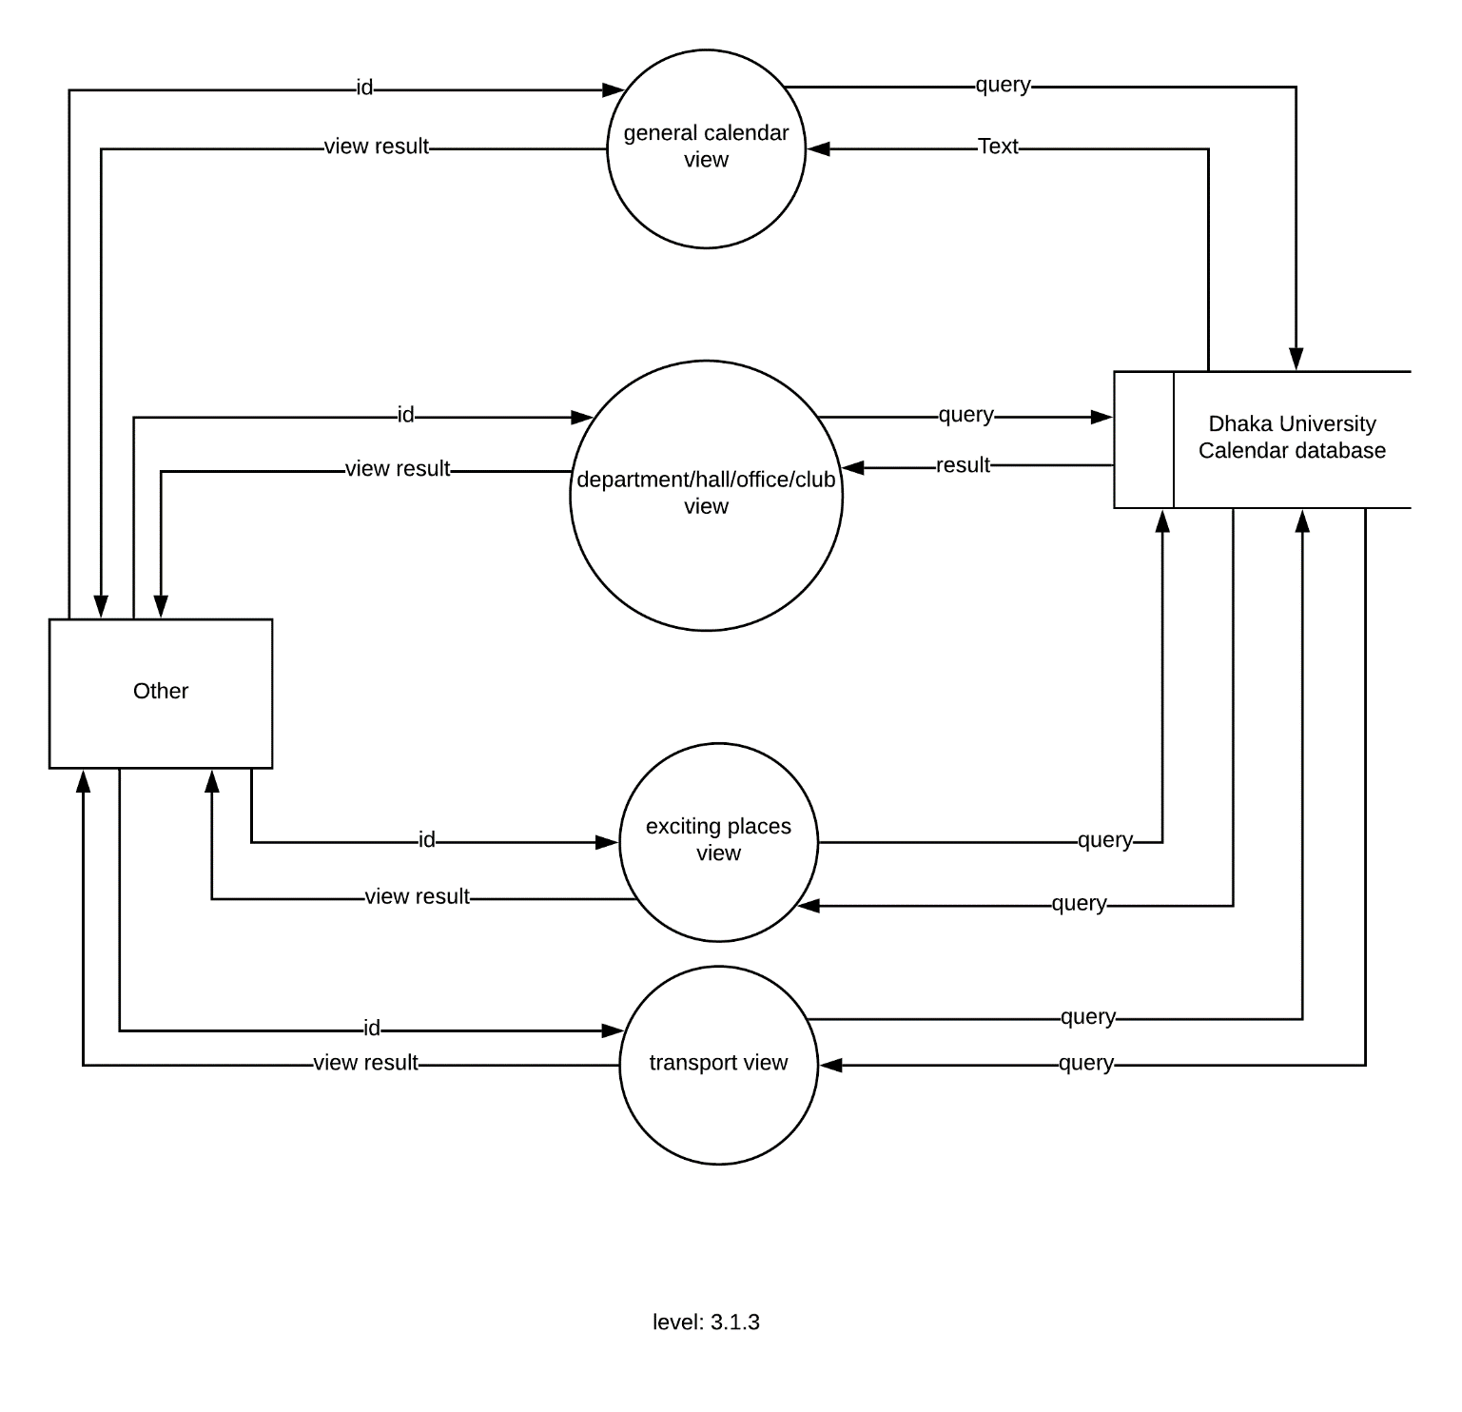

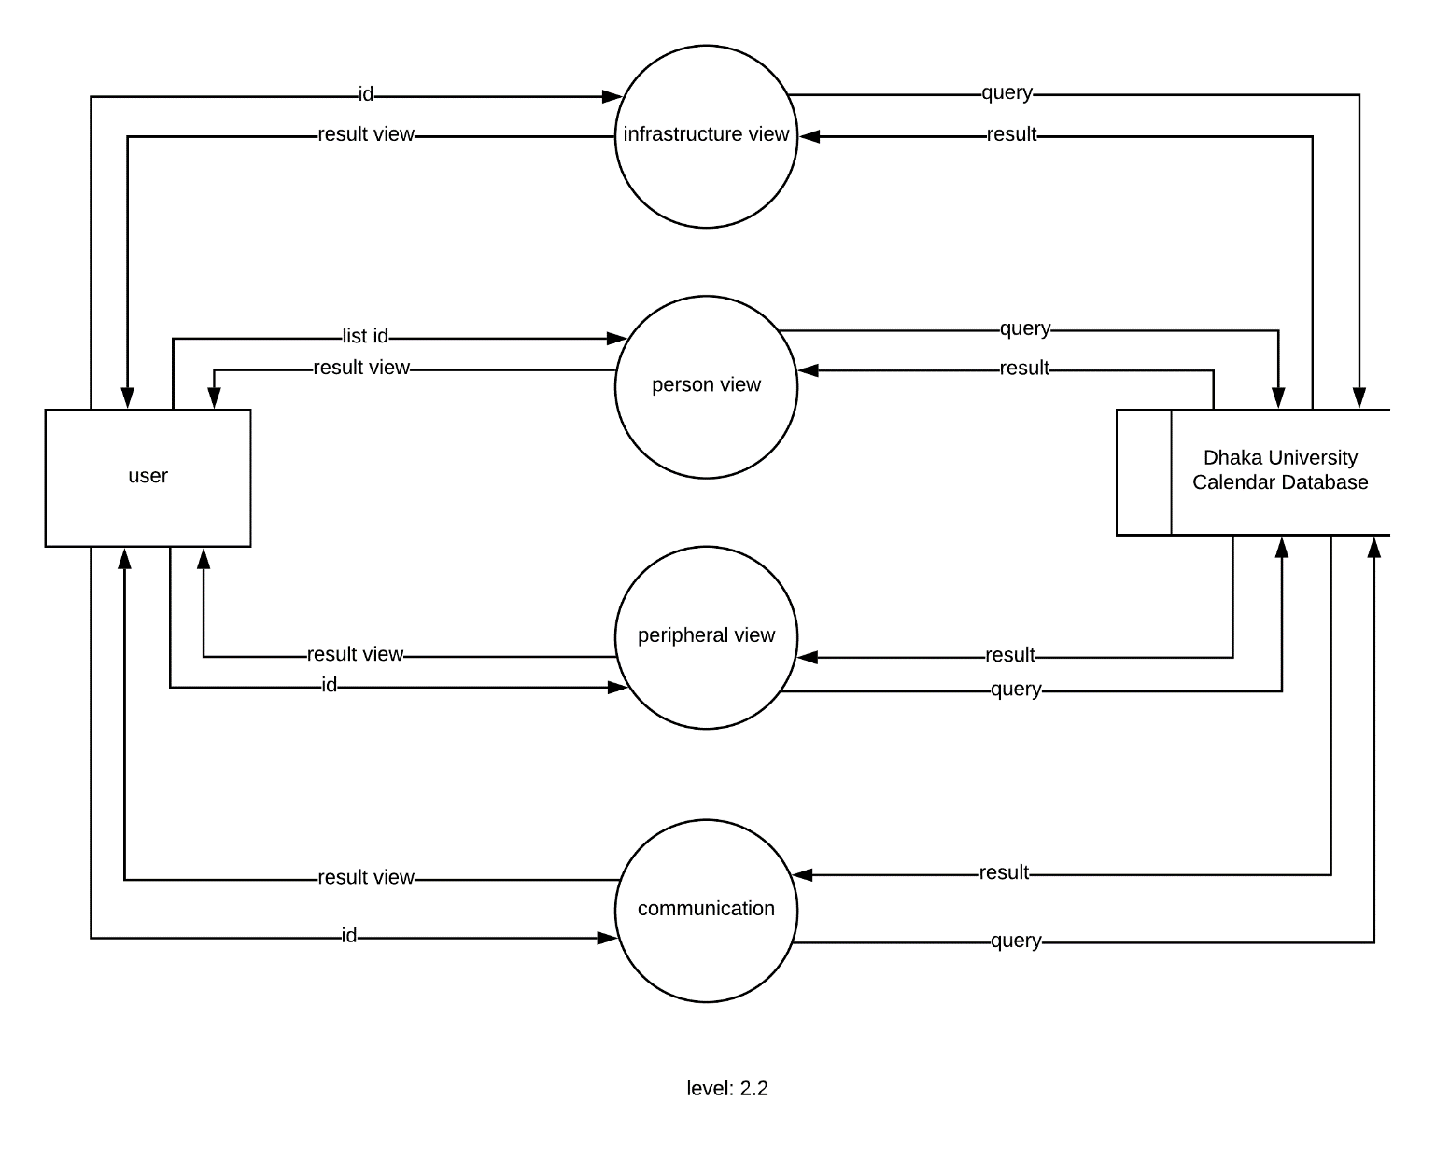

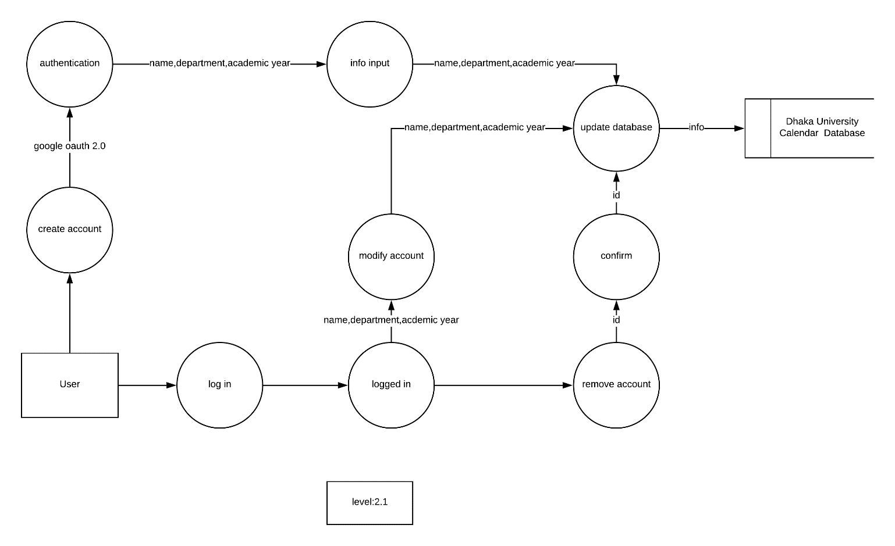

**Chapter 8: Behavioral Model**

The behavioral model indicates how software will respond to external events.

**8.1 State Diagram**

State diagram represents active states for each class the events (triggers).

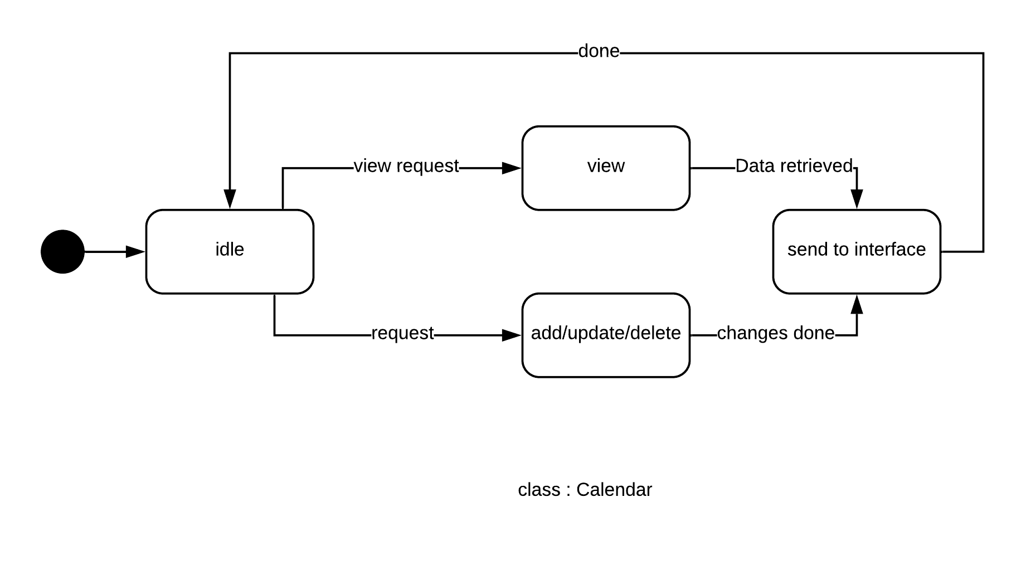

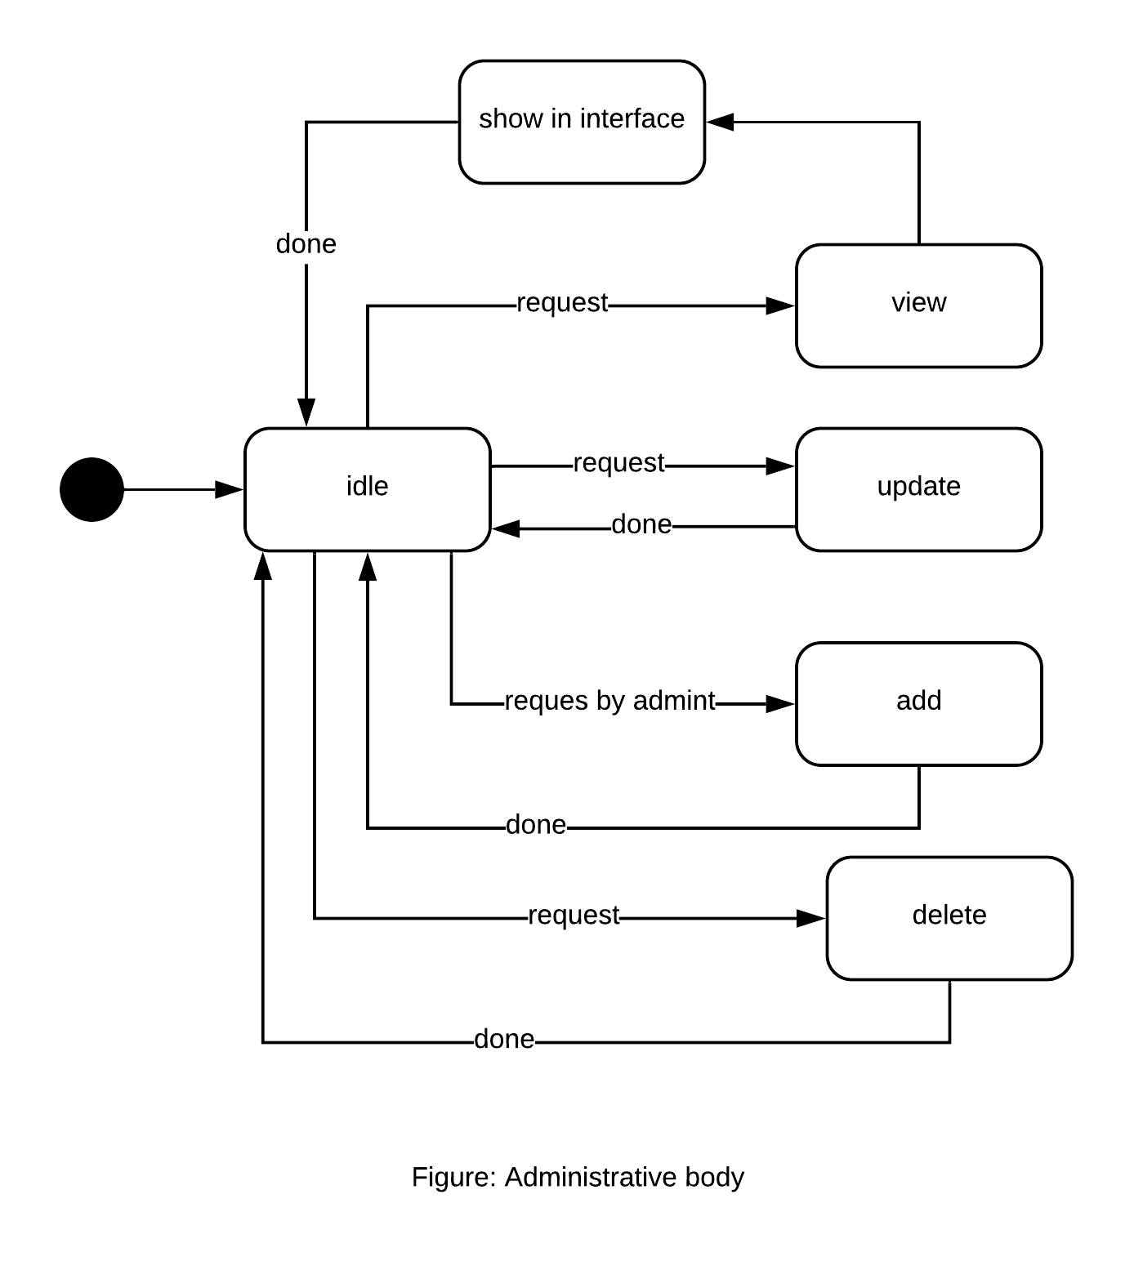

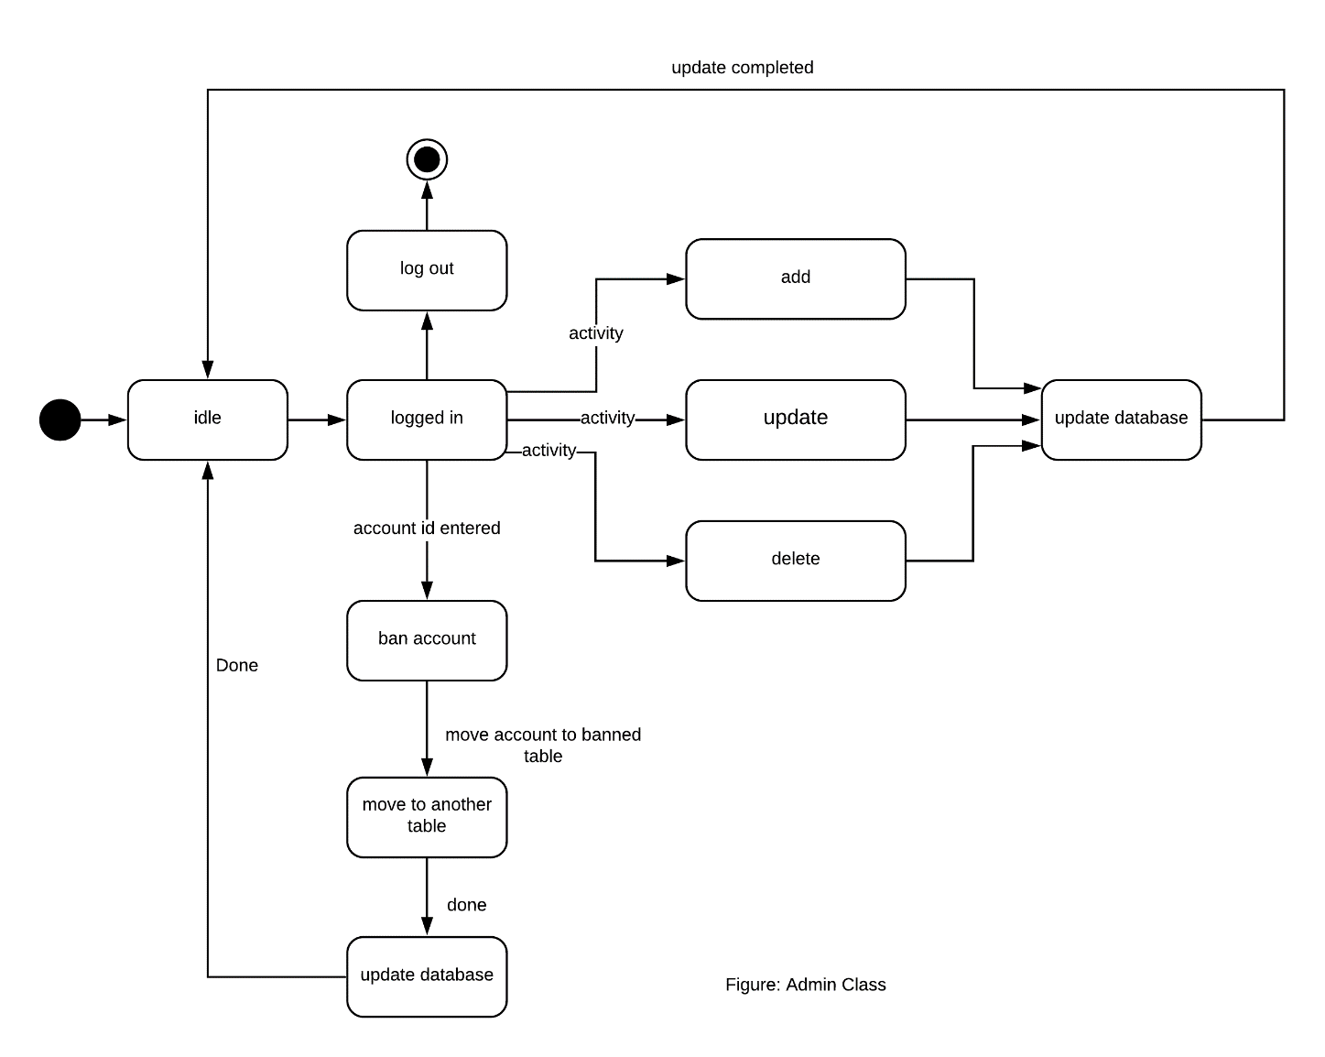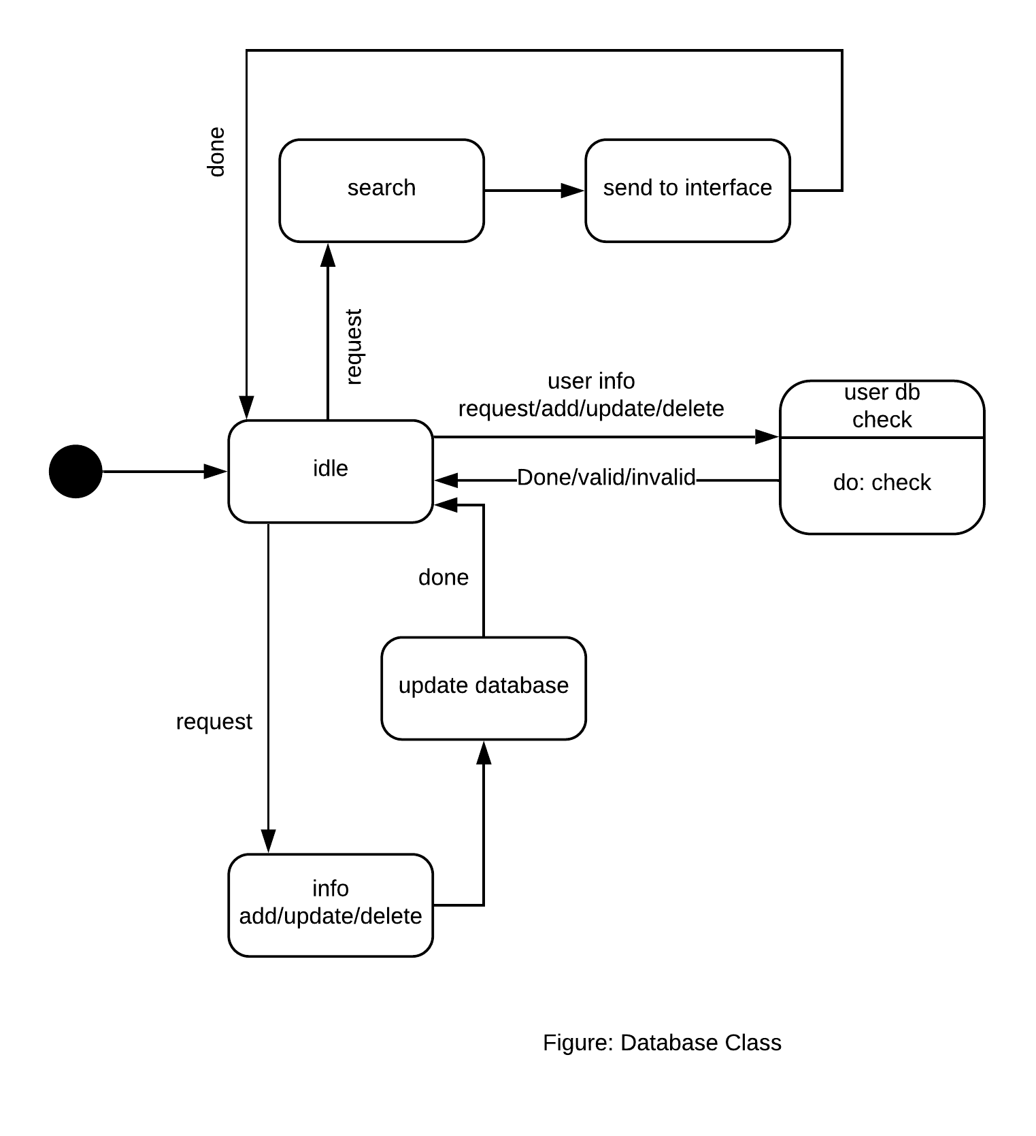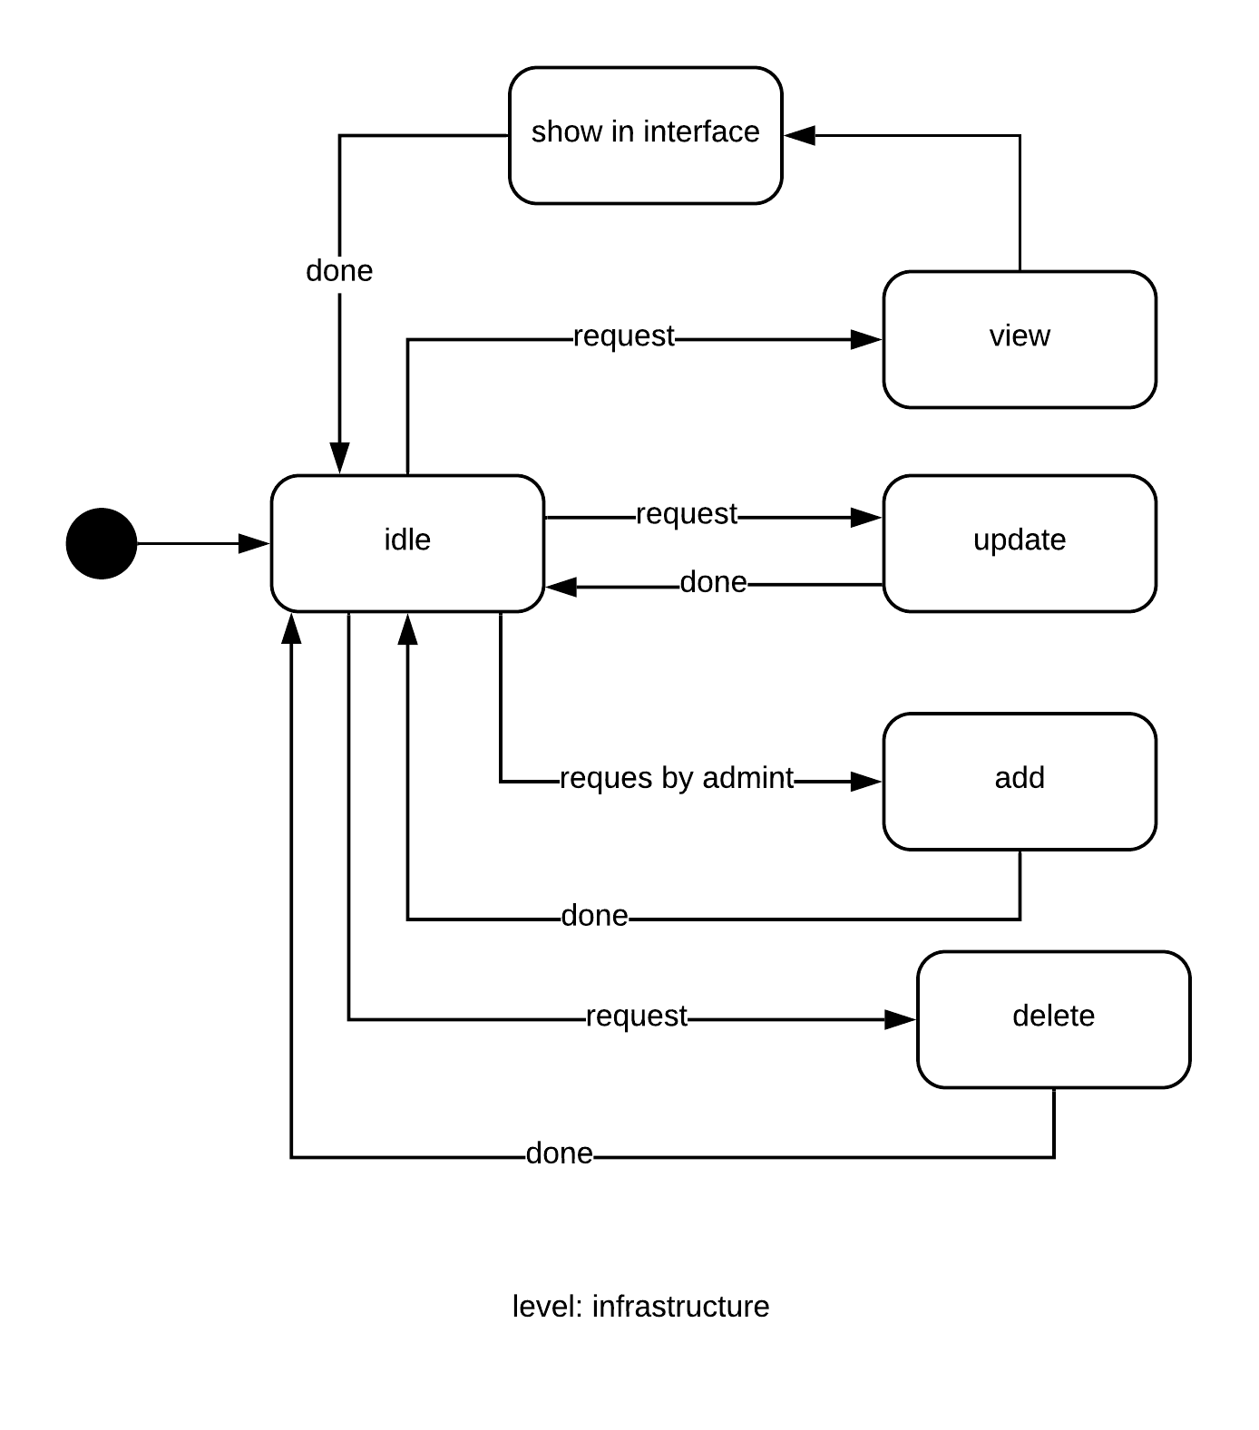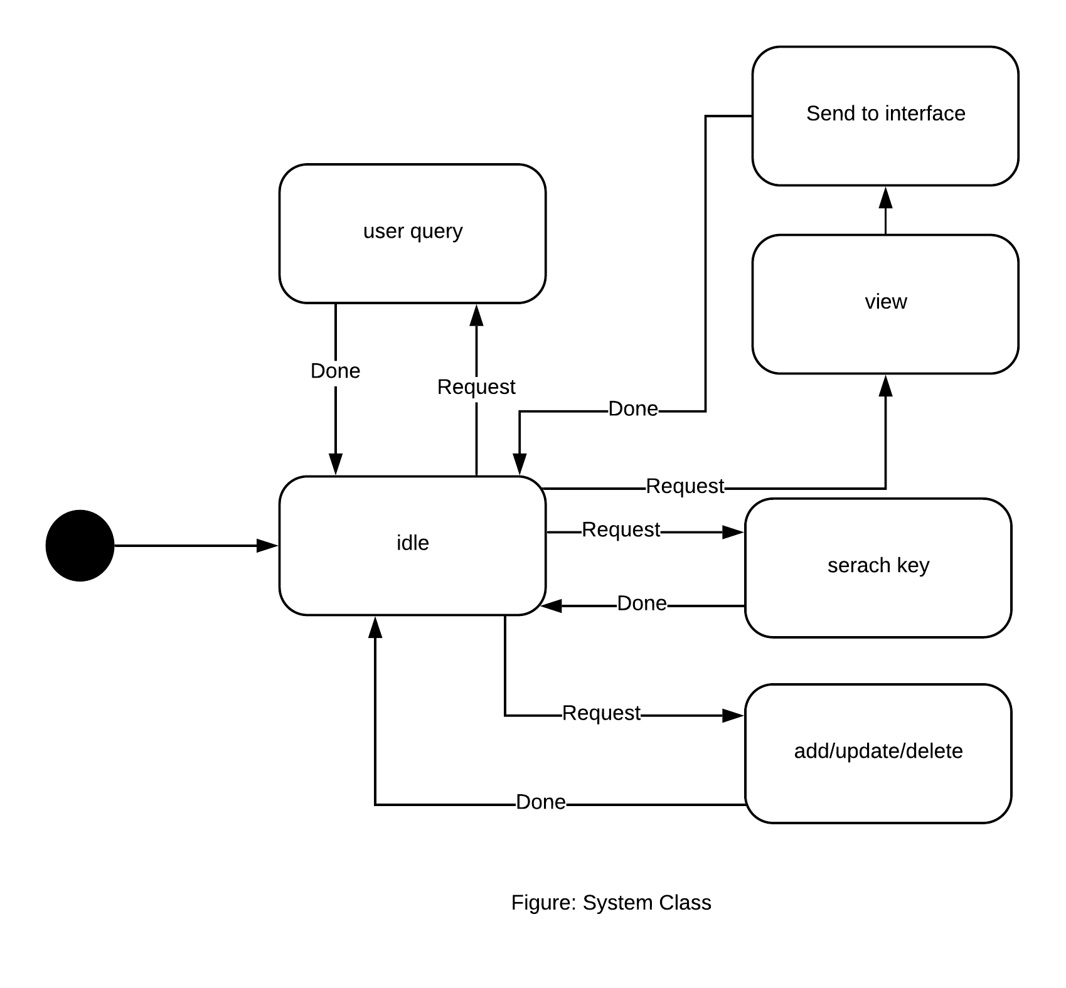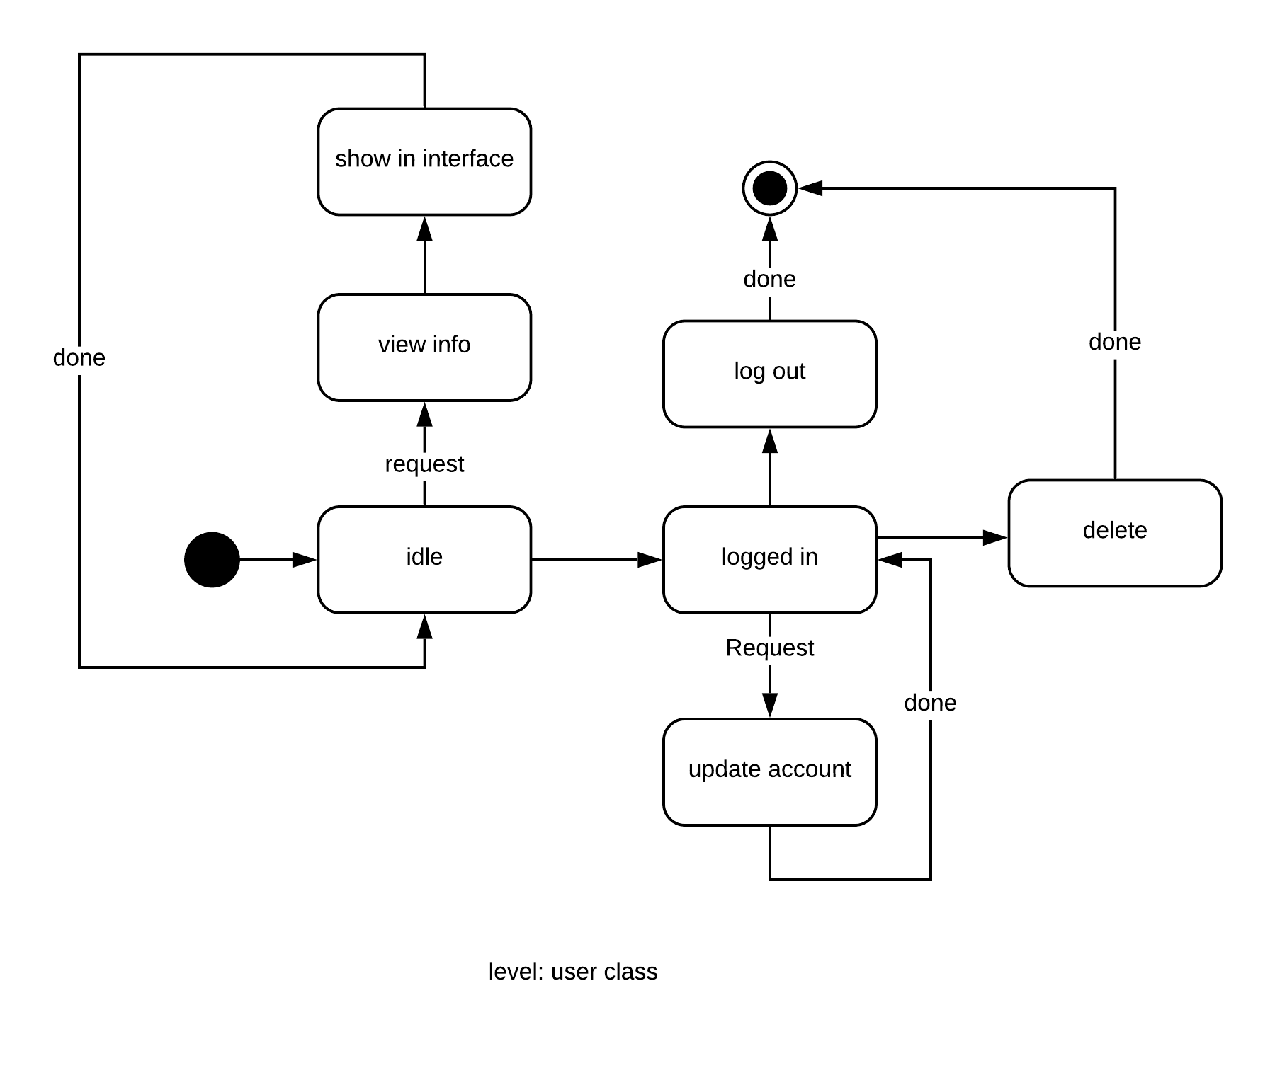

**8.2 Sequence Diagram**

Sequence diagram indicates how events cause transitions from object to object.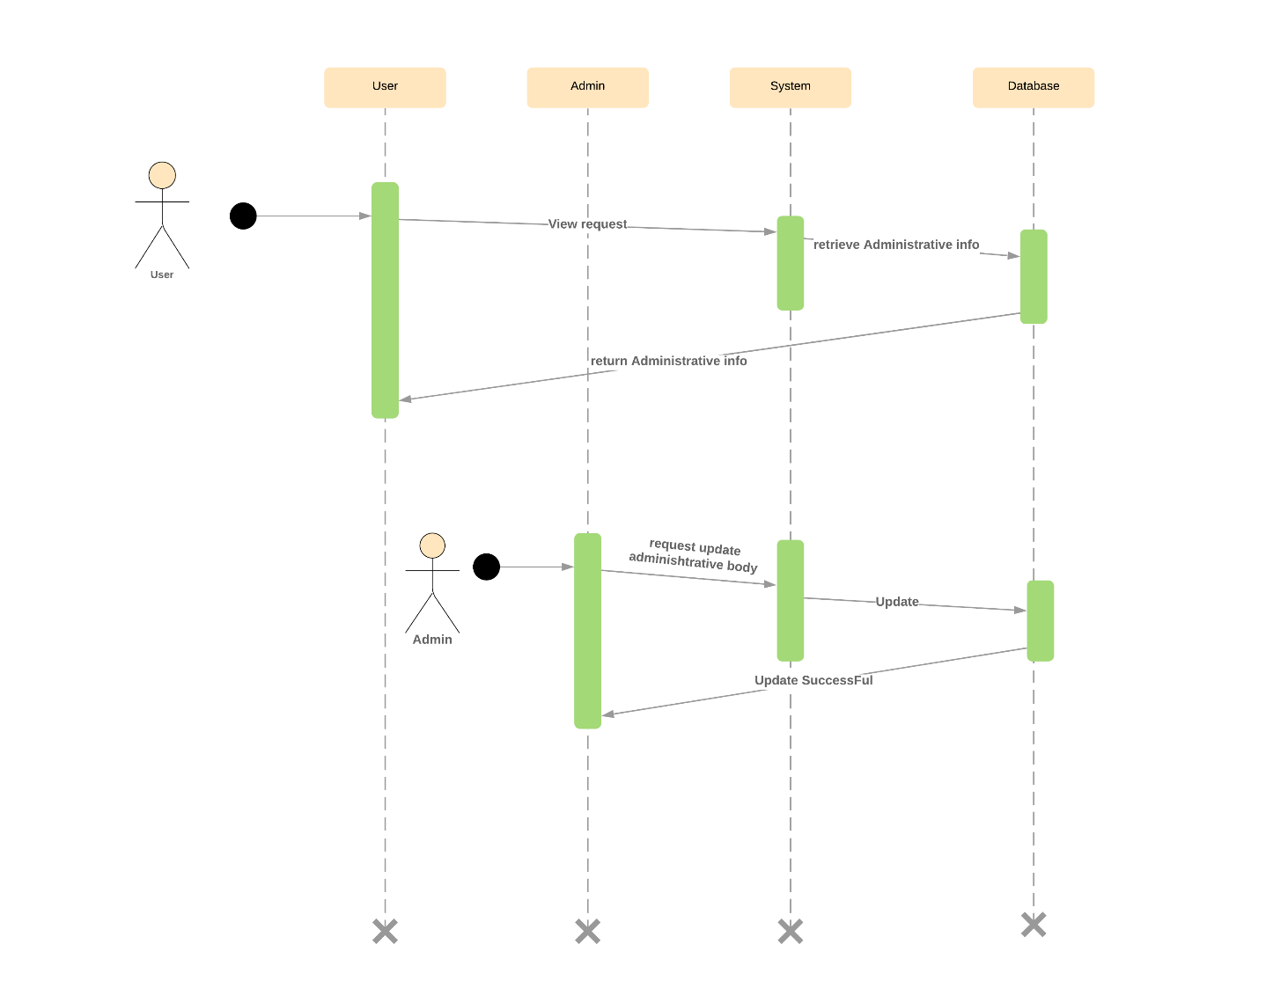

**Figure : Sequence Diagram for Sign up**

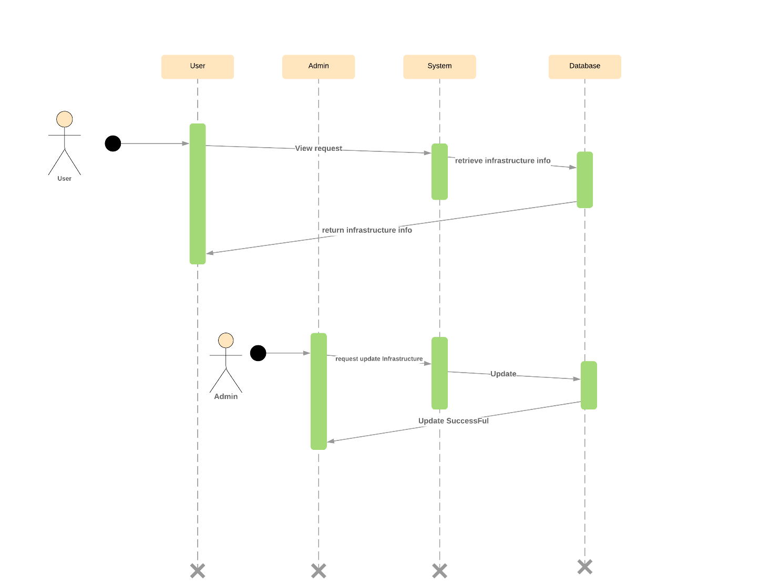

**Figure : Sequence Diagram for Infrastructure**

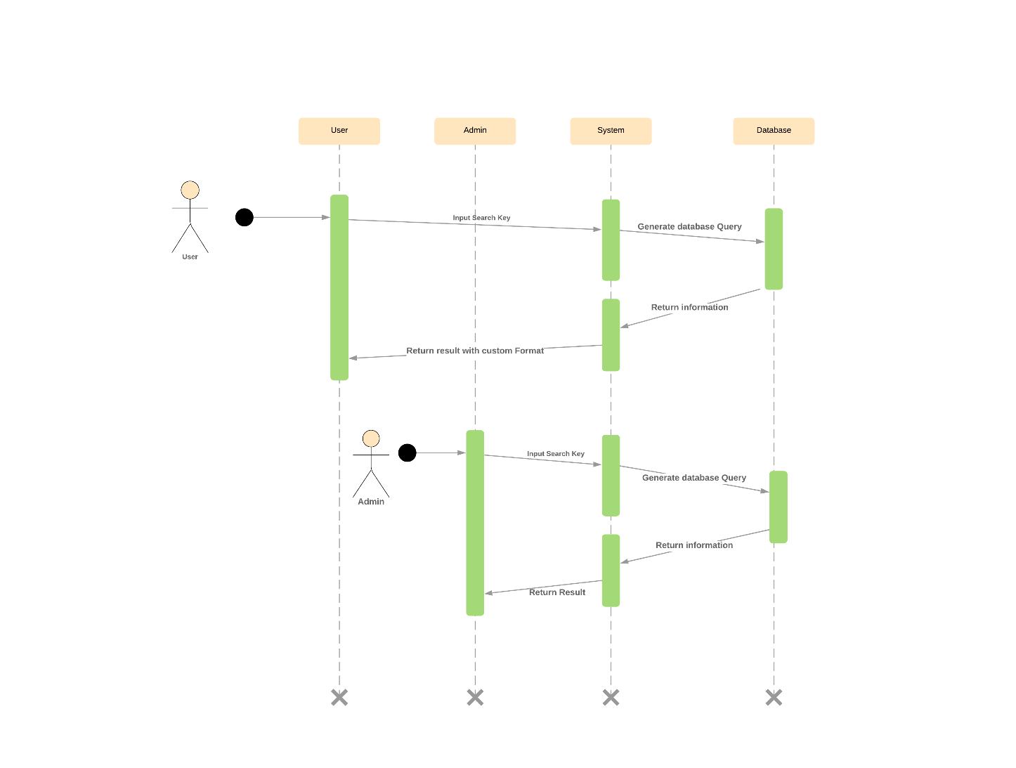

**Figure : Sequence Diagram for Search**

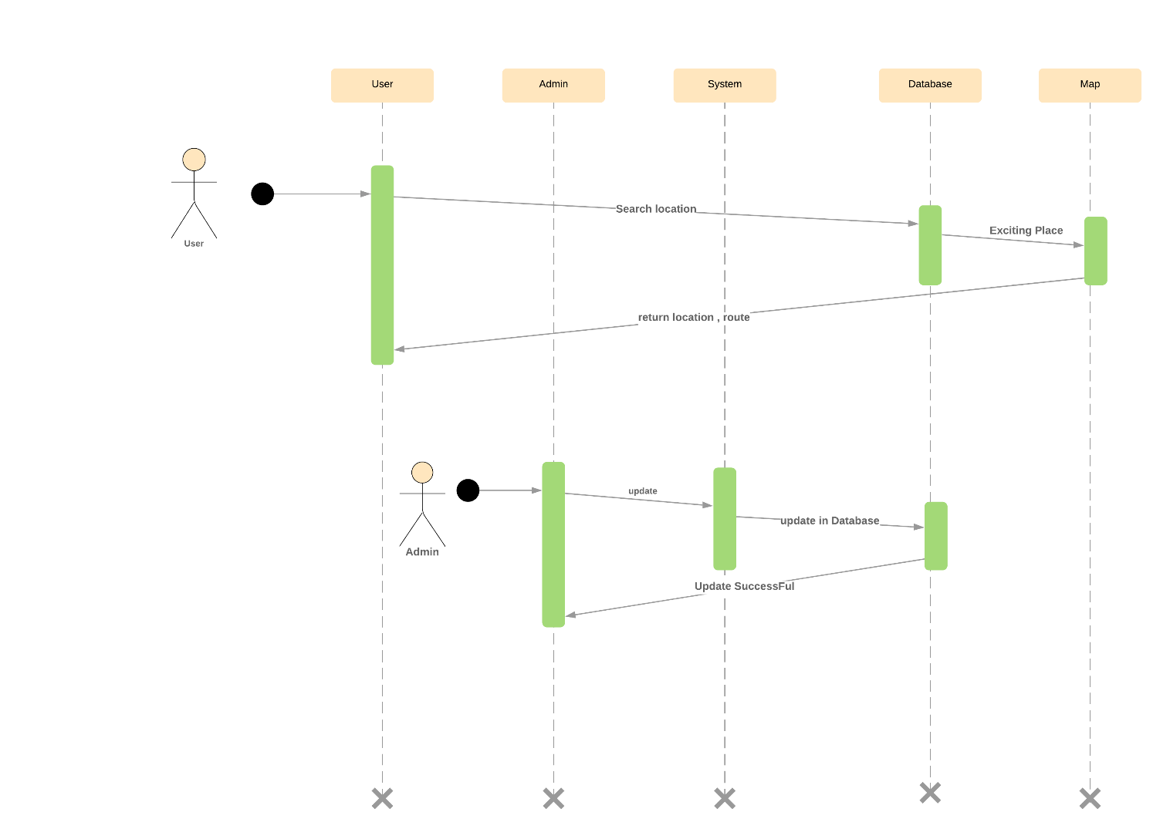**Figure : Sequence Diagram for Map**

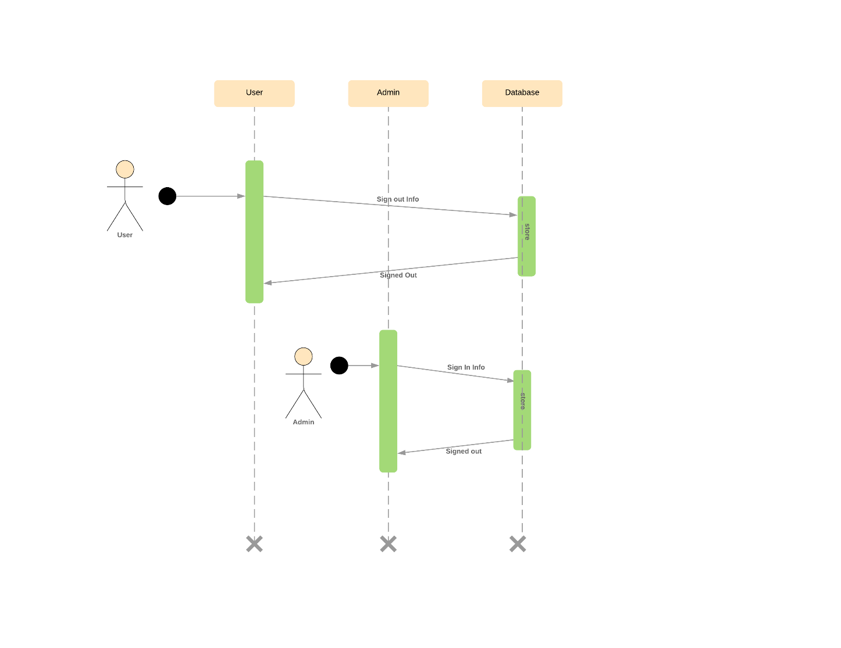

**Figure : Sequence Diagram for Sign out**

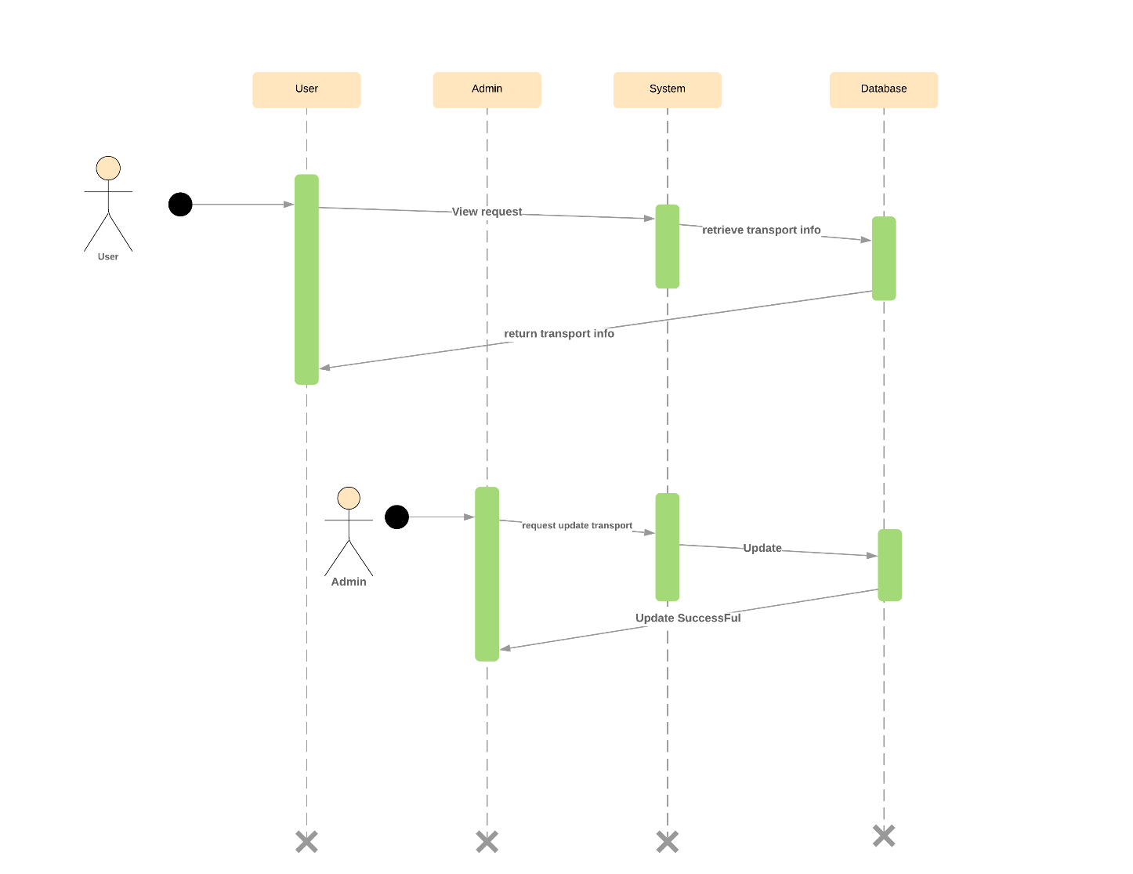

**Figure : Sequence Diagram for Transport**

**Chapter 9: Conclusion**

We are pleased to submit the SRS Dhaka University Calendar Management Application  
From this, the readers will get a clear and easy view of the overall system. This SRS  
document can be used effectively to maintain the software development cycle. It will  
be very easy to conduct the whole project using this SRS.  
We tried our best to remove all dependencies and make an effective and fully designed SRS. We believe that the reader will find it in order.

146

**References**

**1.** Book- Pressman, Roger S. Software Engineering: A Practitioner's Approach (7th  
Edition)

**2.** ER diagram- https://www.tutorialcup.com/dbms/er-data-model.htm [Last  
accessed: 18/03/2019 4.30 PM]

**3.** CRC diagram-http://csis.pace.edu/~marchese/cs615sp/L4New/l4senewf.htm  
[Last accessed: 17/03/2019 3.50 PM]

13